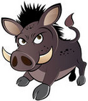 Animal Charades
- Cat Chef
- Rabbit Scientist
- Moose Waiter
- Elephant Actor
- Duck Doctor
- Horse Plumber
- Lion Farmer
- Sheep Bus Driver
- Monkey News Reporter
- Chicken Race Car Driver
- Dog Firefighter
- Beaver Police Officer
- Bear Teacher
- Giraffe Limo Driver
- Hamster Astronaut
- Cow Electrician
- Zebra Librarian
- Camel Zoo Keeper
- Flamingo Cashier
- Kangaroo Radio DJ
- Horse Mail Carrier

