 LET’S GET TO KNOW EACH OTHER 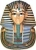

NAME:

- Ambition _______________________________________________

- Fondest memory __________________________________________

- Favourite Musical Artist / Band _____________________________

- Best Vacation ____________________________________________

- Craziest Dream ___________________________________________

- Proudest Moment _________________________________________

- Biggest Challenge ________________________________________

- Perfect Day _____________________________________________

- Indulgence / Special Treat ___________________________________

- Last Purchase ____________________________________________

- Most Enjoyable Movie ____________________________________

- Desired “Superpower” _____________________________________

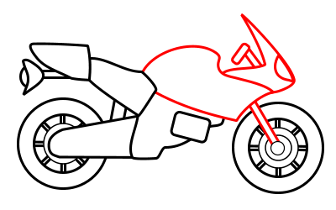

- What do you like to do in your free time & why? _______________
_______________________________________________________
- In school, what are you good at? ____________________________
_______________________________________________________
- In school, what is hard for you? _____________________________
_______________________________________________________

Name 2 things that you do with your family.
1.

2.

List 2 things that you want to do but your folks think you’re too young.

1.

2.

Write 3 places that you’d like to visit.
1.

2.

3.
What do you like to read?

What do you want to learn at school this year?

How can you help others in school?

How can others help you in school?

What makes you laugh? Why?

What else should your teachers know about you?

