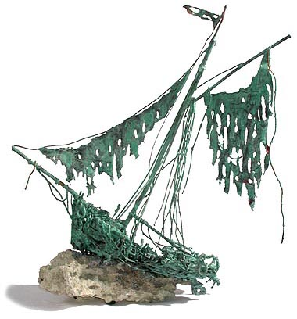 LOST AT SEA RATIONALE

According to the U.S. Coastguard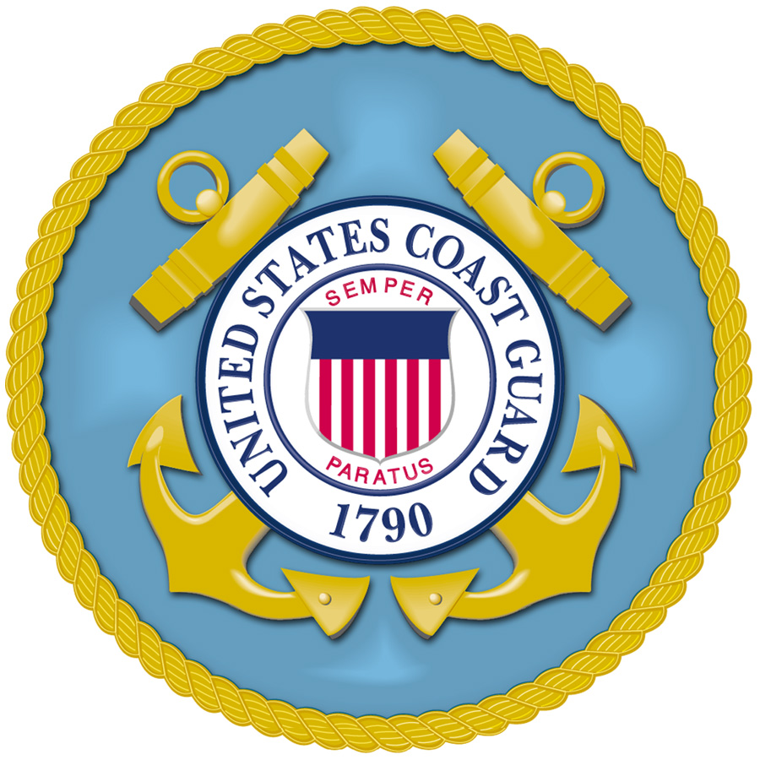, the basic supplies needed when a person is stranded mid-ocean are articles to attract attention & to aid survival until rescue arrives. Without signaling devices, there is almost no chance of being spotted & rescued.

Most rescues occur within the first 36 hours. A person can survive with only a minimum of food & water during that period. The list below ranks the items in their order of importance to your SURVIVAL.

- The shaving mirror would be critical for signaling.

- The oil / petroleum mixture would also help signal others. It would float on water & could be ignited with the paper currency and a match.

- The water would be necessary to replenish fluids lost through perspiration.

- One case of army rations would provide basic food intake.

- The opaque plastic sheet could be used to collect rain water and provide shelter.

- The chocolate bars could provide energy as well.

- The fishing kit is ranked lower. There’s no guarantee that you will catch fish.

- The nylon rope could be used to secure people / equipment to prevent them from being washed overboard.

- The floating seat cushion is a life preserver if someone fell overboard.

- Shark repellent

- The rum contains 80% alcohol, which is enough to treat injuries. (antiseptic= to kill germs) It will cause dehydration if ingested.

- The transistor radio is useless. – No transmitter so you can’t talk to others. Also you would be out of range of radio stations and would not receive any stations.

- Maps of the ocean are useless without navigation equipment.

- The mosquito netting is useless. There are no mosquitoes there. The fishing equipment is much better for catching fish.
