**2D GEOMETRY – ANSWERS**

Question 1: An acute angle measures...

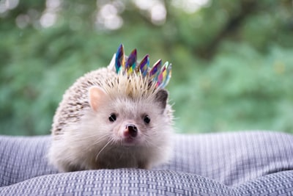

1. less than 90°
2. more than 90° but less than 180°
3. 90°
4. none of the above

Question 2: This shape can be classified as a(n)...

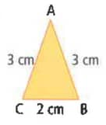

1. obtuse scalene triangle
2. acute isosceles triangle
3. right scalene triangle
4. acute equilateral triangle

Question 3: An isosceles triangle is a triangle with...

1. Three equal sides
2. Two equal sides
3. No equal sides
4. Five equal sides

Question 4: An obtuse angle measures...

1. 90°
2. More than 90° but less than 180°
3. Less than 90°
4. 45°

Question 5: A road runs parallel to a set of train tracks. That means it...

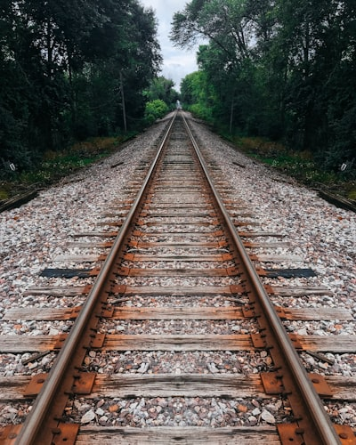

1. Crosses the train tracks
2. Is completely separate from the train tracks.
3. Is beside the tracks going in the same direction.
4. Leads into town.

Question: Congruent shapes are shapes that...

1. have the same shape only.
2. have the same colour.
3. have the same size.
4. have the same shape and size.

Question 7: Are all of these shapes kites?

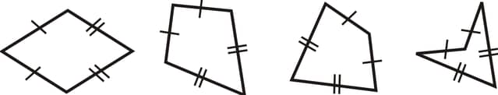

1. Yes
2. No
3. All but one on the far right
4. All but the one on the left

Question 8: A triangle with three 9cm sides is a(n)...

1. Equilateral triangle
2. Isosceles triangle
3. Acute triangle
4. Obtuse triangle

Question 9: A translation could also be described as a...



1. Turn
2. Flip
3. Bop
4. Slide

Question 10: A reflection could also be described as a...



1. Turn
2. Bop
3. Flip
4. Slide

Question 11: A rotation could also be described as a...

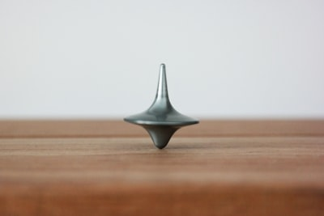

1. Turn
2. Flip
3. Hop
4. Slide

Question 12: Which of the following is a quadrilateral?

1. Rhombus
2. Hexagon
3. Circle
4. Triangle

Question 13: Which of the following is a transformation?



1. Reflection
2. Rotation
3. Translation
4. All of the above

Question 14: A shape and its photocopy would be considered...

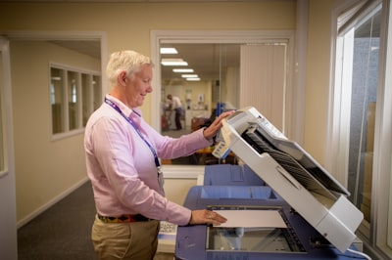

1. Similar
2. Congruent
3. Unrelated

Question 15: All squares are similar to each other, regardless of size.



1. True
2. False
3. Sometimes

Question 16: A polygon with six sides is called a(n)...

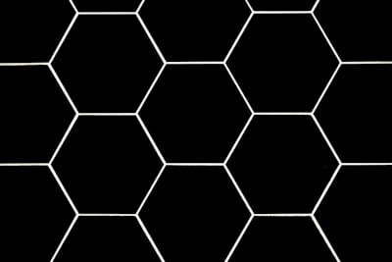

1. Paragon
2. Hexagon
3. Octagon
4. Pentagon

Question 17: A polygon with five sides is called a...

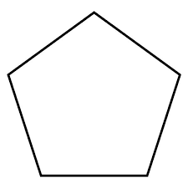

1. Hexagon
2. Nonagon
3. Pentagon
4. Triangle

Question 18: A traffic intersection is an example of roads running...



1. Parallel
2. Perpendicular
3. Parapsychologically
4. Congruent

Question 19: If two triangles have the same perimeter, they must be congruent.

1. True
2. False

Question 20: If two squares have the same perimeter, they must be congruent.

1. True
2. False

Question 21: This is a(n)…

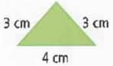

1. Equilateral triangle
2. Isosceles triangle
3. Scalene triangle
4. Perpendicular triangle

Question 22: This is a(n)…

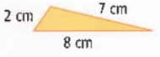

1. Equilateral triangle
2. Isosceles triangle
3. Scalene triangle
4. Perpendicular triangle

Question 23: This is a(n)…

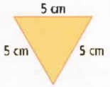

1. Equilateral triangle
2. Isosceles triangle
3. Scalene triangle
4. Perpendicular triangle

Question 24: This is a(n)…

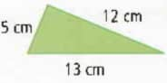

1. Equilateral triangle
2. Isosceles triangle
3. Scalene triangle
4. Perpendicular triangle

Question 26: Are these three figures congruent?

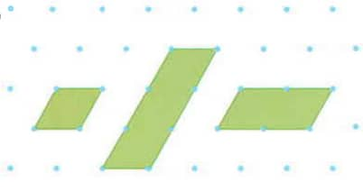

1. Yes
2. No
3. Sometimes
4. Only on Wednesdays

Question 27: These two shapes are...

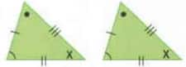

1. Isosceles triangles
2. Congruent triangles
3. Similar angles
4. Equilateral triangles

Question 28: These two shapes are...

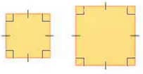

1. Similar triangles
2. Congruent triangles
3. Similar squares
4. Congruent rectangles

Question 29: This shape is a...

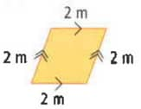

1. Triangle
2. Rhombus
3. Rectangle
4. Square

Question 30: This shape is a…

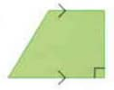

1. Parallelogram
2. Rhombus
3. Trapezoid
4. Kite

Question 31: A quadrilateral with four equal sides and no right angles is a...

1. Square
2. Rhombus
3. Kite
4. Rectangle

Question 32: A quadrilateral is…

1. A shape with four sides
2. A shape with more than three sides
3. A shape with right angles
4. A shape without right angles

Question 33: What shape is this?

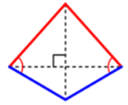

1. Parallelogram
2. Rhombus
3. Kite
4. Trapezoid

Question 34: What shape is this?

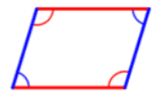

1. Kite
2. Parallelogram
3. Trapezoid
4. Circle

Question 35: What shape is this?

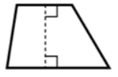

1. Parallelogram
2. Rhombus
3. Trapezoid
4. Kite

Question 36: Which of these is NOT a quadrilateral?

1. Pentagon
2. Rhombus
3. Parallelogram
4. Trapezoid

Question 37: Can an acute triangle and an obtuse triangle be similar?

1. Yes
2. No
3. Sometimes

Question 38: A vertex is…

1. A vertical line
2. A point where two sides of a figure meet
3. A type of parallel line
4. A type of perpendicular line

Question 39: The yellow lines on this road run _____ to the white lines.



1. Perpendicular
2. Parallel
3. Obtuse
4. Acute

Question 40: Triangles can be classified by their...

1. Lengths and angles
2. Heights and weights
3. Colour and size
4. Heights and angles

Question 41: If you are facing forwards and turn 180°, you will be facing...

1. To your left or right side
2. Forwards
3. Backwards
4. None of the above

Question 42: If you are facing forwards and turn 360°, you will be facing...

1. To your left or right side
2. Forwards
3. Backwards
4. None of the above

Question 43: Classify this triangle in two ways.

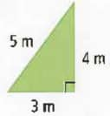

1. Equilateral right triangle
2. Isosceles right triangle
3. Scalene right triangle
4. Equilateral scalene triangle

Question 44: This quadrilateral is a…

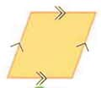

1. Parallelogram
2. Rhombus
3. Rectangle
4. Square

Question 45: This quadrilateral is a…

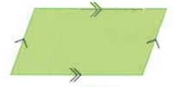

1. Parallelogram
2. Rhombus
3. Rectangle
4. Trapezoid

Question 46: A decagon has…

1. Eight sides
2. Five sides
3. Ten sides
4. Nine sides

Question 47: A nonagon has…

1. Eight sides
2. Ten sides
3. Nine sides
4. Six sides

Question 48: You are facing forwards and turn 90° clockwise. Now you are facing...

1. To your right side
2. To your left side
3. Backwards
4. Forwards

Question 49: You are facing forwards and turn 90° counterclockwise. Now you are facing...

1. To your right side
2. To your left side
3. Backwards
4. Forwards

Question 50: This is an example of a…

Upload

1. Line segment
2. Line
3. Ray
4. Midpoint

Question 51: This is an example of a…

Upload

1. Line segment
2. Line
3. Ray
4. Vertex

Question 52: This is an example of a…

Upload

1. Ray
2. Line segment
3. Line
4. Vertex

Question 53: What type of transformation is this?

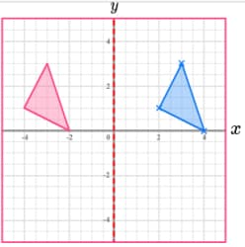

1. Reflection
2. Rotation
3. Translation
4. All of the above

Question 54: What type of transformation is this?

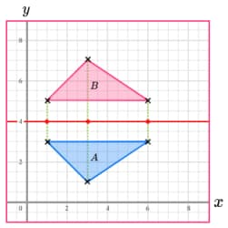

1. Translation
2. Reflection
3. Rotation
4. Impression

Question 55: The top left and bottom right figure are...

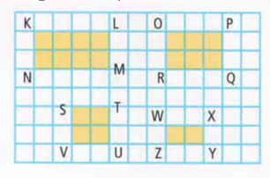

1. Congruent
2. Similar
3. Neither

Question 56: Identify the missing angle.

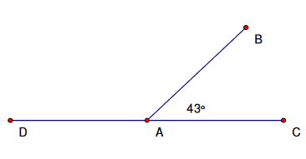

1. 137°
2. 110°
3. 47°
4. 99°

Question 57: Identify the missing angle.

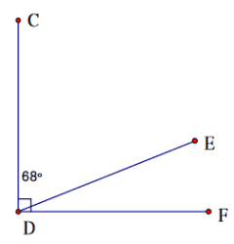

1. 158°
2. 22°
3. 90°
4. 44°