**NUMERATION – ANSWERS**

Question 1: The acronym to remember the Order of Operations is...

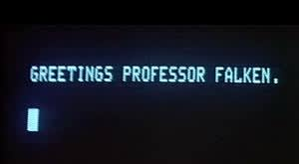

1. WOPR
2. BEDMAS
3. ARPANET
4. SWAG

Question 2: In the Order of Operations, BEDMAS represents...

1. Bear Eggs Dream, Mice Acquire Salt
2. Please Excuse My Dear Aunt Sally
3. Brackets, Exponents, Division/Multiplication, Addition/Subtraction
4. Brackets, Examples, Divide Many, Add Some

Question 3: Evaluate 4 + 6 x 5



1. 50
2. 34
3. 26
4. 15

Question 4: Evaluate 2 x 8 – 6

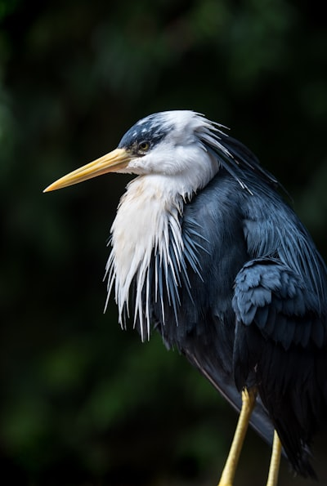

1. 16
2. 12
3. 22
4. 10

Question 5: Evaluate (8 - 3) x 3 – 2

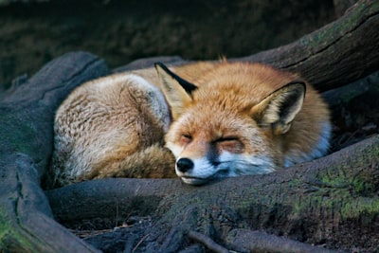

1. 13
2. 15
3. 17
4. 25

Question 6: Evaluate 2 + 4 x 4 – 2

1. 27
2. 10
3. 8
4. 16

Question 7: Evaluate 3³ + 3

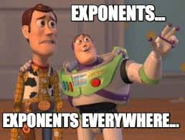

1. 12
2. 27
3. 30
4. 119

Question 8: Evaluate (8 + 1) ÷ 3 x 2



1. 3
2. 42
3. 9
4. 6

Question 9: A vertex is...



1. Perimeter/area
2. The point on a figure where two sides meet
3. The height of a triangle
4. The perimeter of a circle

Question 10: Evaluate 1 + 2 x 4

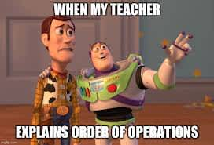

1. 6
2. 12
3. 7
4. 9

Question 11: Evaluate (8 + 3) x 5 + 5

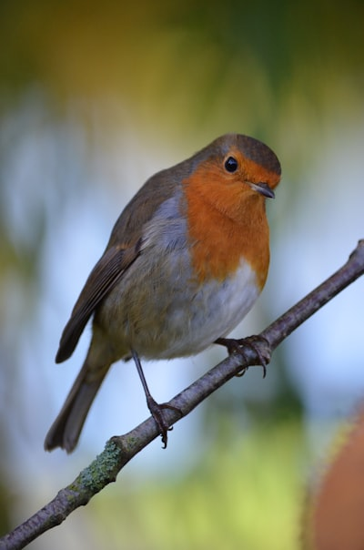

1. 60
2. 55
3. 115
4. 28

Question 12: What operation do you complete first in an equation, the brackets or multiplication?

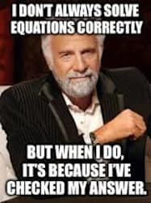

1. Brackets
2. Multiplication
3. Neither
4. Both

Question 13: Evaluate 4 + 3 x (1 + 1) - 2²



1. 6
2. 10
3. 12
4. 20

Question 14: Evaluate 6 x 6 – 27



1. 9
2. 36
3. 11
4. 19

Question 15: Evaluate 3 x 8 - 8 x 2

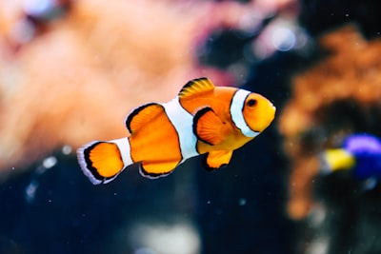

1. 14
2. 8
3. 36
4. 10

Question 16: Evaluate 20 + 3 x 4

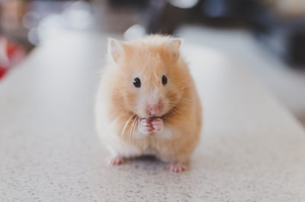

1. 92
2. 32
3. 30
4. 12

Question 17: Evaluate 9² - 1 x 9

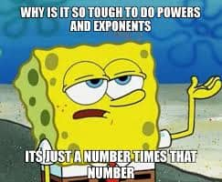

1. 9
2. 81
3. 18
4. 72

Question 18: Evaluate (8 x 2) - (10 - 4)

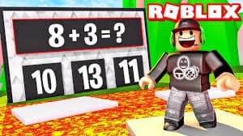

1. 6
2. 10
3. 12
4. 16

Question 19: Evaluate (1 + 1 + 6 + 1) ÷ 3

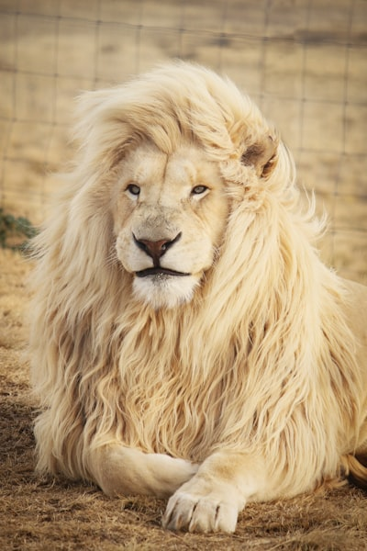

1. 6
2. 12
3. 9
4. 3

Question 20: Evaluate 10 x 10 + 1 - (5 + 3)

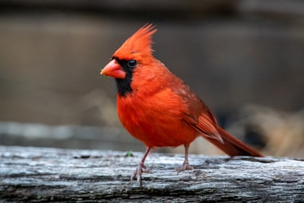

1. 101
2. 102
3. 93
4. 110

Question 21: Evaluate 4 ÷ 4 + 8 - (2 + 6)

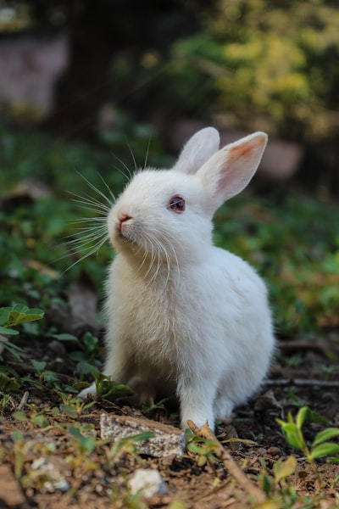

1. 8
2. 12
3. 1
4. 6

Question 22: Evaluate 2 x 4 x (1 + 2) ÷ 3

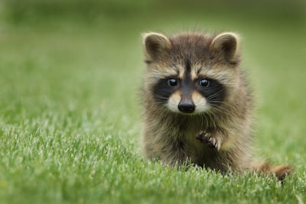

1. 3
2. 4
3. 7
4. 8

Question 23: Evaluate (7 - 4) x 2 ÷ (5 - 3)

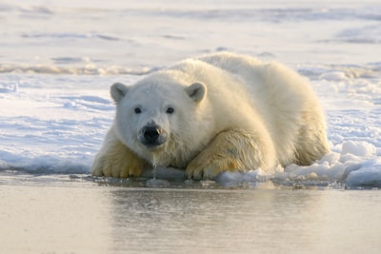

1. 6
2. 7
3. 3
4. 2

Question 24: Evaluate (10 + 14) - 4² + (2 x 4)

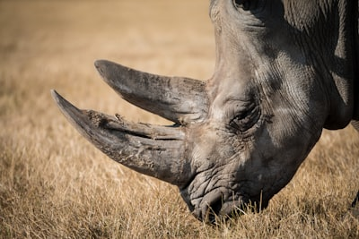

1. 16
2. 24
3. 48
4. 57

Question 25: Evaluate 110 - 100 ÷ 5

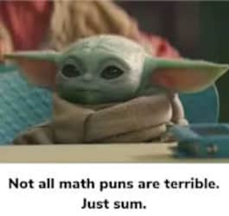

1. 45
2. 90
3. 2
4. 5

Question 26: What is the area of a square with a length and width of 12m?



1. 144m²
2. 12m²
3. 122m²
4. 142m²

Question 27: A triangle with a base and height of 10m has an area of...

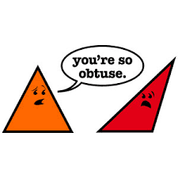

1. 20m²
2. 50m²
3. 100m²
4. 30m²

Question 28: What is the formula to determine the area of a parallelogram?



1. A = b x h ÷ 2
2. A = l x w
3. P = s + s + s + s
4. A = b x h

Question 29: What is the area of a parallelogram with a base of 12m and a height of 3m?



1. 30m²
2. 36m²
3. 360m²
4. 43m²

Question 30: What is the formula to determine the area of a triangle?

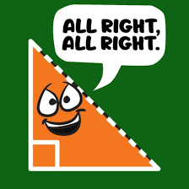

1. A = b x h
2. A = l x w
3. A = b x h / 2
4. A = (a + b) x h / 2

Question 31: A rectangle with an area of 110m² and a length of 10m has a width of...



1. 20m
2. 10m
3. 7m
4. 11m

Question 32: The area of a 4m x 6m rectangle is...



1. 64m²
2. 12m²
3. 24m²
4. 48m²

Question 33: A triangle with an area of 21m² and a base of 7m has a height of...

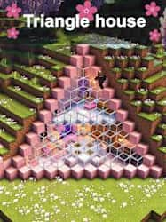

1. 7m
2. 12m
3. 6m
4. 3m

Question 34: The perimeter of a 12m x 12m square is...



1. 144m²
2. 48m
3. 44m
4. 121m²

Question 35: A rectangle with an area of 110m² and a length of 10m has a width of...

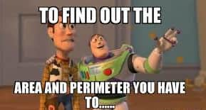

1. 11m
2. 10m
3. 7m
4. 20m

Question 36: The area of a triangle with a base of 9cm and a height of 9cm is...



1. 81cm²
2. 40.5cm²
3. 72cm²
4. 41cm²

Question 37: A parallelogram with an area of 35cm² and a base of 5cm has a height of...

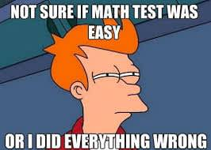

1. 7cm
2. 35cm
3. 3.5cm
4. 5cm

Question 38: Do an 8m x 10m rectangle and a parallelogram with a base of 8m and a height of 10m have the same area?

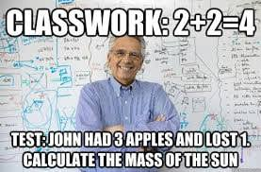

1. Yes
2. No
3. Sometimes, it depends

Question 39: The area of a trapezoid with a base of 7m, and a base of 5m, and a height of 3m is...

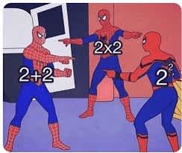

1. 105m²
2. 16m²
3. 225m²
4. 18m²

Question 40: The perimeter of a 9m x 9m square is...



1. 81m²
2. 81m
3. 27m
4. 36m

Question 41: The area of a trapezoid with a base of 9m, a base of 1m, and a height of 7m is...

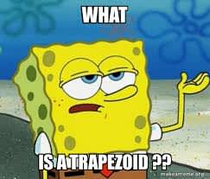

1. 63m²
2. 45m²
3. 35m²
4. 70m²

Question 42: The area of a triangle with a 12cm base and a 7cm height is...

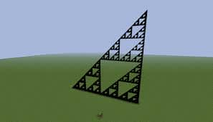

1. 84cm²
2. 77cm²
3. 42cm²
4. 44cm²

Question 43: The area of a parallelogram with a base of 8m and a height of 9m is...



1. 81m²
2. 99m²
3. 72m²
4. 76m²

Question 44: A rectangle with an area of 30m² and a length of 6m has a width of...

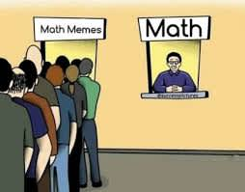

1. 30m
2. 12m
3. 6m
4. 5m

Question 45: The area of a parallelogram with a 5m height and a 12m width is...



1. 55m²
2. 66m²
3. 60m²
4. 70m²

Question 46: The area of a trapezoid with a base of 6m, a base of 8m, and a height of 20m is...

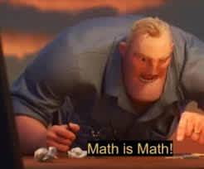

1. 140m²
2. 280m²
3. 70m²
4. 960m²

Question 47: The area of a triangle with a 4cm base and a 7cm height is...



1. 7m²
2. 56m²
3. 14m²
4. 28m²

Question 48: The perimeter of a rectangle with a 5cm length and a 20cm width is...

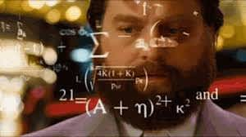

1. 100cm²
2. 50cm
3. 25cm
4. 500cm²

Question 49: A triangle with an area of 50m² and a height of 10m has a base of...



1. 20m
2. 10m
3. 2.5m
4. 5m

Question 50: The area of a rectangle with a 6m length and a 12m width is...



1. 66m²
2. 96m²
3. 72m²
4. 36m²