**ALGEBRA, PART II – ANSWERS**

Question 1: 5 less than x

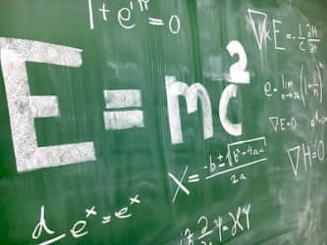

1. x-5
2. 5x
3. 5-x
4. 5

Question 2: the quotient of x and 12

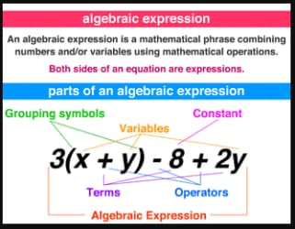

1. x-12
2. (x-12)
3. 12x
4. x/12

Question 3: two times the sum of x and 7

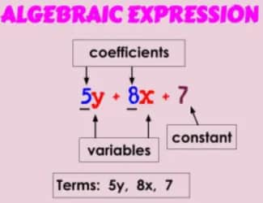

1. 2x+7
2. 2(x+7)
3. 2x+27
4. (2+x)⁷

Question 4: four times the difference of 15 and x

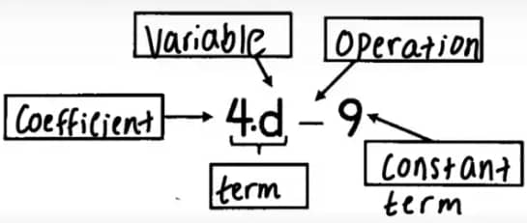

1. 15+x
2. 4x
3. 4(15-x)
4. 4x-15

Question 5: A ____ is a part of an algebraic expression separated by + or - signs

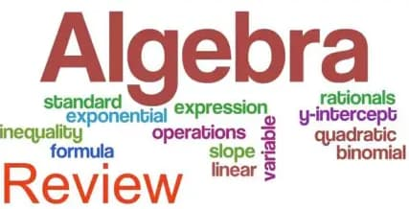

1. Term
2. Coefficient
3. Variable
4. Constant

Question 6: A _______________ is a number in front of a variable. This number is multiplied by the variable.

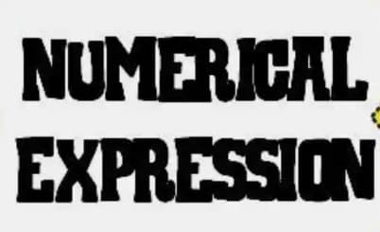

1. Term
2. Coefficient
3. Variable
4. Constant

Question 7: A ___________ is a letter or symbol that represents an unknown number.

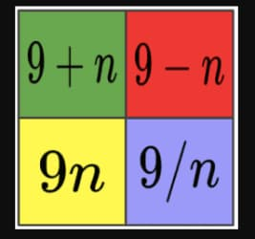

1. Term
2. Coefficient
3. Variable
4. Constant

Question 8: A ____________ is a number that stands alone.



1. Term
2. Coefficient
3. Variable
4. Constant

Question 9: 4 less than a number

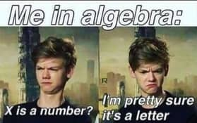

1. 4-a
2. a-4
3. 4/a
4. a/4

Question 10: What is a mathematical phrase consisting of numbers, variables, and operations?



1. Coefficient
2. Algebraic Expression
3. Numerical Expression
4. Constant

Question 11: Choose the expression: The product of a number and 19



1. 19x
2. 19/x
3. 19-x
4. 19+x

Question 12: Write: 8 more than 7 times x

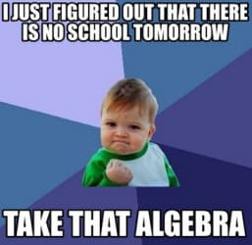

1. 8+7x
2. 7+8x
3. 8-7x
4. 8x-7

Question 13: Write: The quotient of a number and 20

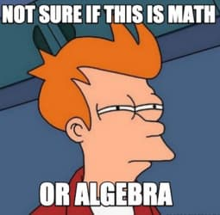

1. 20 ÷ x
2. x ÷ 20
3. 20x
4. 20 + x

Question 14: Write: The sum of 10 and x, divided by 7

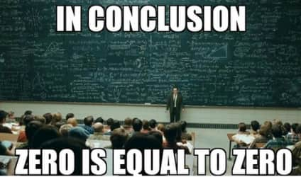

1. 7(x+10)
2. (10+x) ÷7
3. 10+x÷7
4. (x÷7)+10

Question 15: Write: Half of x



1. ½x
2. 0.5x
3. x/2
4. 2x

Question 16: Which expression is 8x?



1. The product of 8 and x
2. The quotient of 8 and x
3. The sum of 8 and x
4. The difference of 8 and x

Question 17: 6 more than twice a number



1. 6⋅2x
2. 2x⋅6
3. 2x+6
4. 6x+2

Question 18: the quotient of a number and 4



1. 4÷x
2. x÷4
3. 4x
4. -4x

Question 19: eighteen less than a number

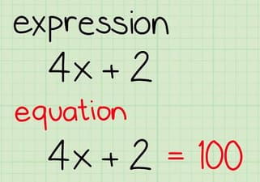

1. x-18
2. 18-x
3. x/18
4. 18/x

Question 20: $3 subtracted from the cost of a book

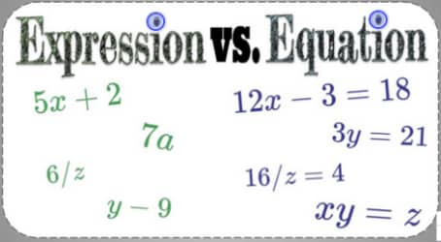

1. b-3
2. 3-b
3. -b-3
4. b+3

Question 21: The sum of 7 and L

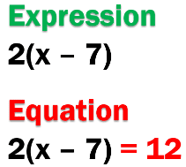

1. 70+L
2. 7+L
3. L-17
4. L+7

Question 22: L times 18

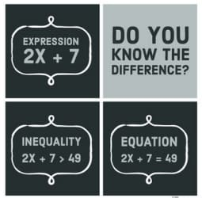

1. 9
2. L-18=9
3. L/18
4. Lx18

Question 23: One half of L



1. ½
2. L/2
3. L
4. 2 x L

Question 24: What is the COEFFICIENT of the following expression: 7c + 8?



1. 7
2. 8
3. c
4. 15

Question 25: What is the VARIABLE of the algebraic expression: 3x + 5?



1. 3
2. 8
3. x
4. 5

Question 26: What is the COEFFICIENT of the algebraic expression: 5m - 6?



1. 0
2. 5
3. 6
4. m

Question 27: What is the CONSTANT term of the algebraic expression: 3x + 4y + 9?



1. 3
2. 9
3. 4

Question 28: Four times n minus eight equals 12.

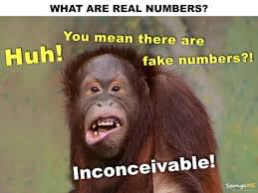

1. 4n - 8 = 12
2. 8 - 4n = 12
3. 12 - 4n = -8
4. 8n - 4 = 12

Question 29: 8 more than a number



1. n+8
2. 8n
3. n-8
4. 8+n

Question 30: 9 times a number



1. n-9
2. 9n
3. 9(n)
4. 9+n

Question 31: Quotient



1. Addition
2. Multiplication
3. Subtraction
4. Division

Question 32: Product



1. Addition
2. Multiplication
3. Subtraction
4. Division

Question 33: 5 more than twice a number



1. 2+5n
2. 10n
3. 2n+5
4. 2(n+5)

Question 34: Taylor went coyote hunting and saw 1 less coyote than her dad. Which expression represents this situation?



1. n-1
2. n+1
3. n
4. 1-n

Question 35: Bradley was playing football and kicked 3 times as many field goals as he had yesterday.



1. 3÷n
2. 3-n
3. 3+n
4. 3n

Question 36: What is the COEFFICIENT of the following expression: 7c + 8?



1. 7
2. 8
3. c
4. 15

Question 37: What is the VARIABLE of the algebraic expression: 3x + 5?



1. 3
2. 8
3. x
4. 5

Question 38: What is the CONSTANT term of the algebraic expression: 3x + 4y + 9?



1. 3
2. 9
3. 4

Question 39: What is the CONSTANT term of the algebraic expression: 3x + 4y + 9?



1. 3
2. 9
3. 4

Question 39: What is the COEFFICIENT of the algebraic expression: 5m - 6?



1. 0
2. 5
3. 6
4. m

Question 40: The sum of three times a number and five



1. 3(x+5)
2. 3x+5
3. 3*x + 3*5
4. 3x-5

Question 41: The difference of a number and three

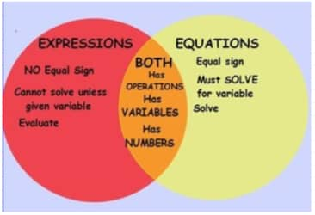

1. -3n
2. 3-n
3. n-3
4. n/3

Question 42: The sum of three times a number and five



1. 3(x+5)
2. 3x+5
3. 3*x + 3*5
4. 3x-5

Question 43: In the expression 5x + 4, x is a



1. Variable
2. Term
3. Coefficient
4. Constant

Question 44: In the expression 5x + 4, the 4 is a



1. Constant
2. Term
3. Constant and term
4. Constant and expression

Question 45: In the expression 5x + 4 , 5x is a



1. Coefficient
2. Term
3. Variable
4. Constant

Question 46: In the expression 5x + 4, the 5 is a

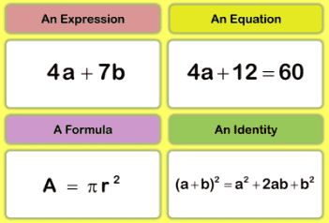

1. Term
2. Constant
3. Variable
4. Coefficient

Question 47: Select the expression.

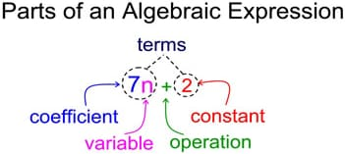

1. 23-p
2. 16 + z – 12 = 32
3. 16x + 4 = 17x
4. x/18 = 9

Question 48: Select the equation

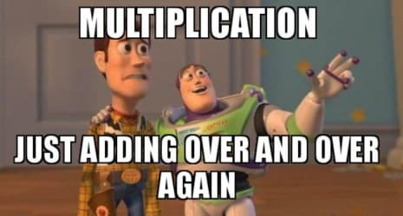

1. 18+z-10
2. -6-42-x
3. 9+x=15
4. 25-q

Question 49: In the expression 2x + 9, the 2x is a



1. Coefficient
2. Variable
3. Term
4. Expression

Question 50: In the expression 2x + 9, the 2 is a



1. Coefficient
2. Term
3. Variable
4. Constant

Question 51: In the expression 2x + 9, the 9 is a

1. Term
2. Constant
3. Term and constant
4. Term, constant, and expression

Question 52: In the expression 3x + 7 = 19, the 19 is a

1. Term
2. Term and constant
3. Constant
4. Term, constant, and expression