Answer Key Data Management Blooket

- Refers to data you obtain from someone else:
  - Primary Data
  - Secondary Data
  - Survey Data
  - Existing Data
- This type of graph shows how each part of the data set compares to a whole:
  - Stem-and-Leaf Plot
  - Bar Graph
  - Circle Graph
  - Pictograph
- Researchers created _____________ data when they recorded what they directly observed in a race.
  - Secondary
  - Tertiary
  - Primary
  - Speed
- Based on this data, what is the least favourable pet to have?
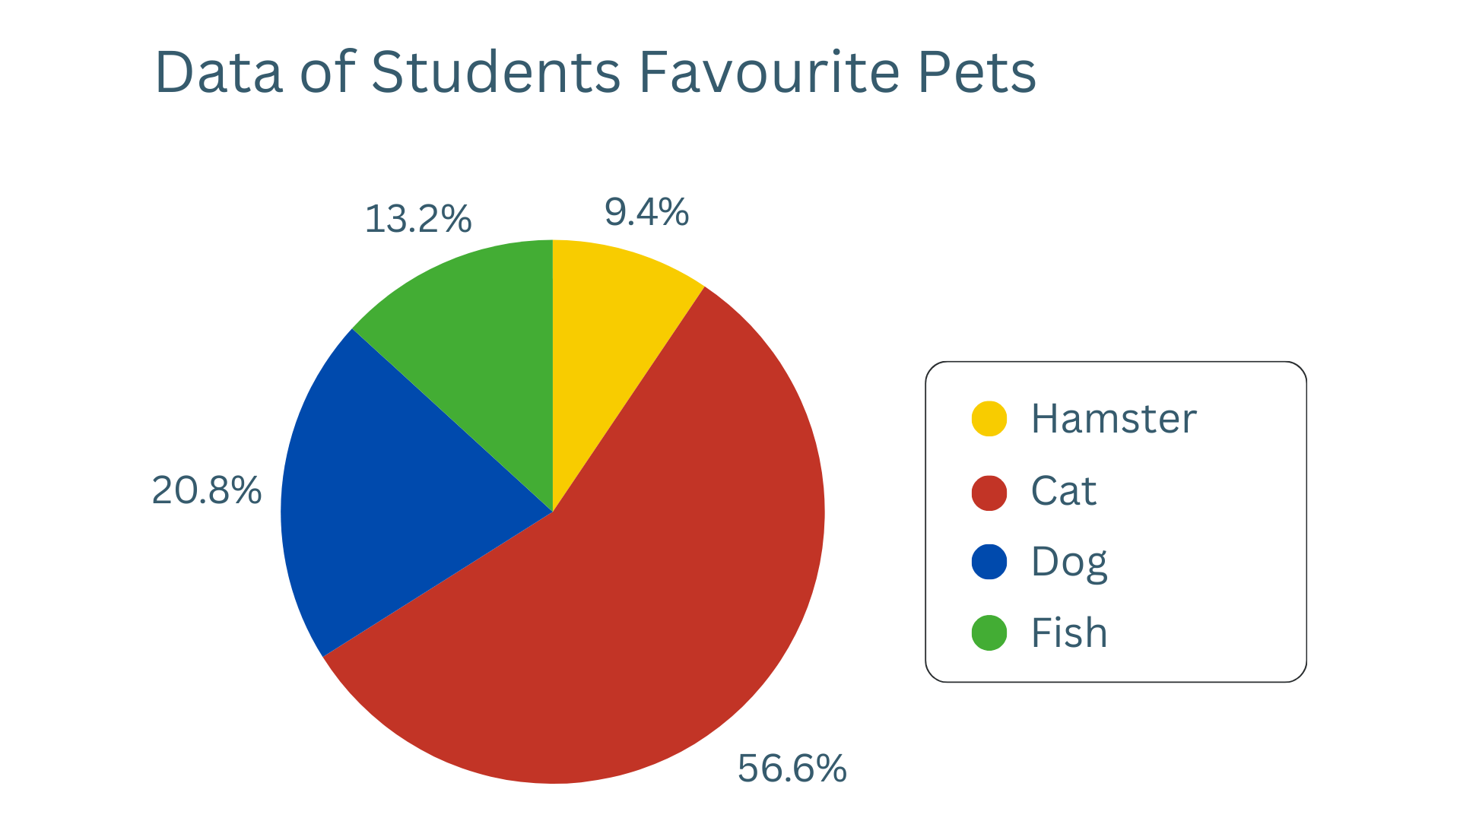
  - Hamster
  - Dog
  - Fish
  - Cat
- The middle value in a set of ordered data:
  - Mean
  - Mode
  - Median
  - Result
- What type of graphs can a spreadsheet develop?
  - Bar graphs
  - Line Graphs
  - Circle Graphs
  - All of the above
- The number that occurs most often in a set of data:
  - Mean
  - Mode
  - Median
  - Sample
- The sum of a set of numbers divided by the amount of numbers in the set:
  - Mean
  - Median
  - Mode
  - Sample
- The organisation of numerical data into categories based on place values:
  - Frequency Table
  - Interval
  - Stem-and-Leaf Plot
  - Mode
- The total number of individuals or items in a survey:
  - Sample
  - Population
  - Survey
  - Census
- What kind of graph best suits data that was collected from a survey?
  - Bar Graph
  - Line Graph
  - Circle Graph
  - Double Graph
- What is the median of this set of numbers?
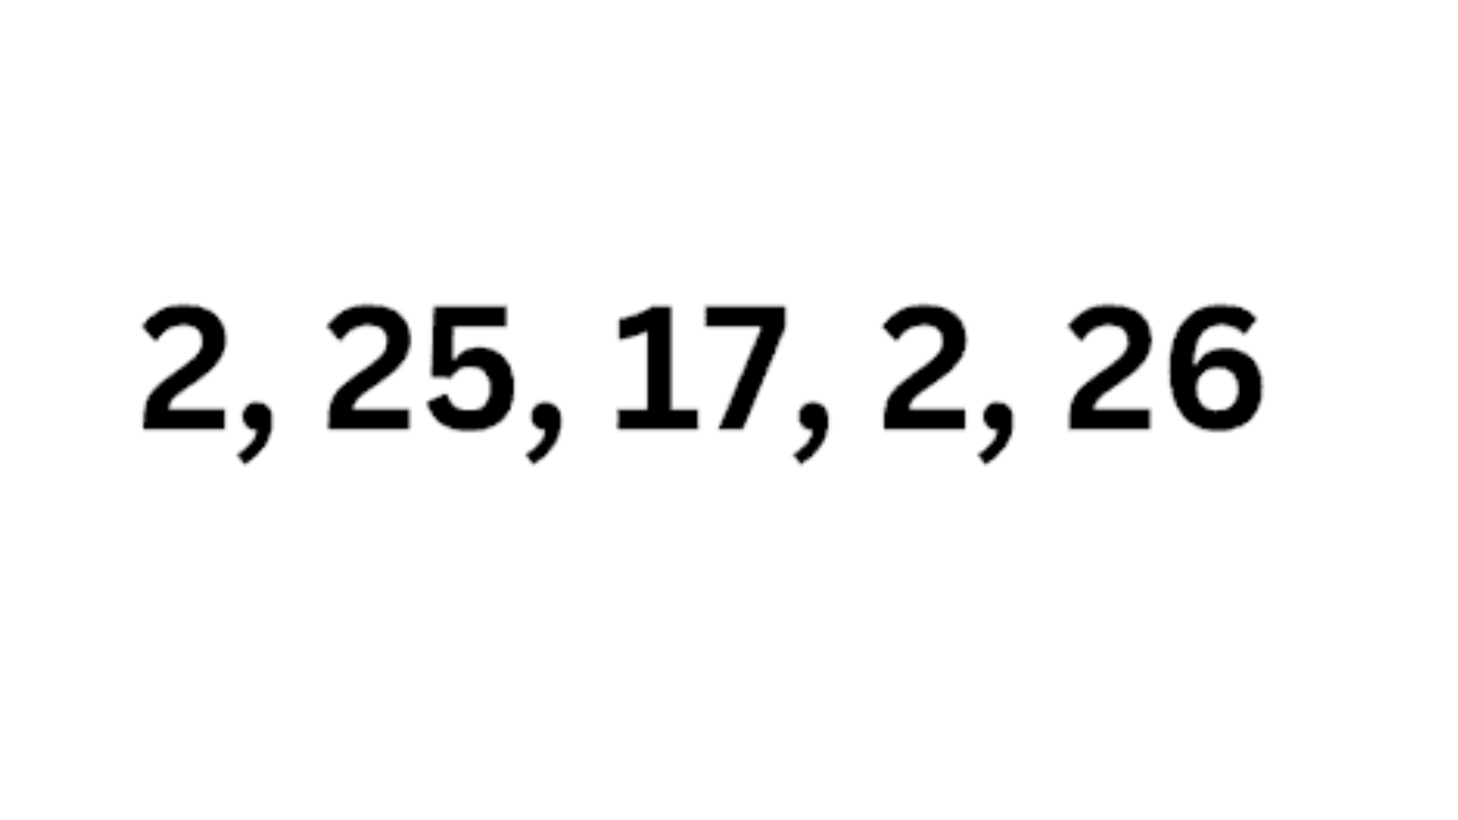
  - 2
  - 14
  - 26
  - 17
- How many people have B-type blood?
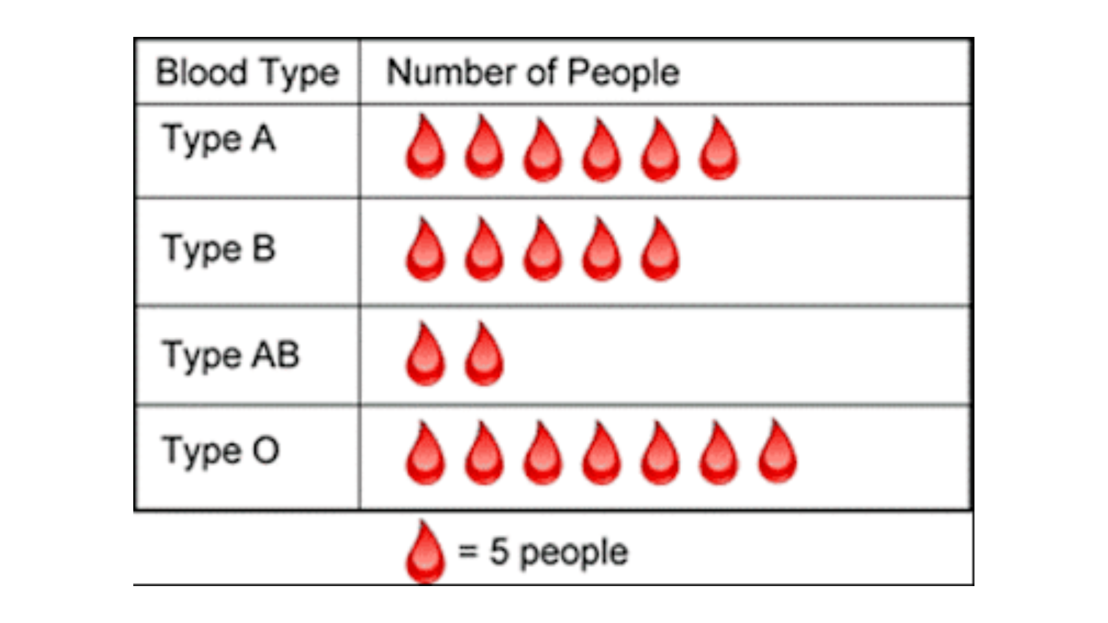
  - 5
  - 35
  - 25
  - 7
- A section of a circle graph measures 90°. What fraction of the whole does this section represent?
  - ⅓
  - ¼
  - ⅔
  - ¾
- How much money does Pat spend on transportation a month?
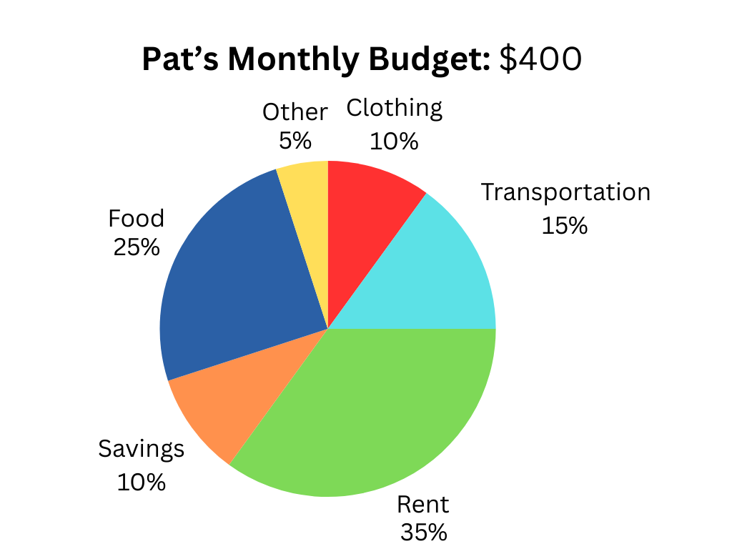
  - $60
  - $45
  - $30
  - $75
- What is the mode of this set of numbers?
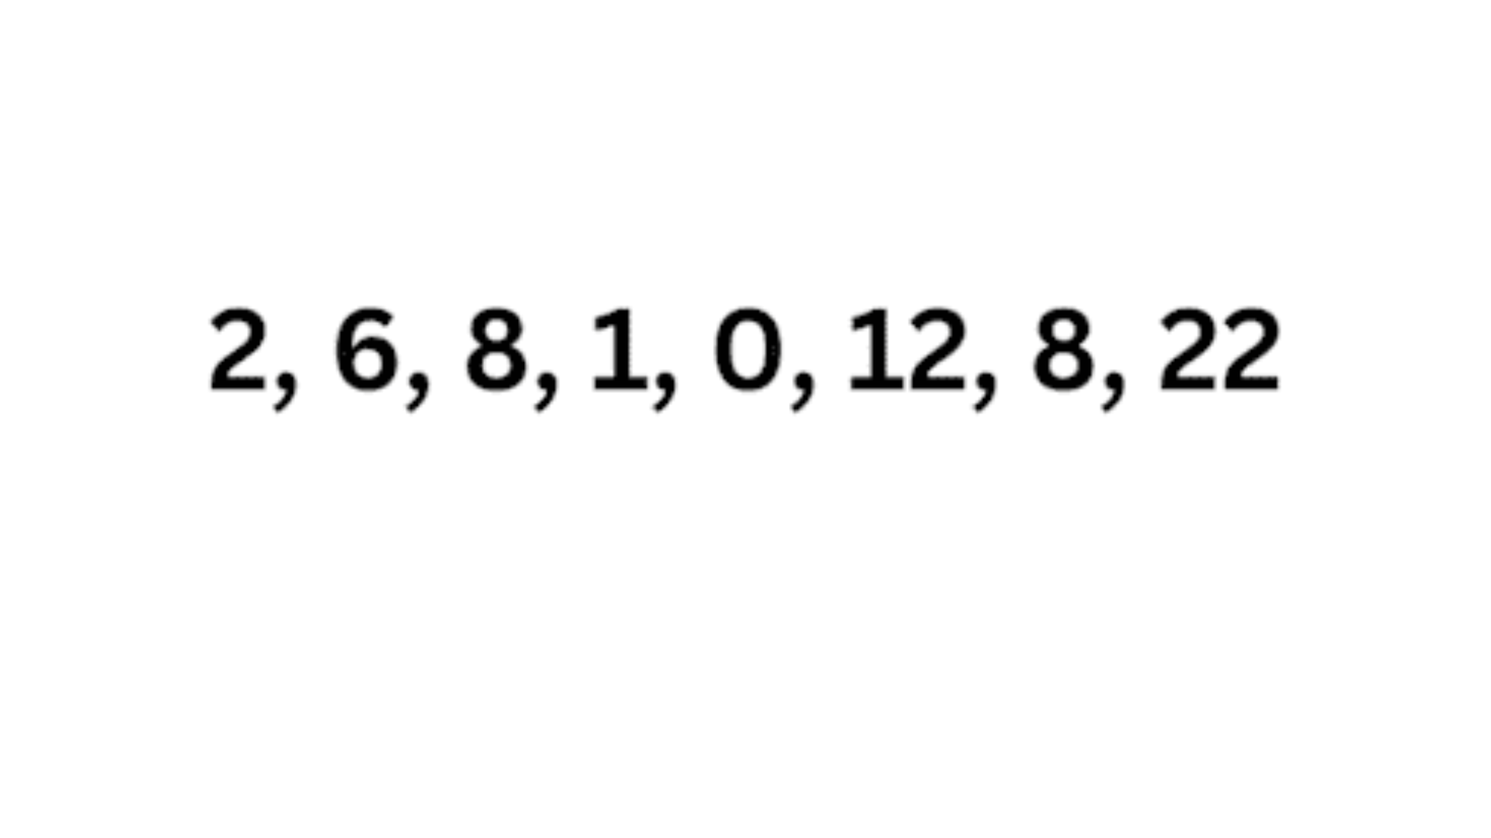
  - 6
  - 12
  - 0
  - 8
- If you conducted a telephone interview and collected responses, it would be an example of WHAT type of data?
  - Secondary
  - Primary
  - Frequency
- A circle graph is NOT divided into sections that represent percentages of a whole.
  - True
  - False
- What is a tally chart used for?
  - Reading experimental data
  - Showing sections of a whole
  - Showing cat symbols or pictures
  - None of the above
- If 4/5 of a circle graph represents 80%, what percent does 2/5 of a circle graph represent?
  - 20%
  - 40%
  - 45%
  - 30%
- What is the mean of this set?
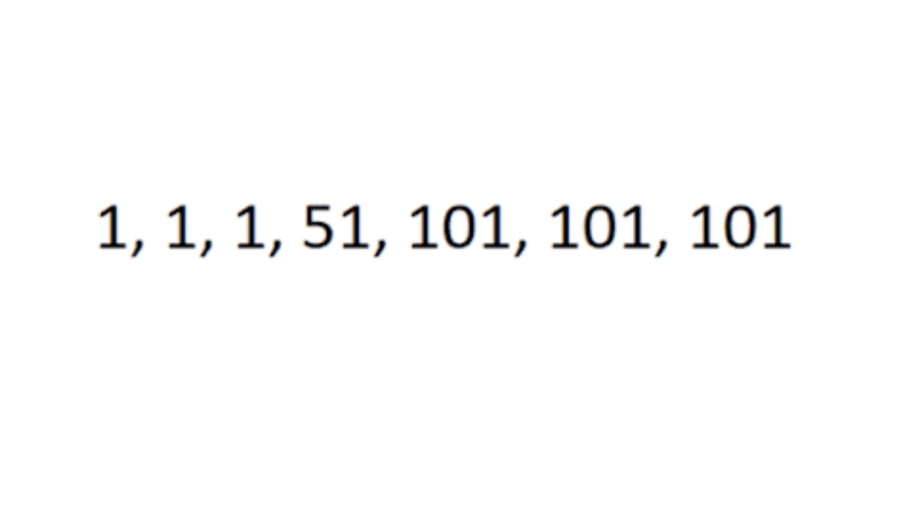
  - 50
  - 55
  - 101
  - 51
- What is the angle represented in the pie chart for the DRAWING sector?
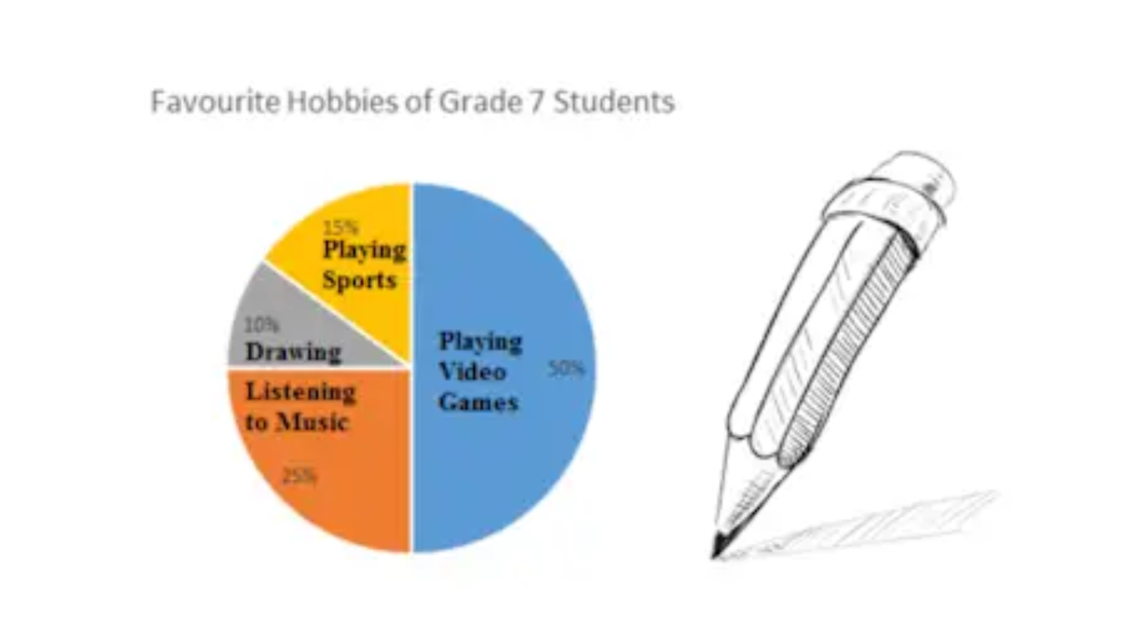
  - 10 degrees
  - 45 degrees
  - 36 degrees
  - 42 degrees
- What is the median of this set of numbers?
  - 2
  - 14
  - 26
  - 17
- What is bias?
  - A positive or negative preference
  - Prejudice
  - A personal inclination
  - All of the above
- "You will never use anything you learn in math in real life" is considered…
  - Fact
  - Bias
- "In 2018, The Institute of Health Metrics and Evaluation stated that Japan has the highest life expectancy in the world"
  - Bias
  - Fact
- This statement - "Reading for fun is a waste of time." - uses what type of tone?
  - Positive
  - Negative
- "Reading for fun is a waste of time." was most likely written by…
  - A teacher
  - A student who enjoys reading
  - A principle
  - A student who does not like to read
- Which graph is not misleading?
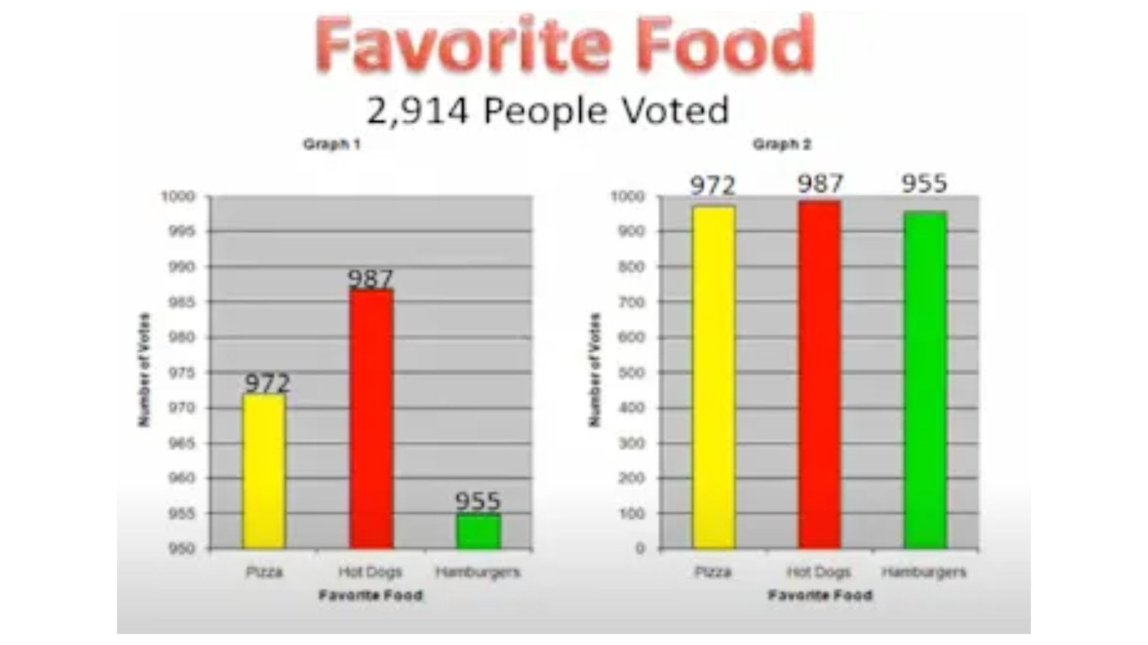
  - Graph 1
  - Graph 2
- How many cities have temperatures between 70 degrees and 99 degrees?
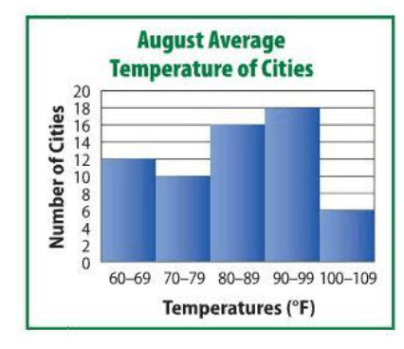
  - 44
  - 34
  - 26
  - 62
- The team scored 80 points. How many points did Porter score?
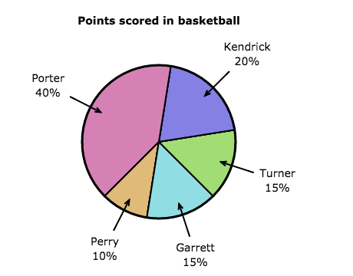
  - 40
  - 14.4
  - 12
  - 32
- Which statement is NOT supported by the data in the table?
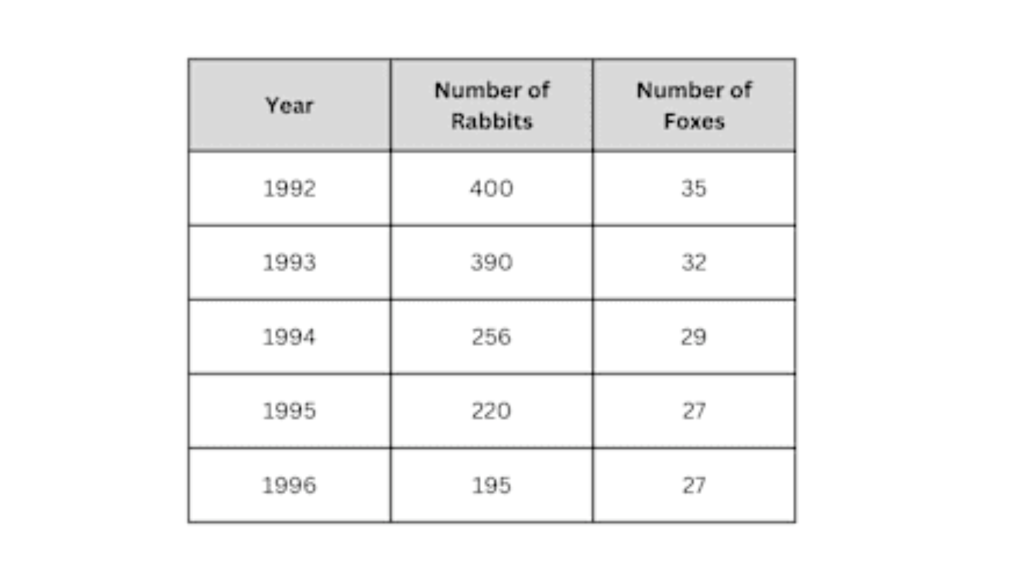
  - The population of rabbits is declining
  - The population of foxes will continue to increase
  - The population of rabbits will likely be about 180 next year
  - The population of foxes will likely be about 26 next year
- Mr. Davidson, a track coach, recorded the sizes of all the nearby track teams. What is the size of the smallest team?
  - 2
  - 3
  - 20
  - 22
- In one year, Toronto experiences the weather shown in the graph. What is misleading about the graph?
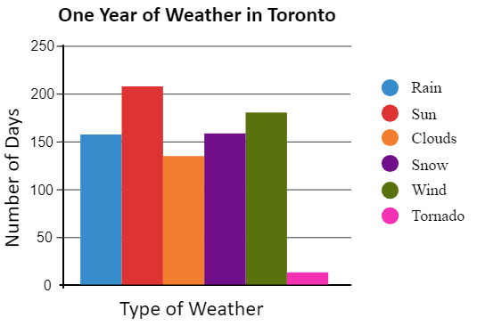
  - There are more days in the data than in one year?
  - Toronto doesn't get tornadoes
  - There are less days in the data than in one year
  - Toronto doesn't get that much snow
- According to the circle graph, what did Raymond spend the most money on?
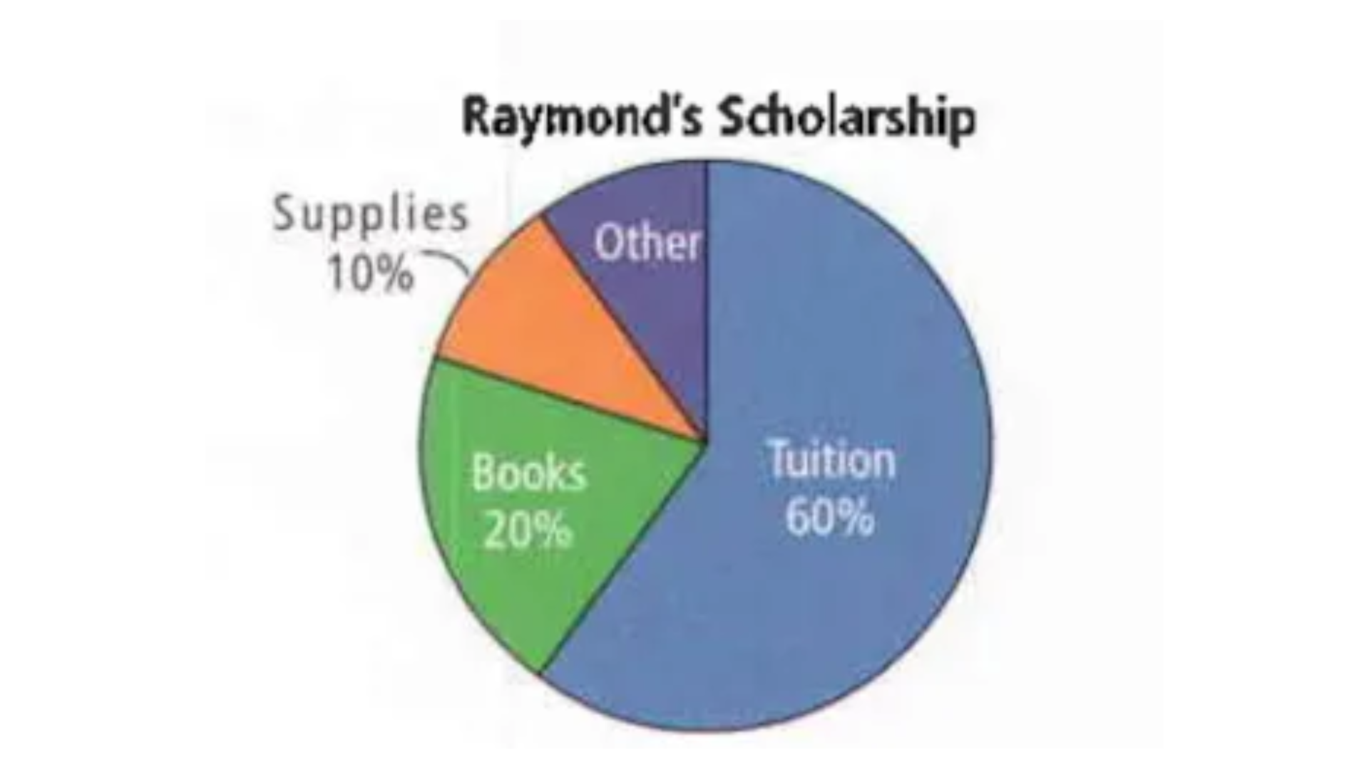
  - Supplies
  - Tuition
  - Books
  - Other
- According to this pictograph, how large was the rabbit population in March?
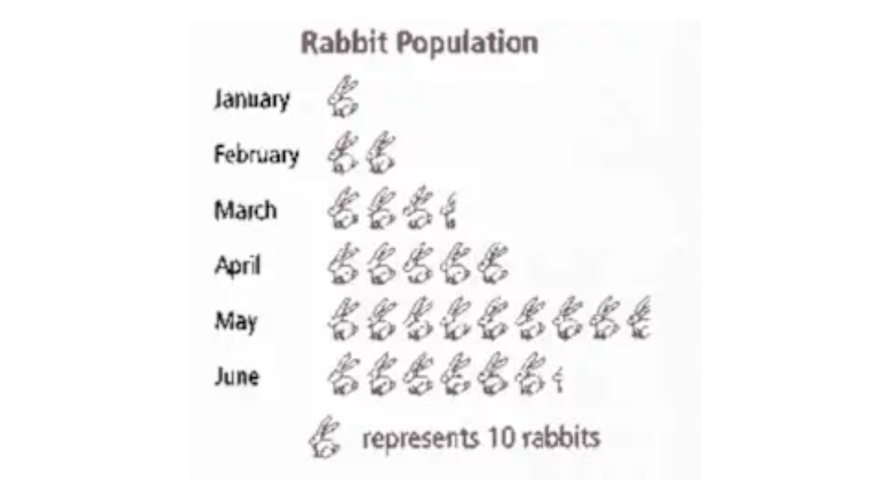
  - 3.5
  - 25
  - 15.5
  - 35
- This stem-and-leaf plot shows the ages of people at a family picnic. How many children are under 10?
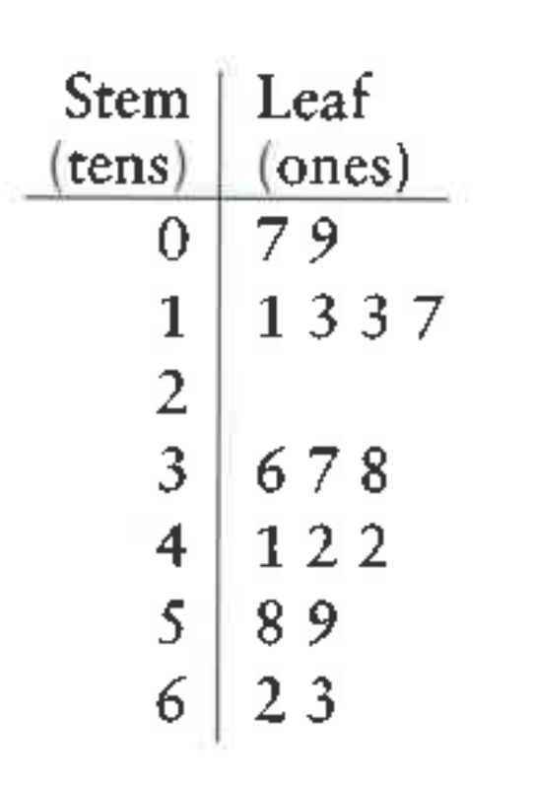
  - 2
  - 3
  - 9
  - 7
- How much money does Mary spend on movies and CDs each month?
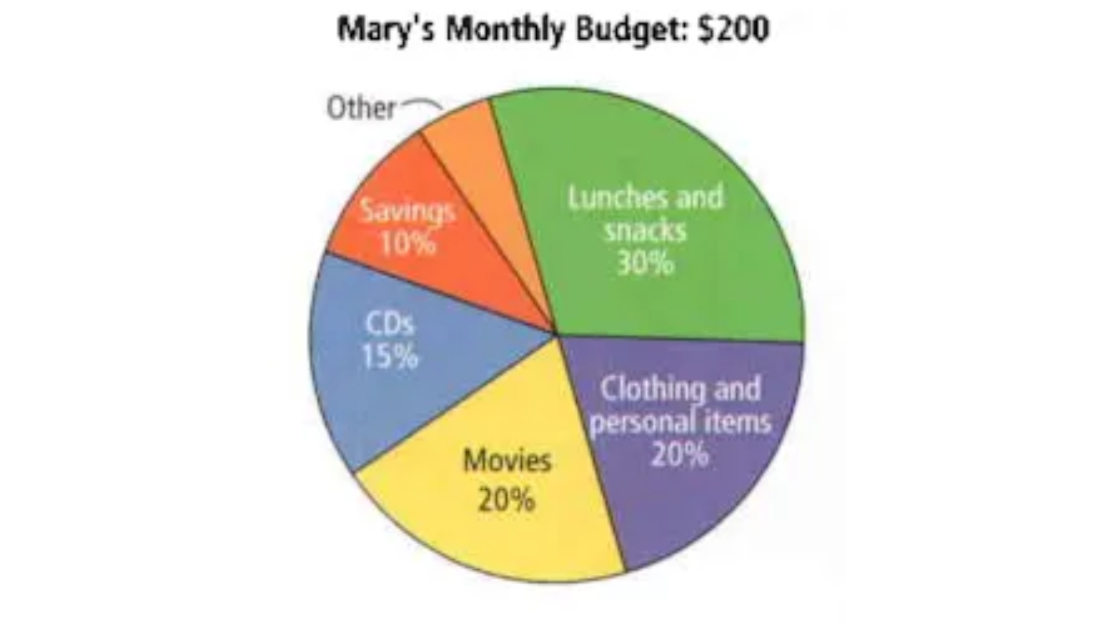
  - $35
  - $65
  - $110
  - $70
- What type of graph shows the relationship between TWO variables?
  - Frequency Table
  - Bar Graph
  - Scatter Plot
  - Circle Graph
- An important component of a scatterplot is the strength of the relationship between the two variables. The slope provides information on the strength of the relationship.
  - True
  - False
- What type of correlation is this?
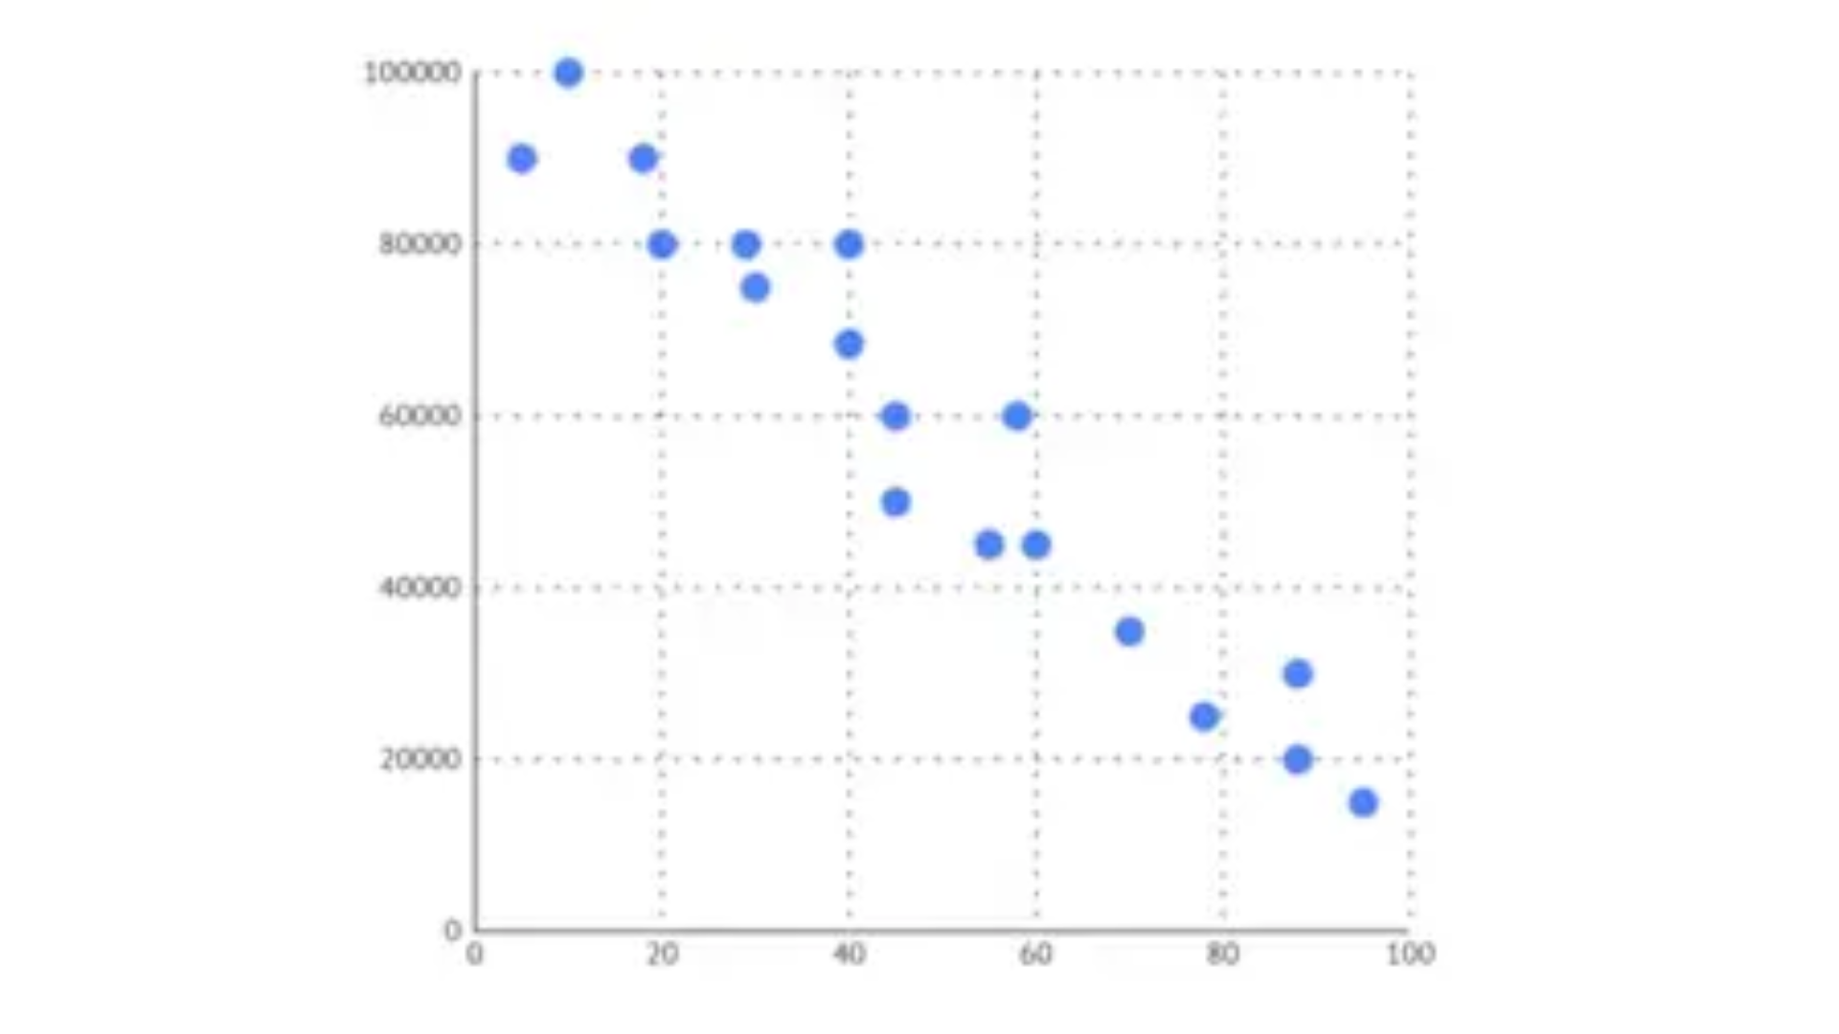
  - Positive
  - Negative
- What type of correlation is this?
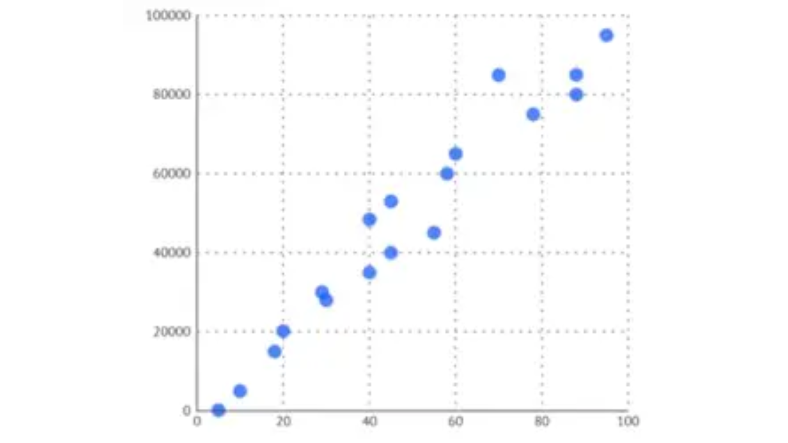
  - Positive
  - Negative
- What is the strength of this scatterplot?
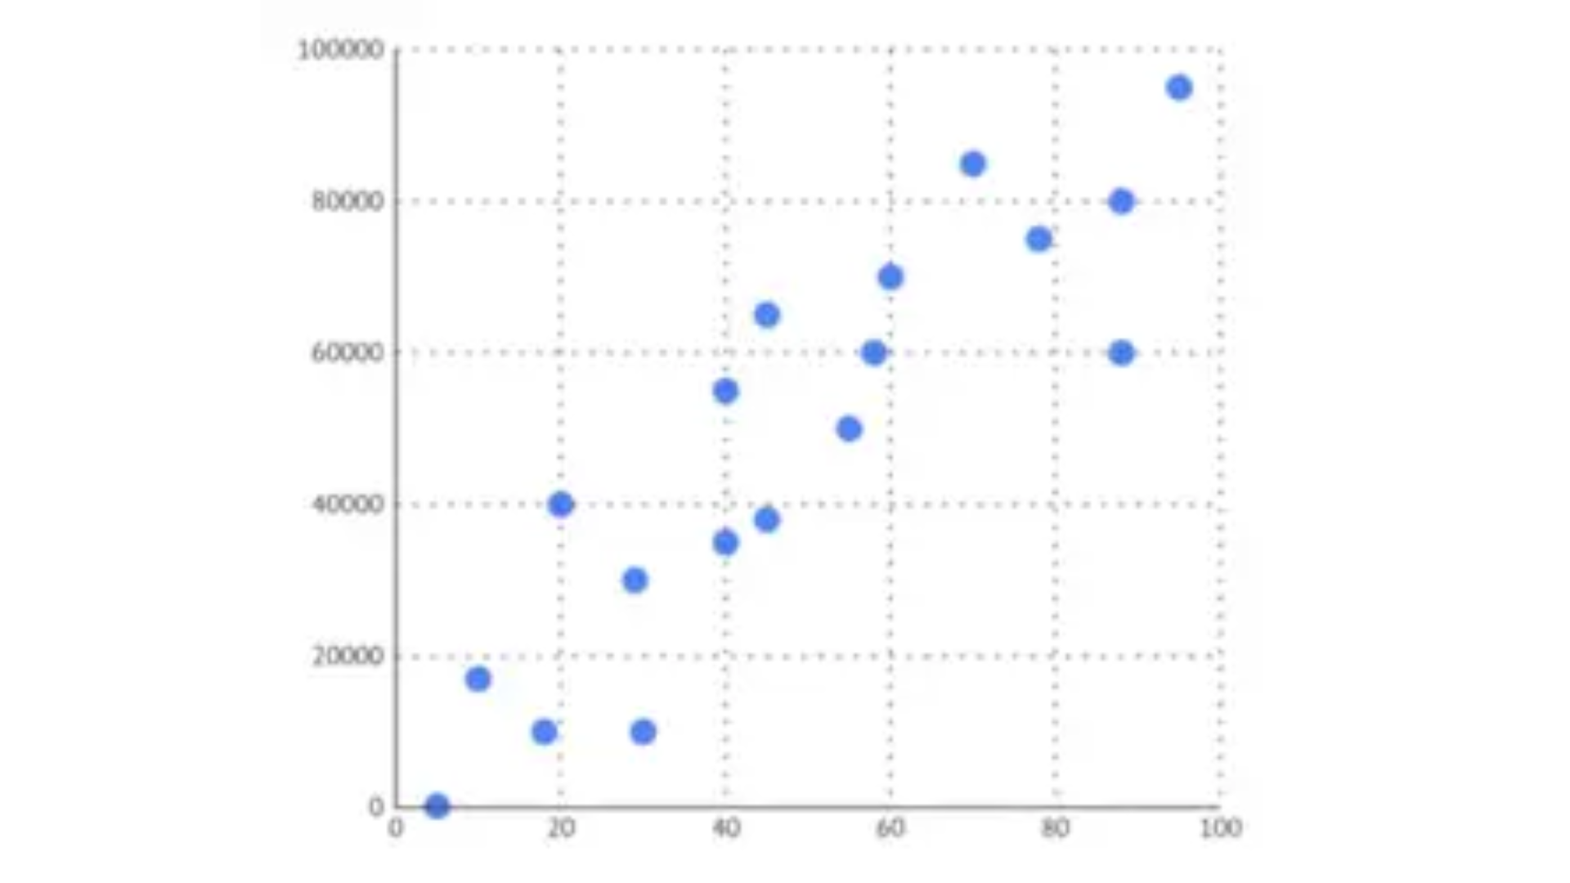
  - Strong
  - Moderate
  - Weak
- What is the strength of this scatterplot?
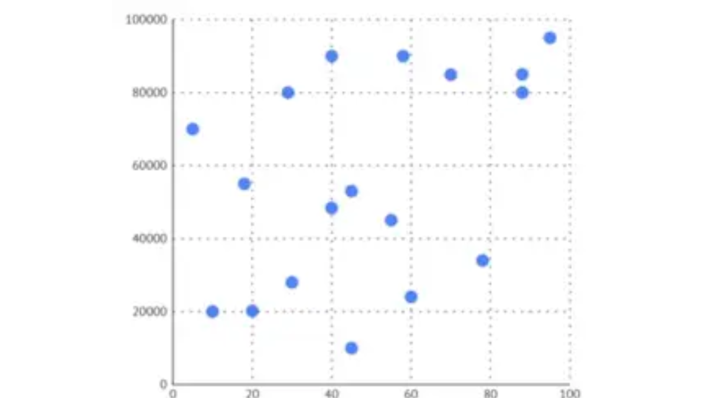
  - Strong
  - Moderate
  - Weak
- What is the strength of this scatterplot?
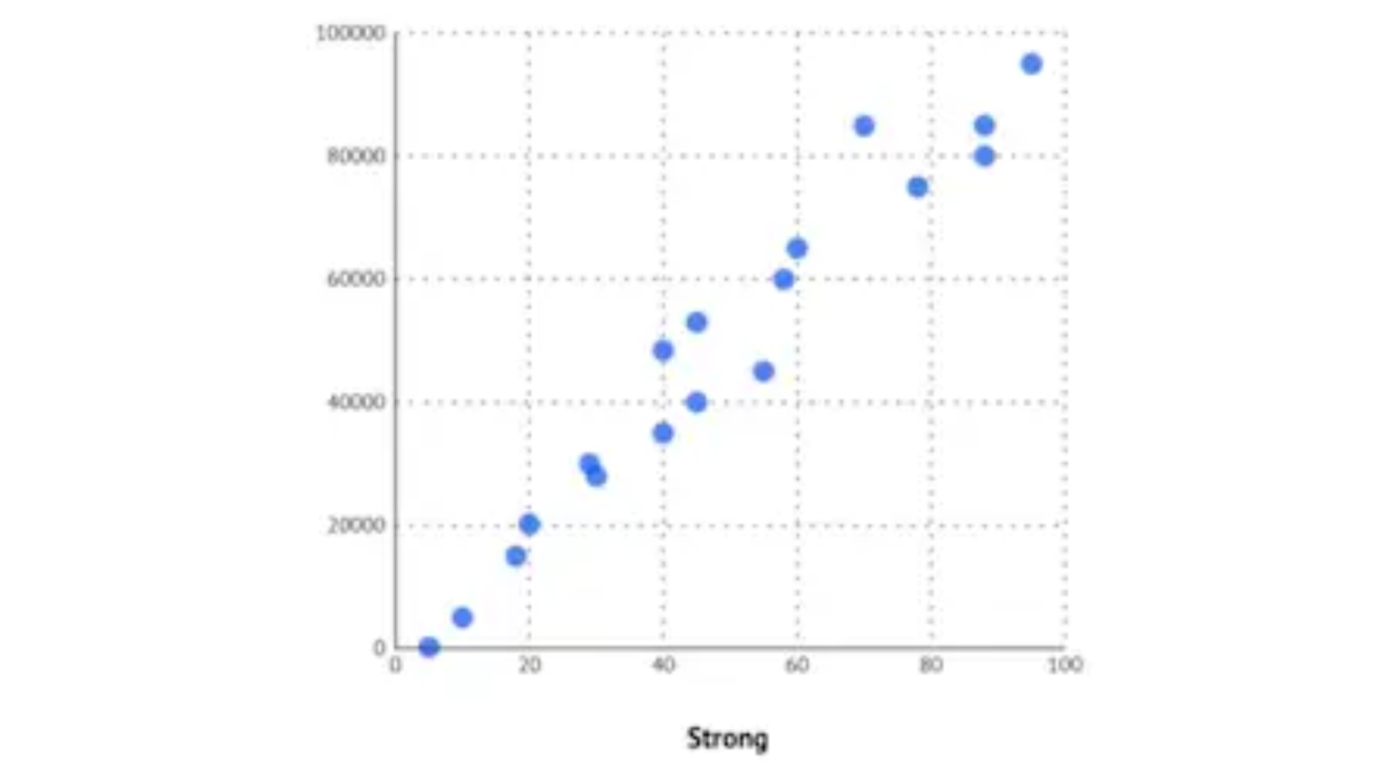
  - Strong
  - Moderate
  - Weak
- The difference between the lowest and the highest value.
  - Range
  - Mean
  - Median
  - Mode
- Which of the following is a source of secondary data?
  - Library
  - Government
  - Advertising Media
  - All of the above
- Which of the following is a benefit of using primary data?
  - You are not personally responsible for the quality of the data
  - No hassles of data collection
  - It is less expensive
  - The data collected is often more specific
- Which of the following is considered a concern of using secondary data?
  - You cannot decide what is collected
  - You can only hope that the data is of good quality
  - Obtaining additional data about something is often not possible
  - All of the above
- Facts and figures applicable to the problem
  - Data
  - Information
  - Answers
  - None of the above

