**Chapter 1 Math Quiz (Show your work.) / 15**

1. Find the perimeter of the trapezoid. (3 marks)

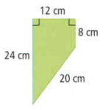

1. Find the perimeter of the pentagon. (3 marks)

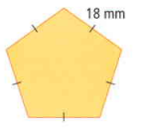

1. Find the area of the parallelogram. (3 marks)

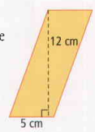

1. Find the area of the triangle *(please)*. (3 marks)

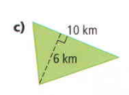

Use the Order of Operations to complete. (1 mark each)

1. 6 + 2 x 5 **6.** (6 +2) x 3 – 9 **7.** 4 + 3 x 4 + 12 $÷$ (6 +6)