**Biased or Not? Kahoot Quiz /22**

**Q1: Bias is:**

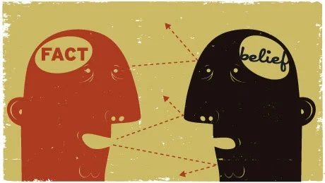

1. A personal inclination.
2. Prejudice.
3. A positive or negative preference.
4. All of the above

**Q2: "Eating grapefruit is the best way to boost your grades." What is the extreme language?**

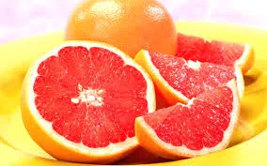

1. Is
2. Best
3. Grades
4. Eating

**Q3: Fact or Opinion...? "Reading for fun is a waste of time."**



1. Opinion
2. Fact

**Q4: Fact or opinion...? "People who spend hour upon hour reading miss out on life"**



1. Fact
2. Opinion

**Q5: Fact or opinion...? "Readers don't really learn anything that is useful about the world."**

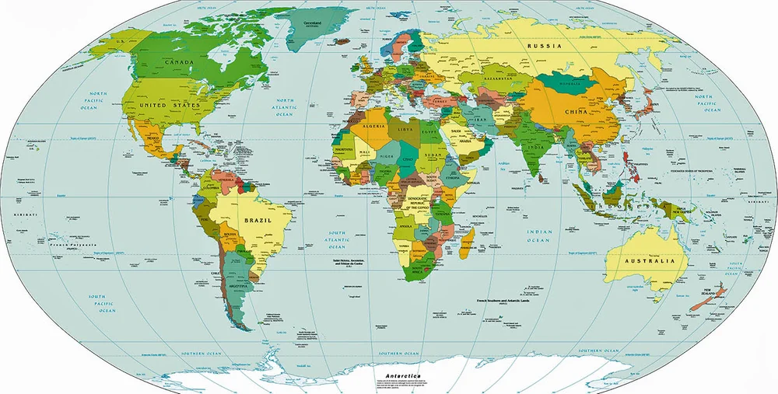

1. Fact
2. Opinion

**Q6: Fact or opinion...? "Teachers always make us read things that are boring."**



1. Fact
2. Opinion

**Q7: The tone of the previous sentences about reading is:**



1. Positive
2. Negative

**Q8: The writer of those sentences is likely…**



1. A teacher
2. A student who likes reading
3. A student who does not like to read
4. A principal

**Q9: The sentences about reading are:**



1. Neutral
2. Moderately biased
3. Very biased
4. None of the above

**Q10: Eating tomatoes is one of the best things you can do. This sentence is a(n):**

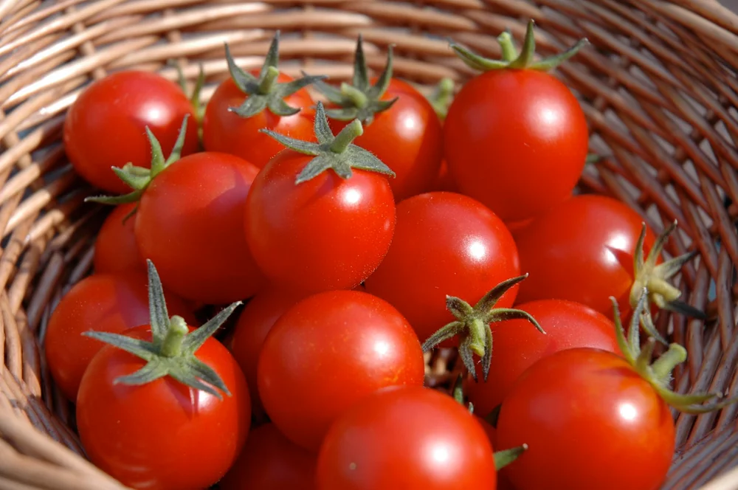

1. Fact
2. Opinion

**Q11: Tomatoes contain Vitamin C. This sentence is a(n):**

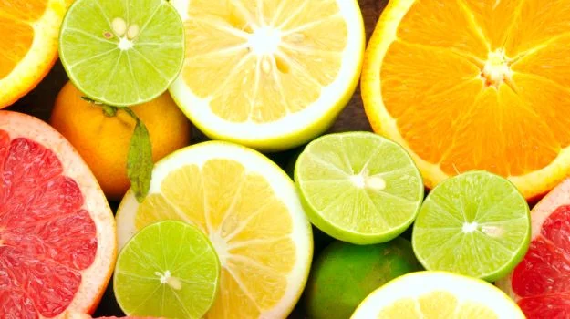

1. Fact
2. Opinion

**Q12: Studies show that eating tomatoes lowers the risk of cancer because they contain lycopene.**



1. Fact
2. Opinion

**Q13: If Tomato Farmers of Canada wrote these sentences, their intent is most likely to:**



1. Entertain
2. Inform
3. Sell
4. Prevent selling

**Q14: If Dr. Paula Medicine wrote the sentences on tomatoes, the author is mostly trying to:**



1. Entertain
2. Inform
3. Sell
4. Prevent selling

**Q15: The tone of the previous sentences about tomatoes is:**



1. Positive
2. Negative
3. Neutral

**Q16: Which author is more personally biased toward tomatoes?**



1. Tomato Farmers of Canada
2. Dr. Paula Medicine

**Q17: "Pink is the ugliest colour I have ever seen?" What type of bias is this?**

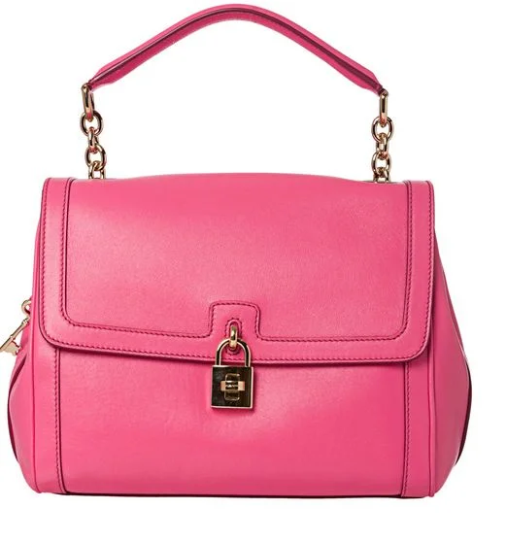

1. Generalization
2. Opinion
3. Exaggeration
4. Loaded words

**Q18: "She is always late for class." What type of bias is this?**



1. Generalization
2. Opinion
3. Exaggeration
4. Loaded words

**Q19: "Parents try to make life difficult for their children." What type of bias is this?**

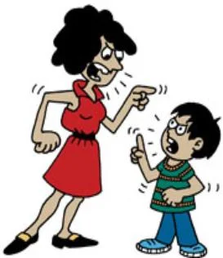

1. Loaded words
2. Exaggeration
3. Generalization
4. Opinion

**Q20: "He is such an inconsiderate person." What type of bias is this?**

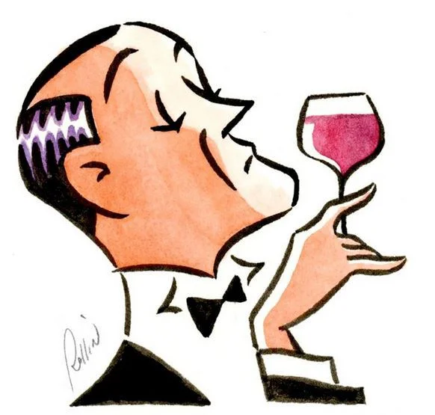

1. Opinion
2. Loaded words
3. Exaggeration
4. Generalization

**Q21: "My dad knows everything about cars." What type of bias is this?**

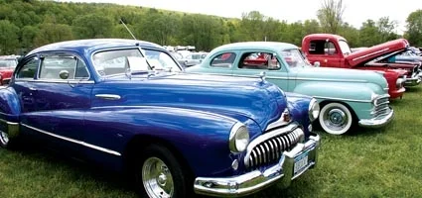

1. Exaggeration
2. Opinion
3. Loaded words
4. Generalization

**Q22: Determining bias in writing is important because:**



1. It could change your opinion.
2. It may not use logical reasoning.
3. It may not be reliable information
4. All of the above