**Data Management Kahoot Quiz /20**

**Q1: What type of chart is this?**

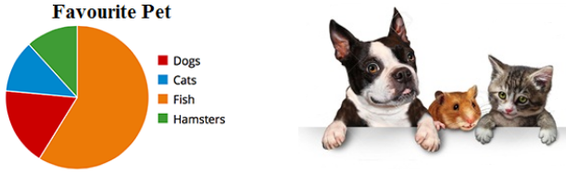

1. Circle chart
2. Round chart
3. Pizza chart
4. Pie chart

**Q2: How many have cats as a favourite?**

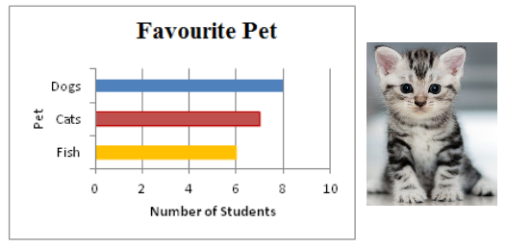

1. 2
2. 8
3. 7
4. 6

**Q3: Researchers made _____ *data* when they recorded what they directly observed in the race.**



1. Primary
2. Secondary
3. Tertiary
4. Vroom! VROOOM!!!

**Q4: How many people have type O blood?**

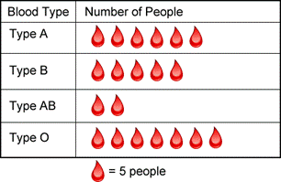

1. 5
2. 30
3. 7
4. 35

**Q5: Who is the strongest Naruto character according to the pictograph?**

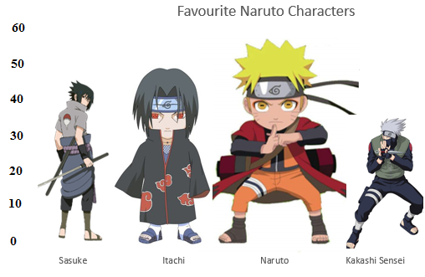

1. Naruto
2. Sasuke
3. Itachi
4. Nani? (What?) –more info. required

**Q6: What is the mode in this set?**

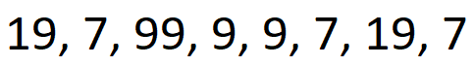

1. 9
2. 7
3. 19
4. 99

**Q7: What is the range for this set of numbers?**



1. 92
2. 90
3. 7
4. 9

**Q8: The mean, median & mode in a set can’t be the same number.**

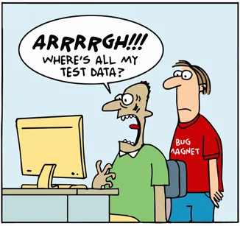

1. True
2. False

**Q9: Jim wrote an article based on Tom’s survey. The article is an example of what *type* of data?**

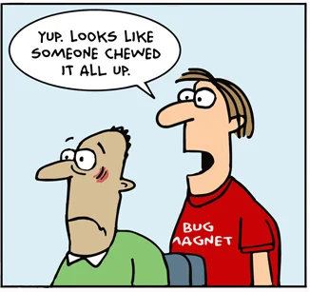

1. Primary
2. Secondary
3. Tertiary
4. Meow!

**Q10: A database is an *organized collection* of data. It is often stored electronically.**

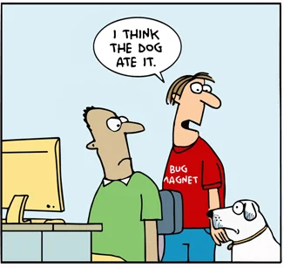

1. True
2. False

**Q11: What is the median in this set?**



1. 5
2. 2
3. 4
4. 3

**Q12: How many students have pets?**

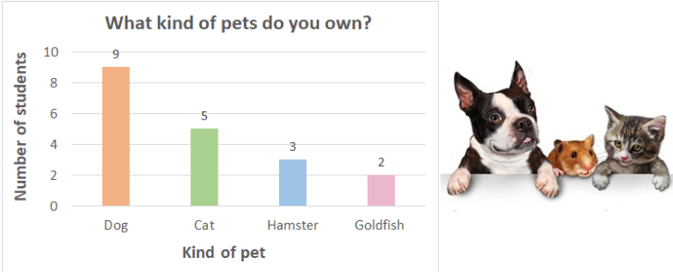

1. 9
2. 14
3. 19
4. 2

**Q13: What is the mean in this set?**



1. 50
2. 51
3. 52
4. 101

**Q14: How many apples were sold in March?**

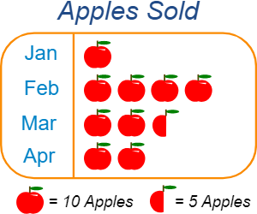

1. 25
2. 15
3. Too many, if you ask Bill Gates! - Long live Microsoft!
4. 2.5

**Q15: 23 people are in line at Tim Hortons. What is the mode of the ages of these people?**

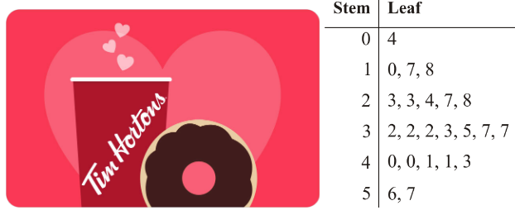

1. 23
2. 40
3. 32
4. 37

**Q16: What percent of students prefer chess?**

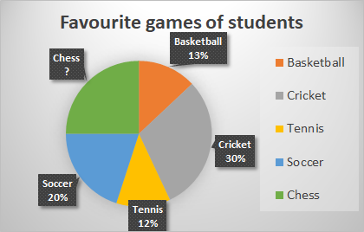

1. 30%
2. 25%
3. 15%
4. 40%

**Q17: The data in the table is represented *correctly* in the graph.**

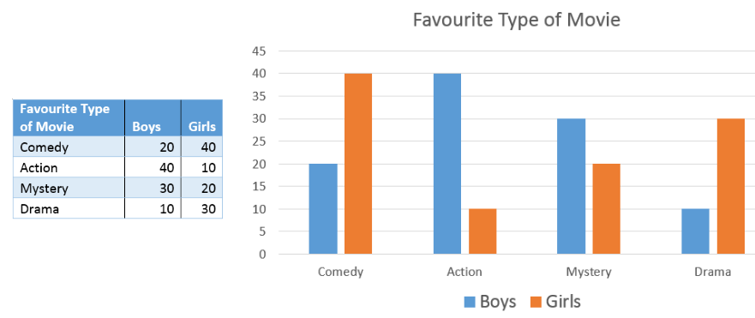

1. True
2. False

**Q18: How much does Sam spend on rent every month?**

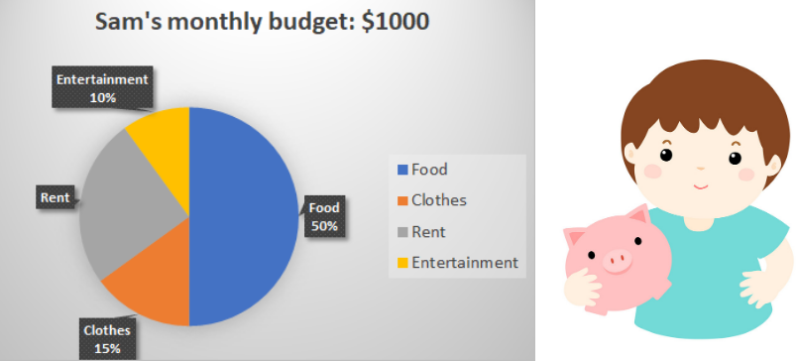

1. Too much!
2. $250
3. $1000
4. $500

**Q19: What is the angle represented in the pie chart for the DRAWING section?**

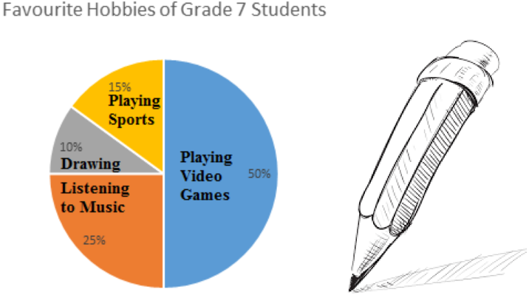

1. 10 degrees
2. 36 degrees
3. 30 degrees
4. 42 degrees

**Q20: How many jackets were donated?**

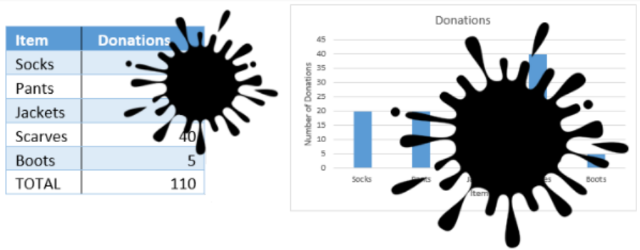

1. I need more information!
2. 20
3. 30
4. 25