**FINANCIAL LITERACY KAHOOT** **/15**

**Q1:** Money paid regularly at a particular rate.

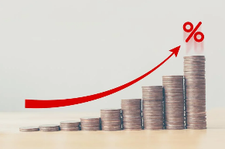

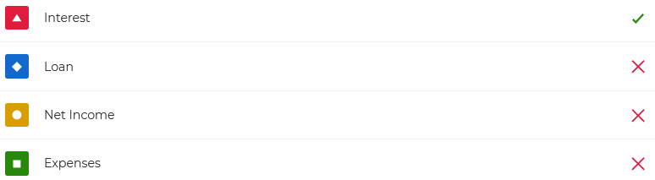

**Q2:** Interest that is calculated based off of the original sum, or principal.

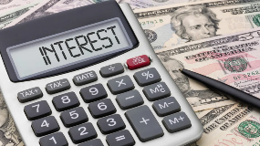

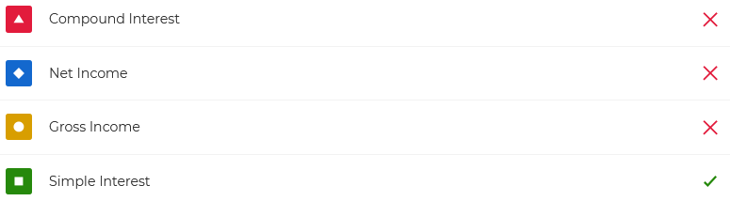

**Q3:** A pair of sunglasses costs $12.99, how much will it cost after tax in Ontario?



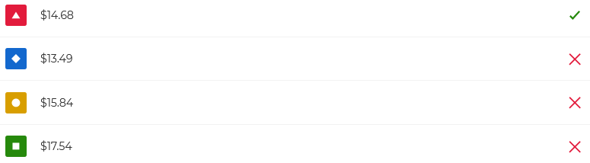

**Q4:** A system of money used in a country is called a

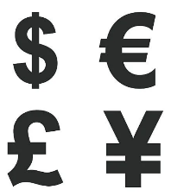



**Q5:** A leather jacket originally priced at $414.99 is on sale for $80 off. What is the pre-tax price?



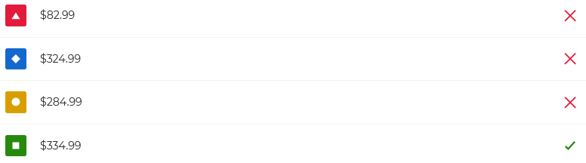

**Q6:** Which of these is a source of income?





**Q7:** The exchange rate from the Canadian Dollar to the US Dollar is 0.79. How much is $500 CAD in USD?

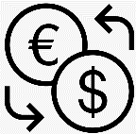



**Q8:** A plan to balance income and expenses.





**Q9:** A jacket priced at $499.99 is on sale for 30% off. What is its pre-tax price?



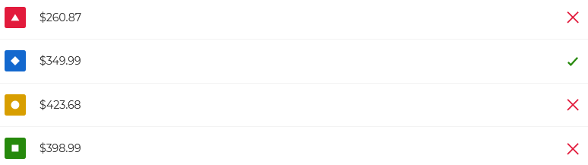

**Q10:** Tara needs to buy 4 of the same item originally priced at $49.99, which is the best sale?





**Q11**: Food is considered a(n)





**Q12:** A bouquet of flowers is originally priced at $35 dollars but is on sale for 10% off. What is the pre-tax price?





**Q13:** Milk has a retail price of $5.99. How much does it cost with tax?



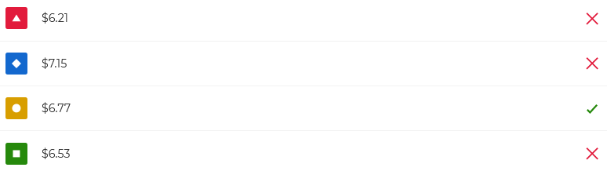

**Q14:** Money paid per hour of work.





**Q15:** A $174.99 motorcycle helmet is discounted at 40% off. What is the pre-tax price?



