**Fraction Kahoot Quiz /25**

**Q1: What fraction is shown?**

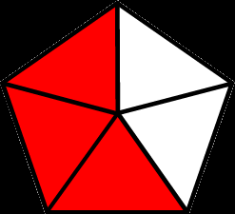

1. 4/5
2. 3/2
3. 3/5
4. 5/3

**Q2: Express this fraction as a *decimal*.**



1. .3
2. .35
3. 6.0
4. .6

**Q3: Express this fraction as a *percentage*.**



1. 30%
2. 60%
3. 40%
4. 35%

**Q4: What is the *Denominator*?**

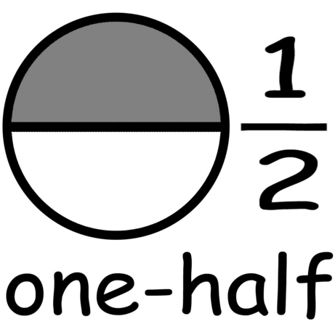

1. 1
2. 2
3. 3
4. Meow!

**Q5: Define *Numerator*.**

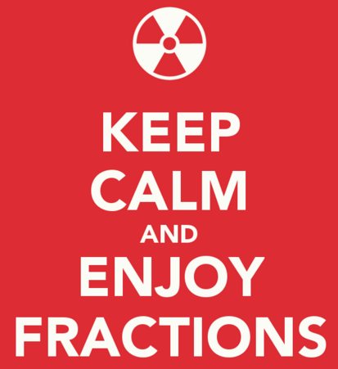

1. The number of parts missing that would complete a whole.
2. It's the # of people that share the parts you have.
3. It is the number of parts that make a whole.
4. It is the number of parts that you have.

**Q6: The fractions below are:**

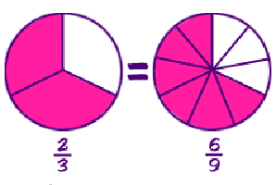

1. Common Denominators
2. Equivalent Fractions
3. Skip counting
4. Factors

**Q7: Express the value as an *improper fraction*.**

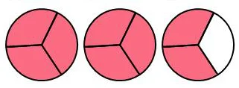

1. 9/3
2. 2 and 2/3
3. 9/9
4. 8/3

**Q8: Define *Denominator*.**

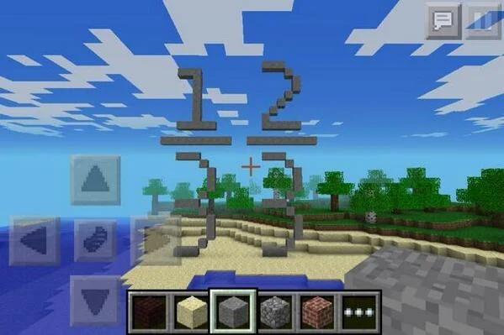

1. It's the fraction as an equivalent fraction over a hundred.
2. It's the # of parts that are missing from a whole item.
3. It's the value of the fraction as a decimal.
4. It's the # of parts that make up a whole item.

**Q9: What is the value of this fraction as an improper fraction?**

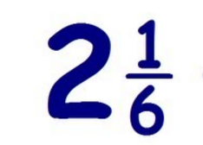

1. 13/6
2. 12/6
3. 1/6
4. 3 wholes

**Q10:** Choose the correct simplified fraction. Dave buys 12 of the school's 36 motorcycles?



1. 1/3
2. 1/4
3. 1/6
4. 3/4

**Q11: What is the value as an improper fraction?**

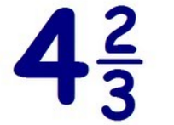

1. 9/3
2. 7/22
3. 3/14
4. 14/3

**Q12: What is the *product*?**

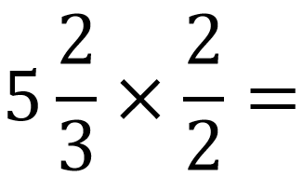

1. 17/3
2. 5 and 4/6
3. 5 and 2/3
4. All the responses listed.

**Q13: What fraction shows *the difference*?**

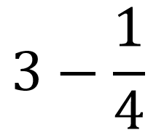

1. 2.75
2. 2 and 2/8
3. 2 and 3/4
4. All the responses listed.

**Q14: What is *the difference*?**

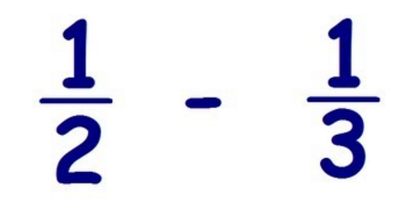

1. 1/6
2. 2/6
3. 1/1
4. 2/5

**Q15: Convert the improper fraction to a *Mixed Number*.**

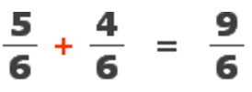

1. Good question!
2. 2 and 1/3
3. 1 and 1/2
4. 6 and 6/9

**Q16: What does *LCD* stand for?**

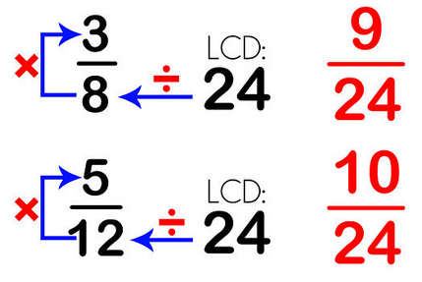

1. **L**ittle **C**oloured **D**ots
2. **L**owest **C**ounted **D**enominator
3. **L**owest **C**ommon **D**enominator
4. Oink!

**Q17: What's the *golden rule* with fractions? ie. What must you always do?**

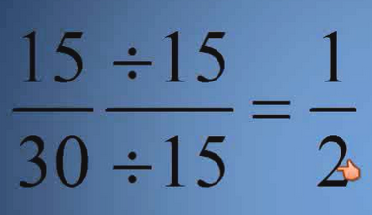

1. When adding, add the denominators as well.
2. Reduce all fractions to their highest terms.
3. Reduce all fractions to their lowest term.
4. Ask Farmer Brown.

**Q18: In fractions, GCF stands for what?**

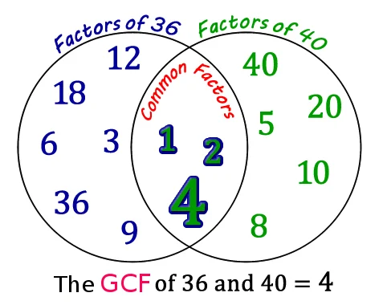

1. **G**o **C**atch **F**lies
2. **G**reatest **C**orrect **F**actor
3. **G**rey **C**loud **F**ight
4. **G**reatest **C**ommon **F**actor

**Q19: The following question is answered...**

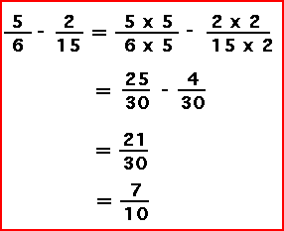

1. Correctly
2. Incorrectly

**Q20: The following question is answered…**

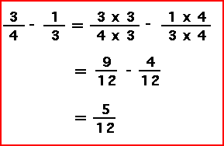

1. Correctly
2. Incorrectly

**Q21: Which fraction has the greatest value?**

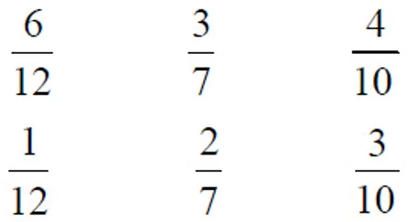

1. 4/10
2. 3/7
3. 3/10
4. 6/12

**Q22: Which response is a *simplified fraction* for using 25 sheets of paper from a pack of 200?**

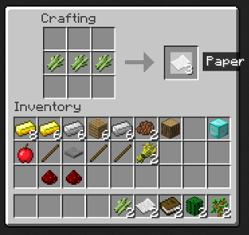

1. 1/6
2. 1/8
3. 25/200
4. 8/50

**Q23: What is the *sum* shown?**

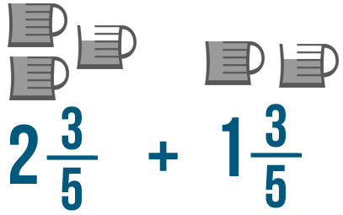

1. 3 and 6/5
2. 4
3. 4 and 1/5
4. None of the responses listed.

**Q24: The statement shown is...**

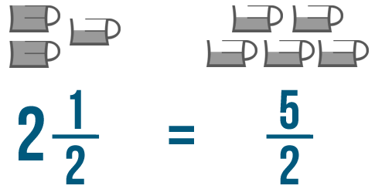

1. Correct
2. Equivalent in value
3. of a mixed number & an improper fraction
4. All of the responses listed.

**Q25: If PJ ate a quarter of his, & his sister ate half of hers, how much more than her would he have left?**

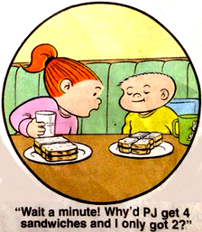

1. 1/2
2. 2/4
3. A whole
4. 1/4