**Integer Review Kahoot Quiz /15**

**Q1: (-5) and (+5) are examples of…**



1. positive integers
2. negative integers
3. zero integers
4. opposite integers

**Q2: What best demonstrates the zero principle?**



1. (+1) - (-1) = 2
2. (+1) + (-1) = 0
3. (+1) + (+1) = 2
4. (-1) + (-1) = -2

**Q3: (-9) - (-4) =**



1. -5
2. 13
3. -13
4. 5

**Q4: (-9) x (+4) =**



1. 36
2. 13
3. -13
4. -36

**Q5: What is the result when a positive integer added to a negative integer?**



1. a negative integer
2. a positive integer
3. zero
4. all of the above

**Q6: What is the result when a negative integer is subtracted from a positive integer?**



1. positive integer
2. negative integer
3. zero
4. all of the above

**Q7: Choose the proper integer expression.**

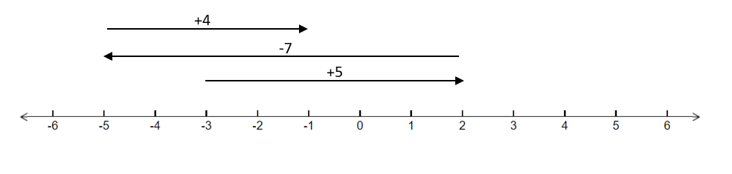

1. (-3) + (-5) + (+7) + (-4) = -1
2. 3 + (+5) + (-7) + (-4) = -1
3. (-3) + (+5) + (-7) + (+4) = -1
4. 3 + (-5) + (+7) + (-4) = 1

**Q8: What set of integers best describe the situation?**

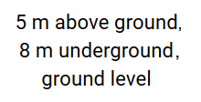

1. (+5, +8, 0)
2. (+5, -8, 0)
3. (-5, -8, 0)
4. (-5, +8, 0)

**Q9: Which set of integers best describes 10 min before the start of class, 20 min after class?**



1. (-10, 20)
2. (-10, -20)
3. (10, 20)
4. (10, -20)

**Q10: Which expression best describes depositing $15, then spending $12 to buy a book?**



1. (-15) + 12 = -3
2. (-15) + (-12) = -27
3. 15 + (-12) = 3
4. 15 + 12 = 27

**Q11: Which subtraction expression describes a whale 11 m under sea level, then dives 7 m deeper?**



1. -11 - 7 = -18
2. 11 - 7 = 4
3. -11 + 7 = -4
4. -11 + (-7) = -18

**Q12: (-7) + (+12) + (-4) =**



1. -1
2. 1
3. -15
4. 8

**Q13: Find the temperature difference from Monday to Tuesday for Calgary.**

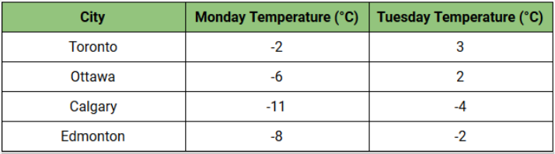

1. 5
2. -7
3. 7
4. -6

**Q14: Which city has the greatest temperature change?**



1. Ottawa
2. Edmonton
3. Toronto
4. Calgary

**Q15: What is the value of x?**

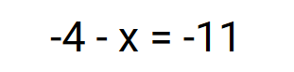

1. 7
2. -15
3. -7
4. 15