**ALGEBRA http://www.downwindkennels.com/me/images/kahooticon.png** /20

1. Check the correctness of the following statements.

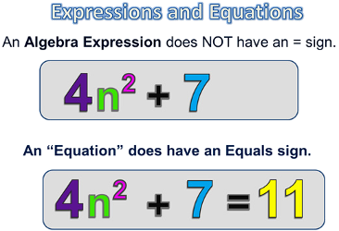

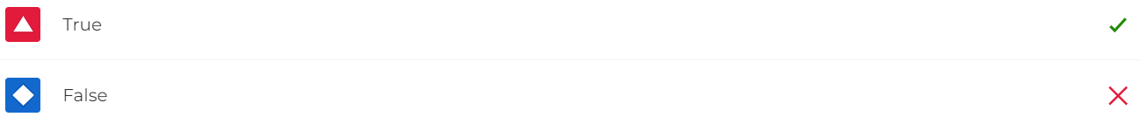

1. Is this correct?

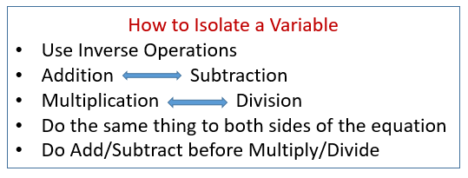

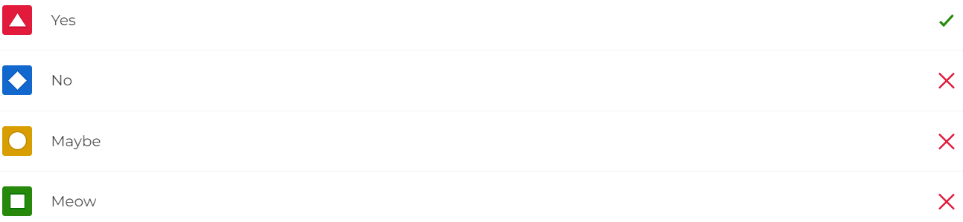

1. The **variable** is also called "*the unknown*".

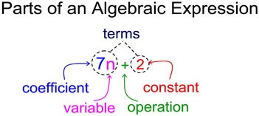

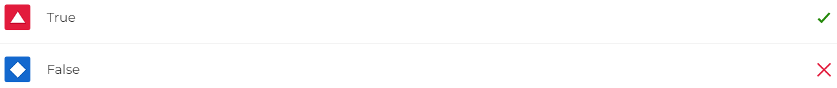

1. What is a ***coefficient***?



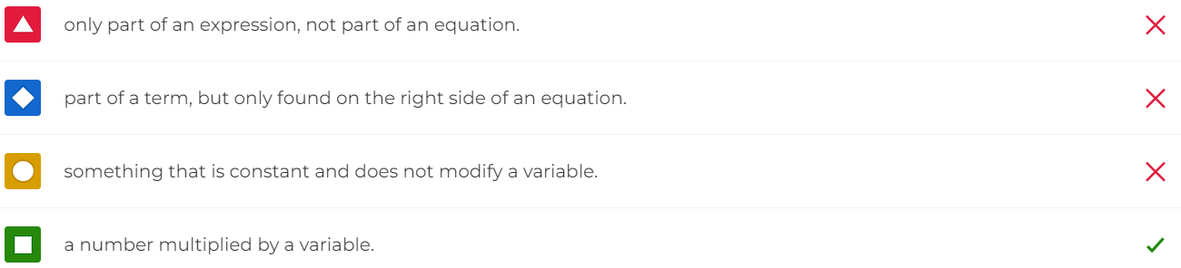

1. In algebra, what is a "***term***"?

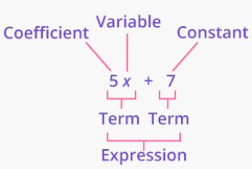

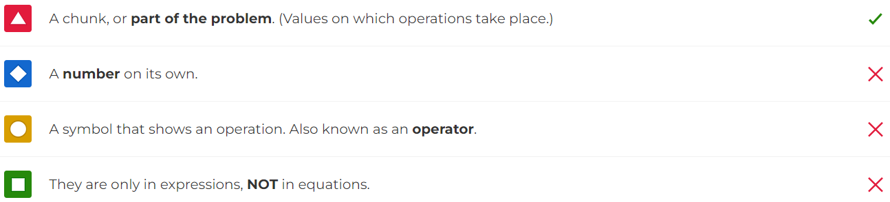

1. In algebra we say, "**Isolate the variable, collect like terms** and...



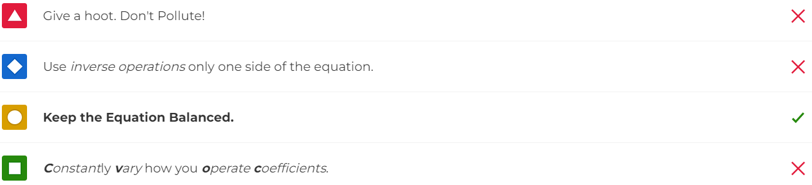

1. Solve for ***m***.

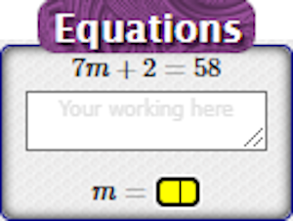

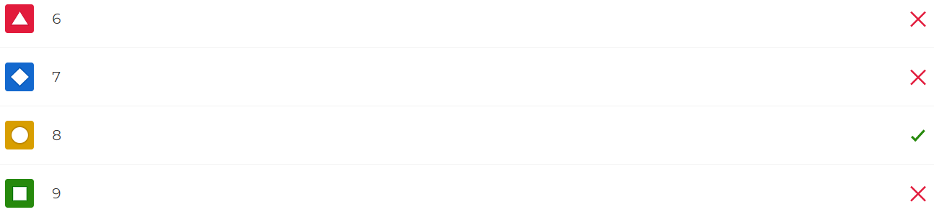

1. Translate into an ***algebraic expression***.



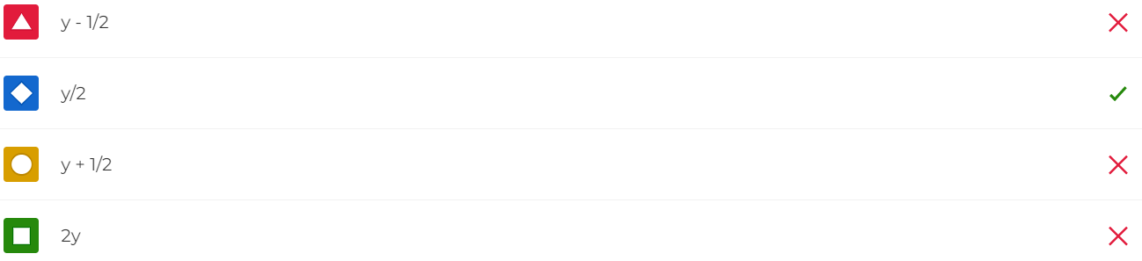

1. Translate into an ***algebraic expression***.



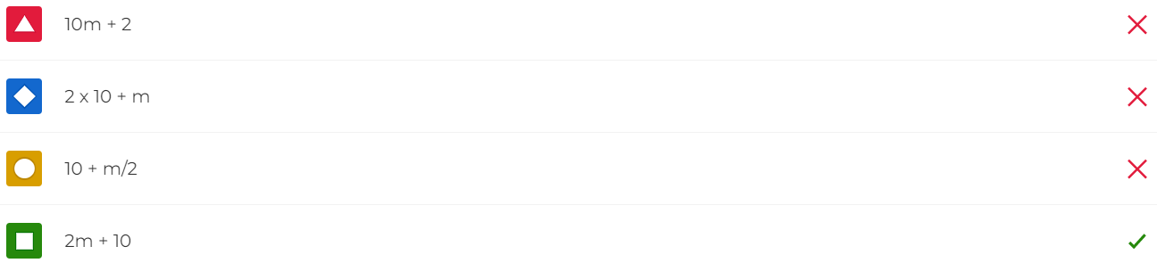

1. Translate into an ***algebraic expression***.



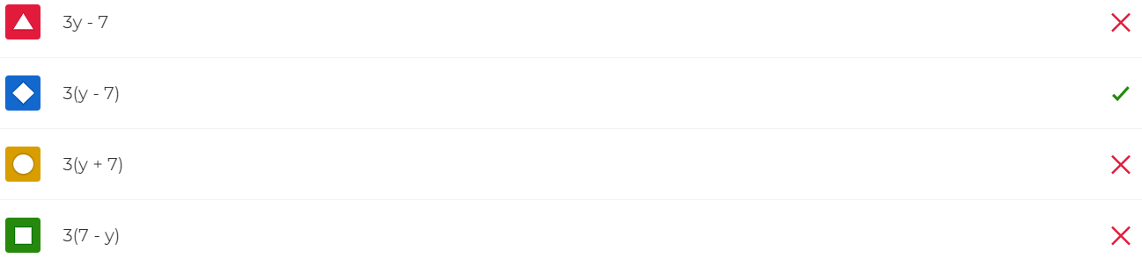

1. Translate into an ***algebraic expression***.



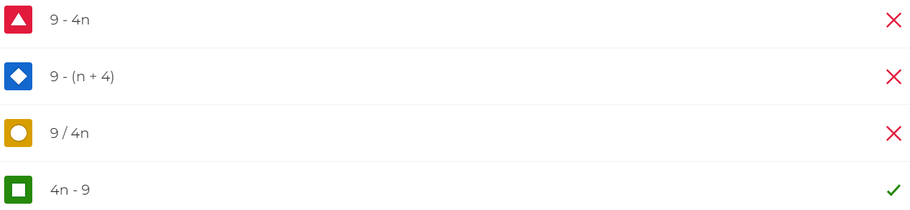

1. Translate into an ***algebraic expression***.

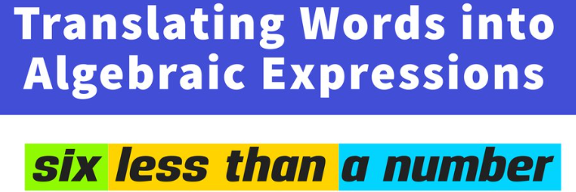

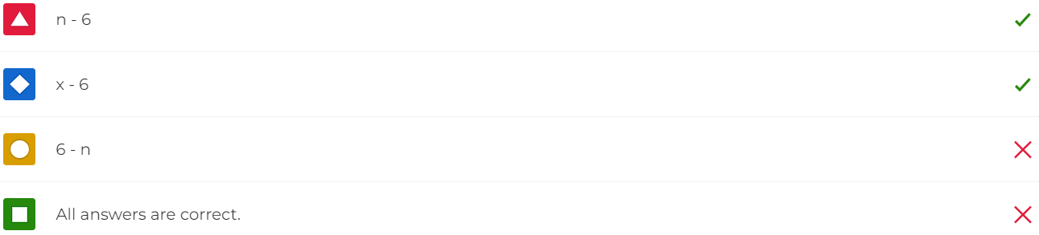

1. If you own 3 motorcycles, how many do you ***need***?

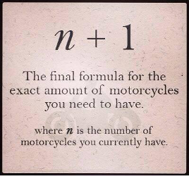

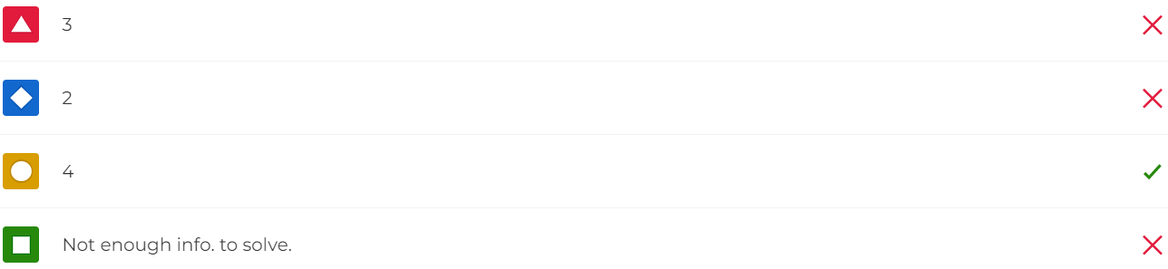

1. What's the posted speed?

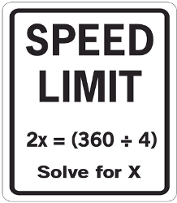

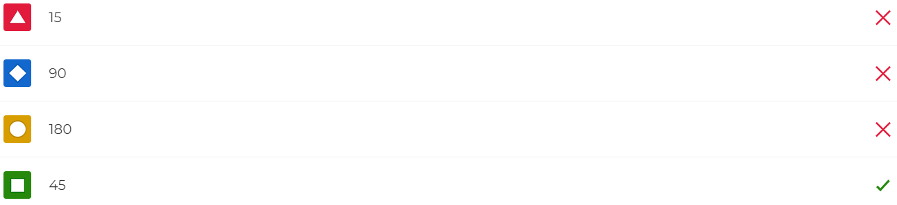

1. How do we "***collect like terms***"?

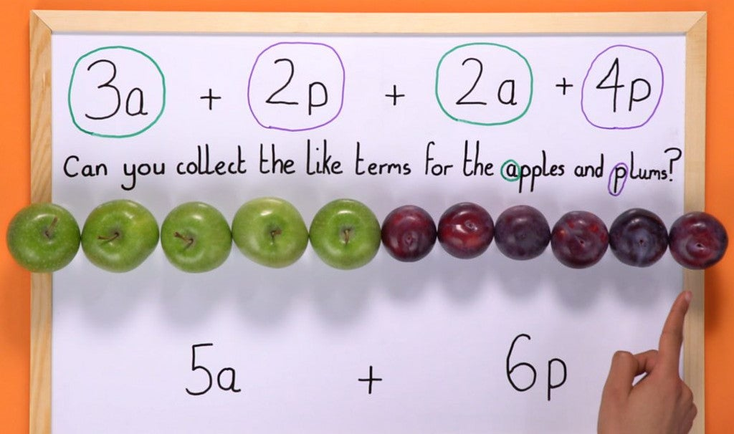

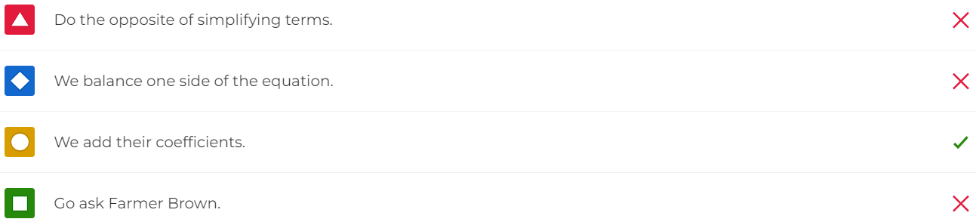

1. Look at the relationship of the ordered pairs. An equation governs each. Choose the correct ***function***.

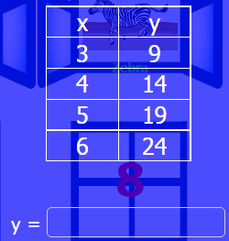

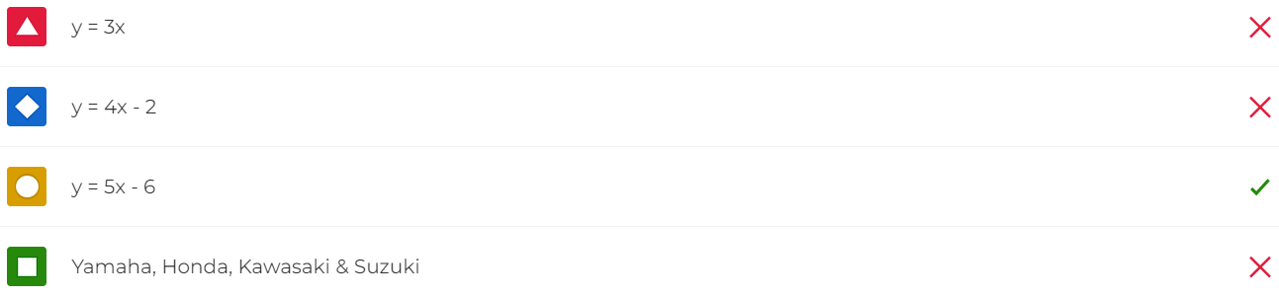

1. Look at the relationship of the ordered pairs. An equation governs each. Choose the correct ***function***.

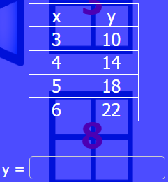

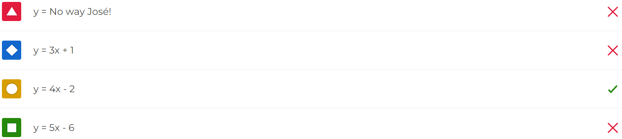

1. Solve for ***x***.

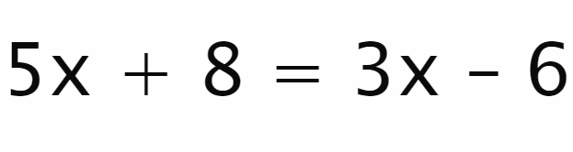

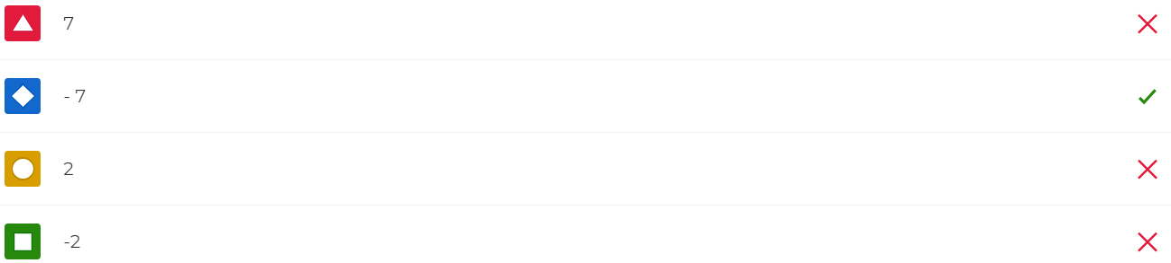

1. Isolate the variable (also known as transposition).

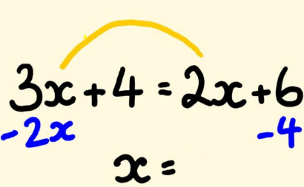

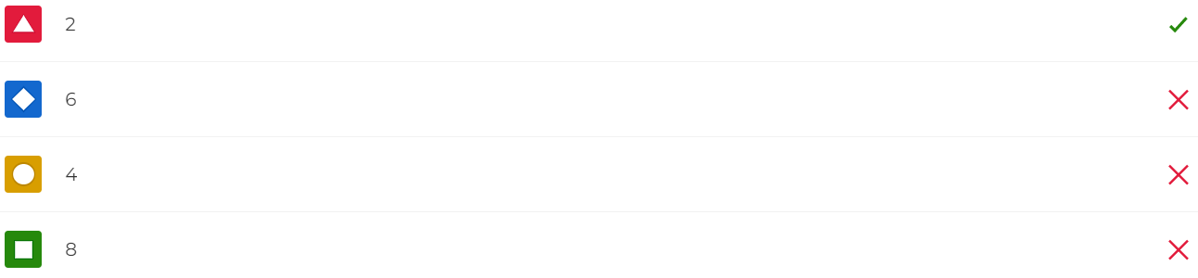

1. Solve for ***x***. Hint: Isolate the variable on one side of the equation.



