**MATH: CIRCLES KAHOOT** /20

Q1: Which of the following are true about circles?

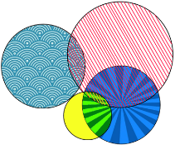

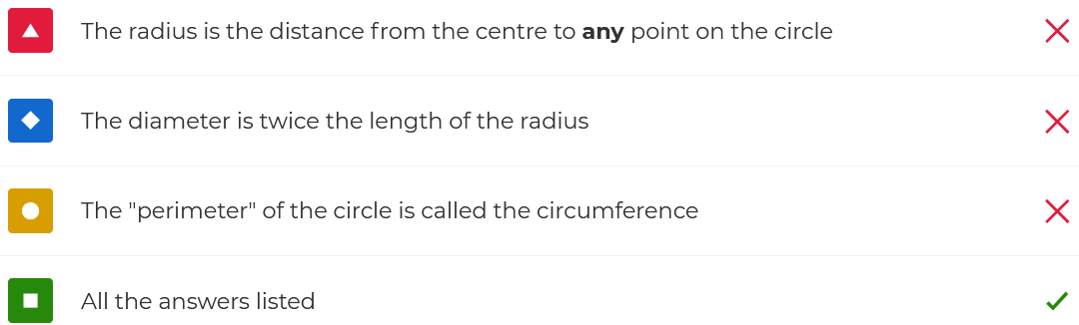

Q2: What's the name of the special tool we use to draw circles?

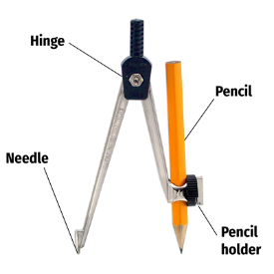



Q3: If you know just **one** thing about a circle (radius, diameter, area, or circumference) you can calculate **everything else**.

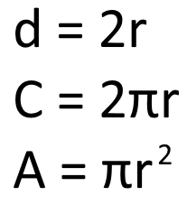



Q4: The line shown below is an example of a

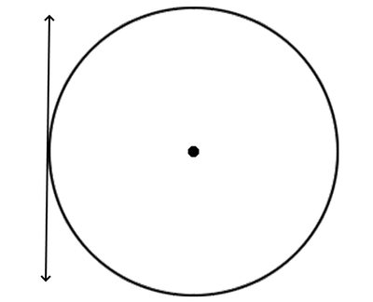



Q5: The line shown below is an example of a

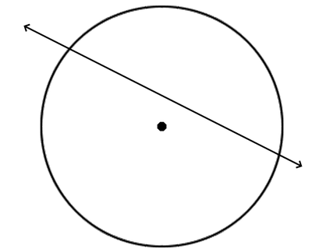



Q6: The diameter of a circle is a chord, but not every chord is a diameter.

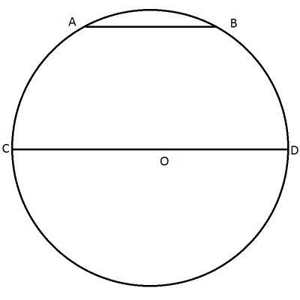



Q7: The shape below is an example of what?

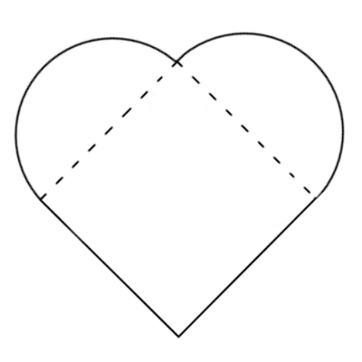



Q8: What is the name for the shaded part of this circle?

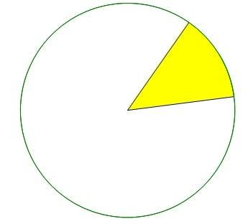



Q9: What is the diameter of this circle?

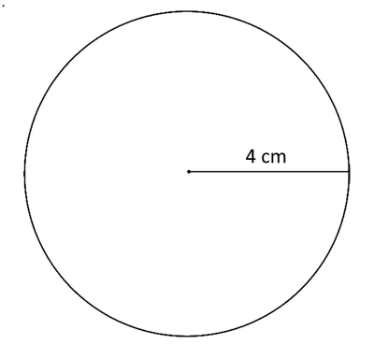



Q10: What is the radius of this circle?

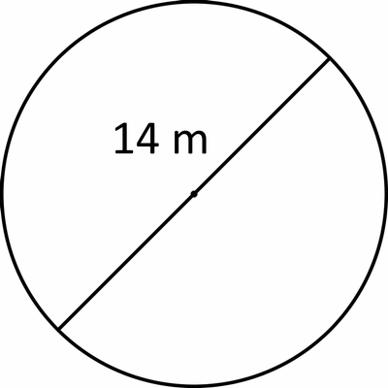



Q11: Why is this line **NOT** the diameter of the circle?

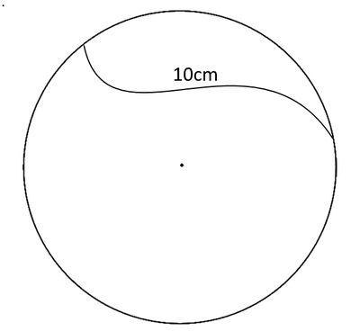



Q12: π is the special number that represents what ratio in a circle?



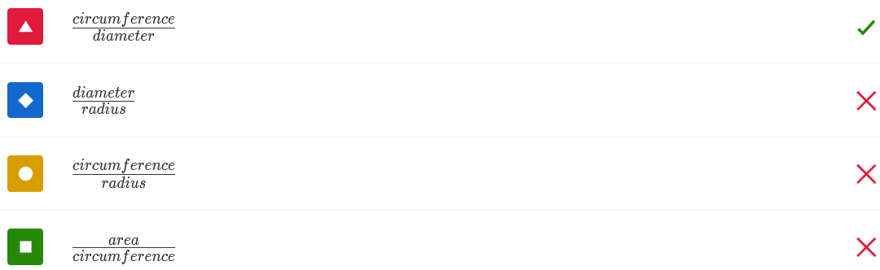

Q13: **Pi** is an irrational number. This means

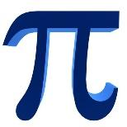



Q14: What is the equation for the circumference of a circle?





Q15: What is the circumference of this circle?

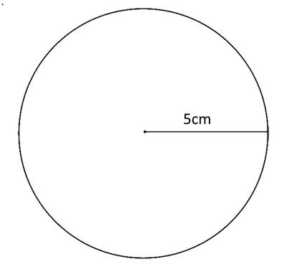



Q16: What is the circumference of this circle?

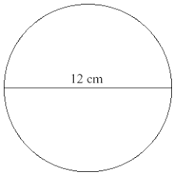



Q17: This circle has a circumference of 100cm. What is its radius?

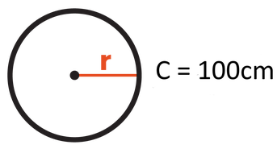



Q18: What is the formula for the area of a circle?

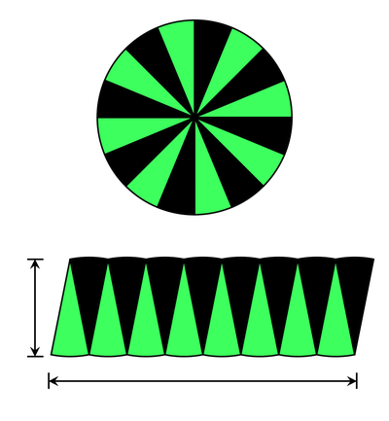



Q19: The radius of this circle is 3m. What is the area of the circle?

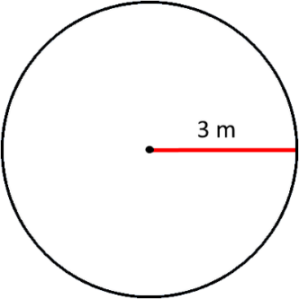



Q20: The diameter of this circle is 7cm. What is the area of the circle?

