Poetic Device Kahoot Quiz /20

Q1: "She was the light of my life" - is an example of?

- Alliteration
- Assonance
- Metaphor
- Onomatopoeia

Q2: What is the name for two OPPOSITE ideas that are put together to create an effect?
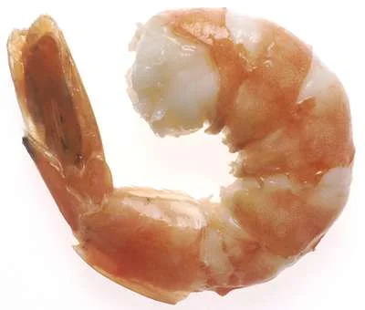
- Hyperbole
- Oxymoron
- Metaphor
- Alliteration

Q3: "Peter Piper Picked a Peck of Pickled Peppers" is an example of _____________?
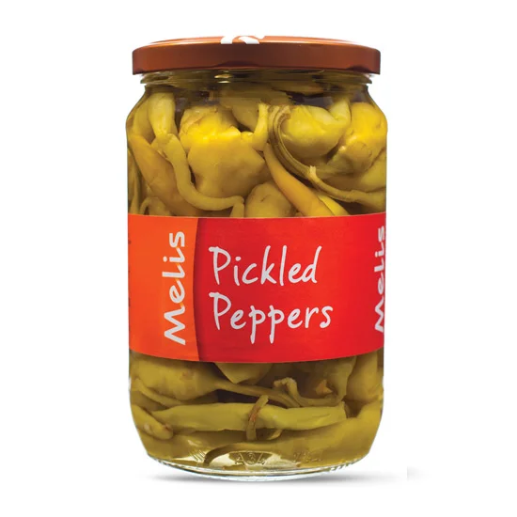
- Alliteration
- Assonance
- Metaphor
- A different sentence to say

Q4: Giving human characteristics to nonhuman things is known as ____________?
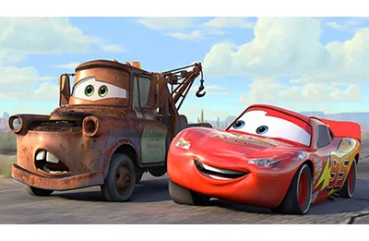
- Symbolism
- Simile
- Onomatopoeia
- Personification

Q5: The hardworking beaver is an example of ____________?
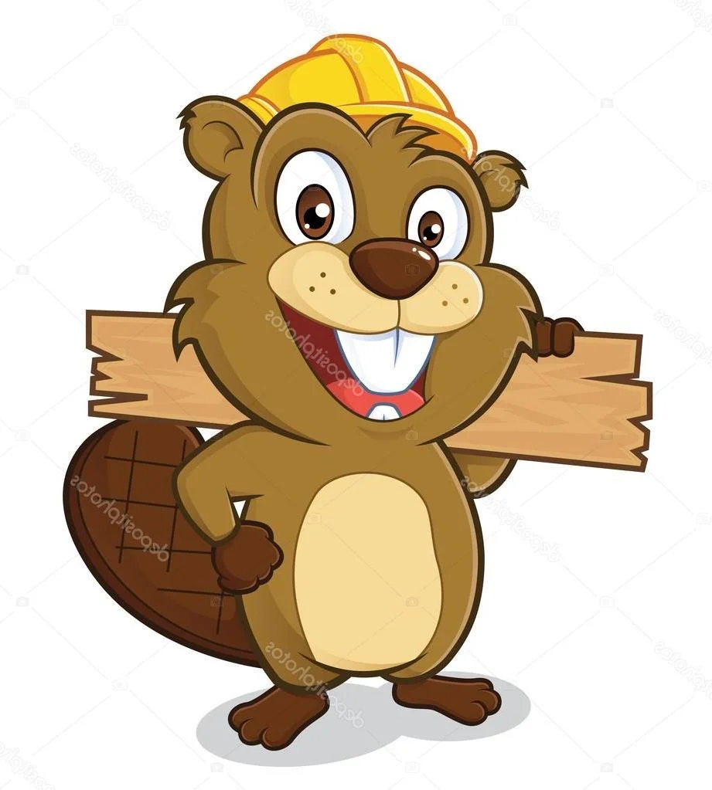
- Oxymoron
- Hyperbole
- Symbolism
- The logging industry
Q6: Choose the phrase that best represents ALLITERATION
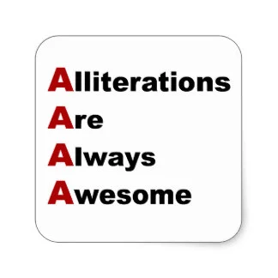
- The rain in Spain falls mainly in the plains
- How much wood could a woodchuck chuck
- The stars were twinkling diamonds
- She sells seashells by the seashore

Q7: Which of the following represents a RHYMING PATTERN?
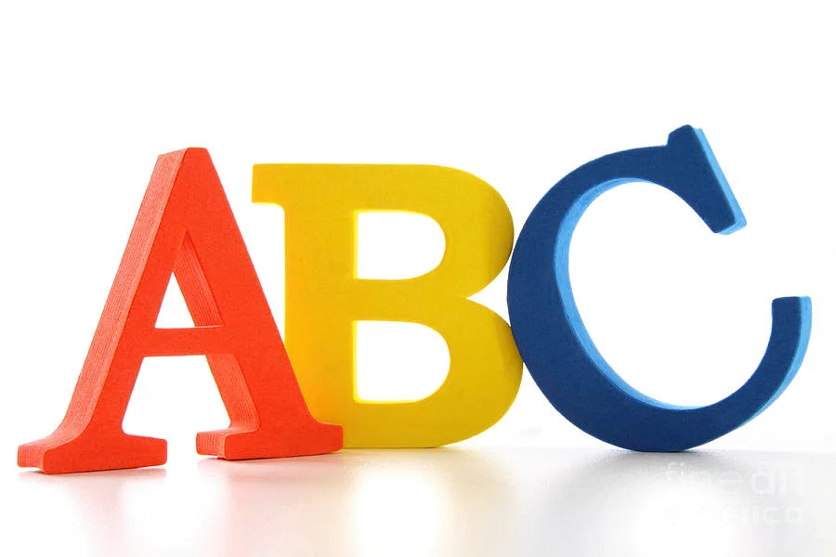
- A, A, B, B
- A, B, A, B
- A, A, B, B, C
- All of them

Q8: Buzz, POW!, Purr, are all examples of ___________?
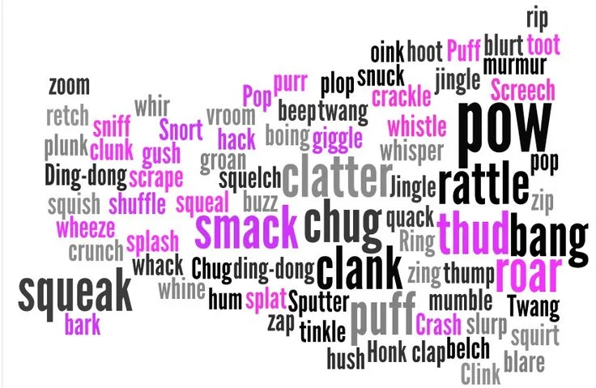
- Onomatopoeia
- Imagery
- Hyperbole
- A cat swatting a bee successfully

Q9: In ASSONANCE, all words START with the same sound.
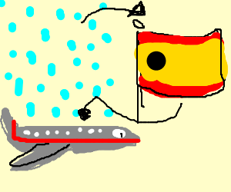
- True
- False

Q10: What is the definition of hyperbole?
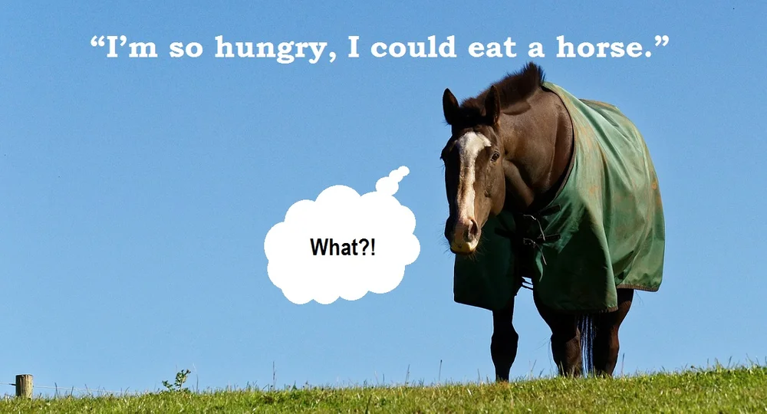
- Extreme exaggeration
- A comparison using like or as
- Two opposite ideas joined together
- A bowl full of sugar
Q11: Which poetic device is known as the flow of sound and silence (the beat)?

- Repetition
- Rhythm
- Dramatic irony
- Imagery

Q12: "Take a hike!" is an example of which poetic device?
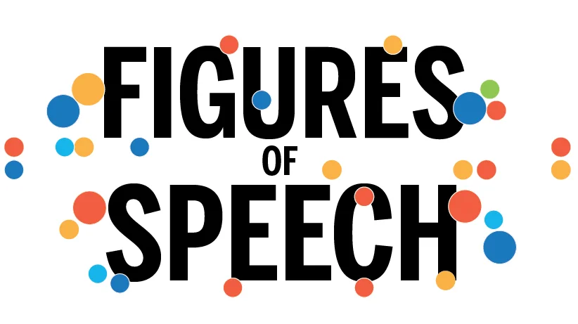
- Personification
- Assonance
- Alliteration
- Imagery

Q13: Repeating words or phrases in a poem for emphasis is an example of ______________?
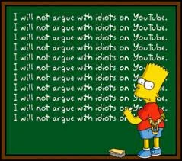
- Rhythm
- Repetition
- Symbolism
- Rhyming patterns

Q14: When words end in similar sounds, it is known as ____________?
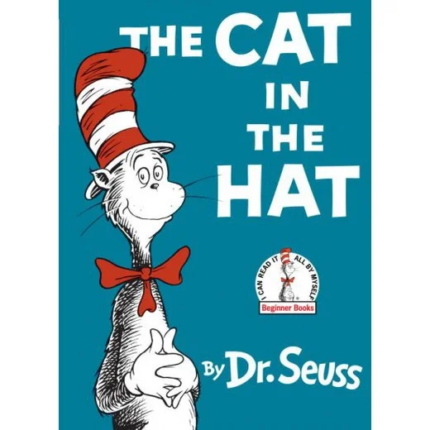
- Alliteration
- Assonance
- Rhyming
- Repetition

Q15: Which of the following is an example of a simile?
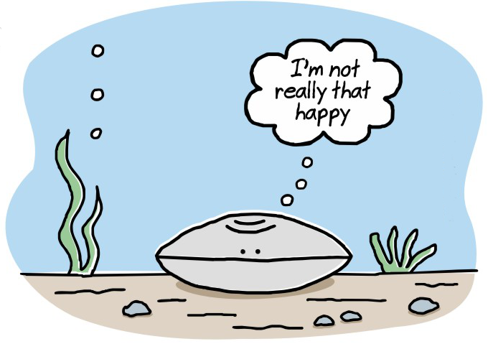
- He was as tall as an oak
- The storm was a bully against my window
- The stars winked in the sky
- The flag waved gracefully in the sky

Q16: A metaphor is a direct comparison using like or as
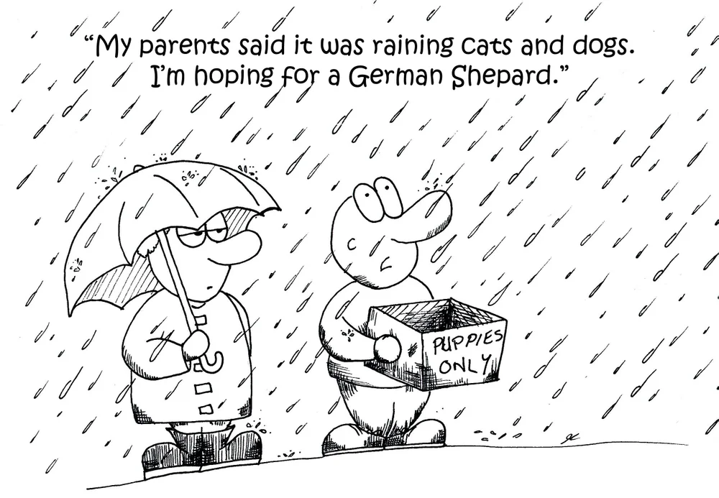
- True
- False

Q17: Creating atmosphere or emotion through setting or tone is known as ________?

- Simile
- Mood
- Oxymoron
- Personification

Q18: Which poetic device is used in comic books to show sound effects?
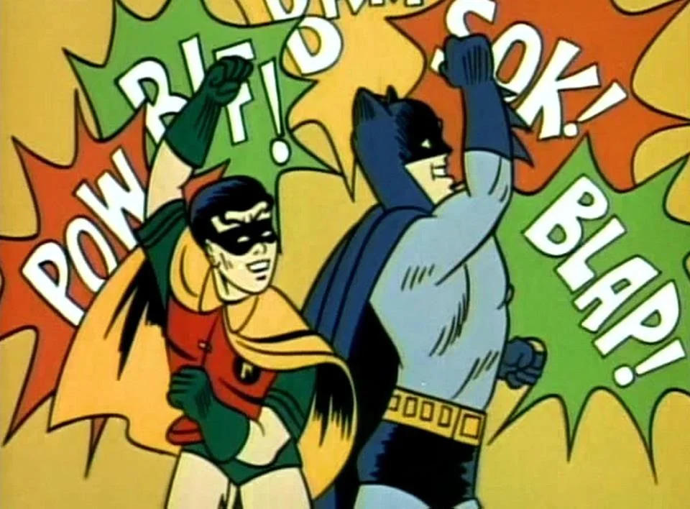
- Imagery
- Personification
- Onomatopoeia
- Symbolism

Q19: "The tree waved goodbye in the wind" is an example of __________?
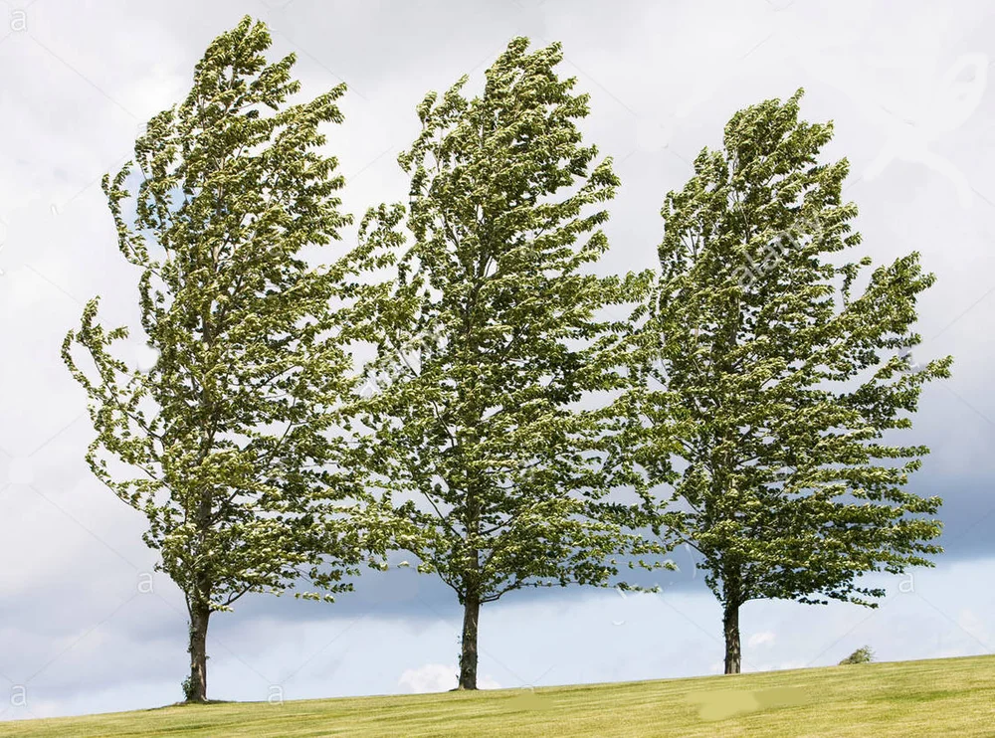
- Simile
- Oxymoron
- An Ent from Lord of the Rings
- Personification

Q20: Which RHYMING PATTERN does a Limerick follow?

- A, A, B, B
- A, A, B, B, A
- A, B, A, B
- A, B, C, D, E, F, G

