# **Probability Kahoot Quiz /20**

# **Q1: Probability is defined as…**

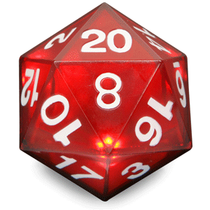

1. the observation of an occurrence.
2. the recording of events.
3. the chance that something will not happen.
4. the chance that something will happen.

**Q2: An event that has an even chance of occurring is…**

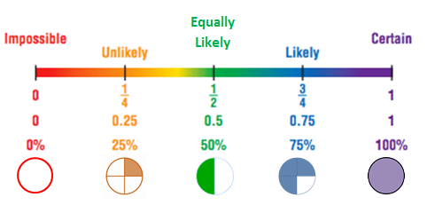

1. impossible
2. certain
3. Improbable
4. equally likely

**Q3: If the desired outcome is probably going to happen, it's...**

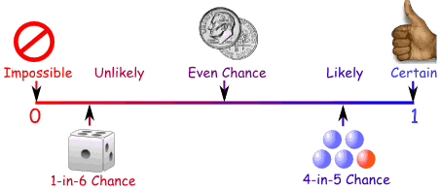

1. .25
2. Karma
3. .75
4. .5

**Q4: On this spinner, which result is more likely?**

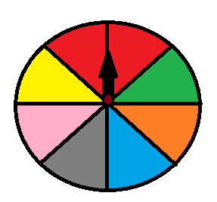

1. green
2. red
3. Farmer Brown
4. grey

**Q5: Flip a coin twice in a row, P(TAILS TWICE)=**

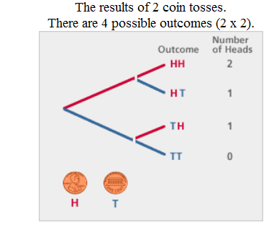

1. .25
2. .50
3. .75
4. Good question sir!

**Q6: Flip a coin 3 times in a row, there are _____ possible outcomes.**

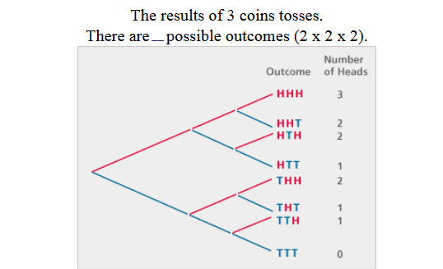

1. 6
2. 10
3. 12
4. 8

**Q7: Flip a coin 3 times in a row, P(at least heads twice)=**



1. 4/8ths of the time
2. 2/8ths of the time
3. 1/4 of the time
4. more than 50% of the time

**Q8: The tree diagram shows ___ coin tosses.**

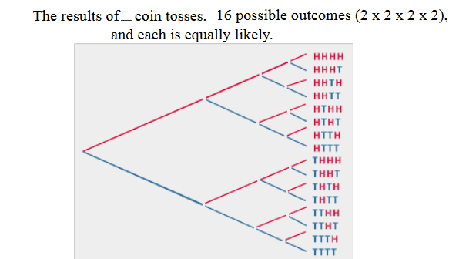

1. 4
2. 5
3. 6
4. 16

**Q9: At what percent of confidence do you have that the blue ball will be picked?**

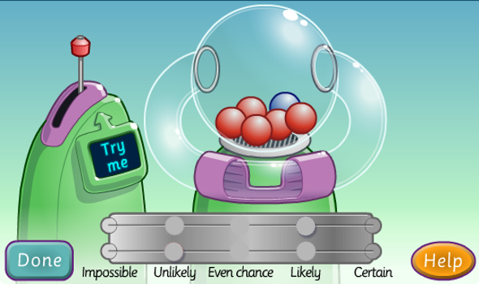

1. <20%
2. >20%
3. 20%
4. 16.66%

**Q10: What's the chance that studying & telling your folks of test dates will increase grades?**

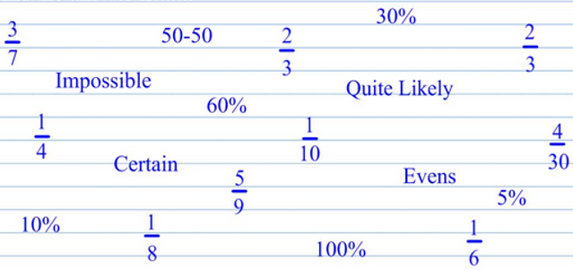

1. certain
2. <50%
3. Improbable
4. >.51

**Q11: Like in SKUNK, the most common score on a roll of two dice is...**

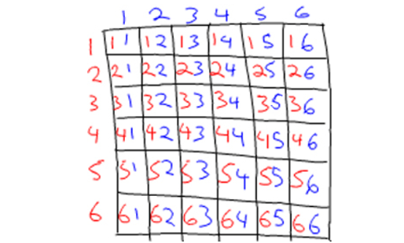

1. 5
2. 6
3. 7
4. 8

**Q12: Like in SKUNK, what's the chance of getting 12 points on a roll of 2 dice?**

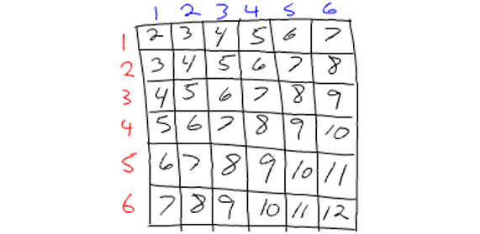

1. 1/36
2. 0.02777 repeating
3. 2.777% repeating
4. All the listed responses.

**Q13: The letters M-O-N-O-P-O-L-Y are put into a bag. What's the chance of picking a vowel?**

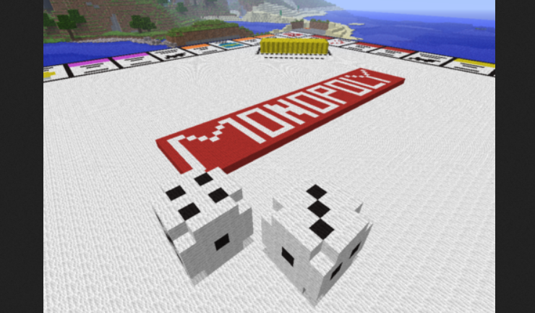

1. 0.33 repeating
2. 0.375
3. 0.50
4. 0.625

**Q14: What's the probability of the spinner landing on a vowel with one spin?**

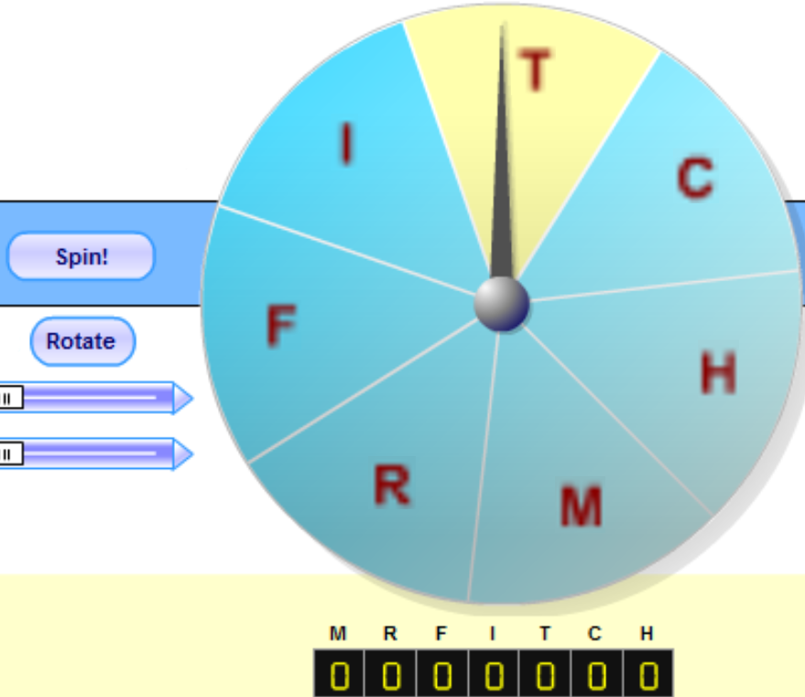

1. 1/8
2. highly improbable
3. ~ 14.3%
4. unknown

**Q15: What's the chance of landing on a vowel twice in a row with 2 spins?**



1. 1/49
2. 1/7
3. 2/49
4. less than 2%

**Q16: What's the chance of getting a red outcome?**

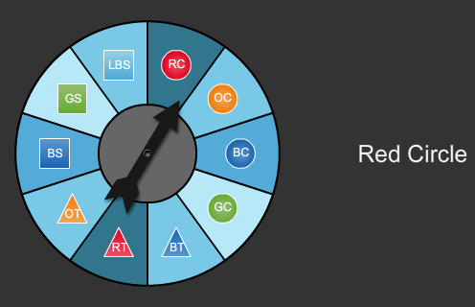

1. 10%
2. 20%
3. less than 20%
4. greater than 20%

**Q17: What's the chance of an outcome which is neither circular nor green?**

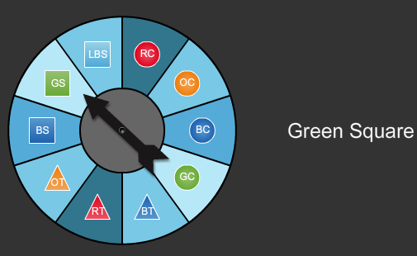

1. 40%
2. 50%
3. 60%
4. None of the responses listed.

**Q18: What's the chance of an outcome which is neither orange, nor green, nor circular?**

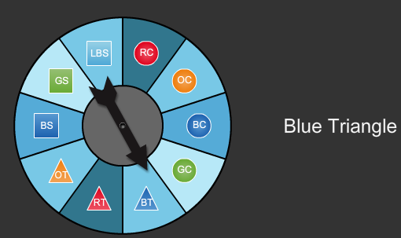

1. 30%
2. 2/5
3. 0.04
4. None of the responses listed.

**Q19: According to theoretical probability, how many red outcomes are expected with 16 spins?**

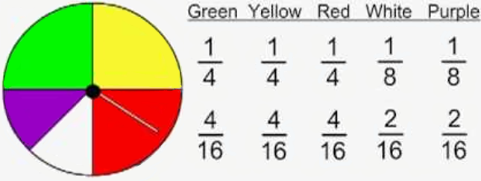

1. 9.0
2. 0.25
3. 4
4. 8

**Q20: P(not blue or red marble) =**

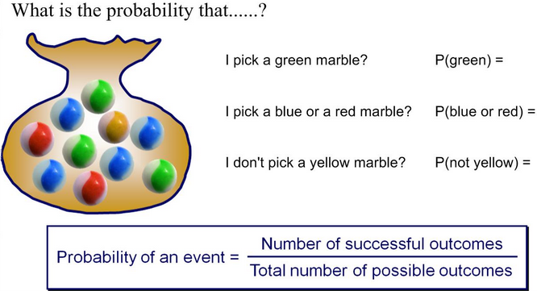

1. 40%
2. 2/5
3. 4/10
4. All the responses listed.