**CIRCLES ONLINE QUIZ ANSWERS (SOCRACTIVE.COM)**

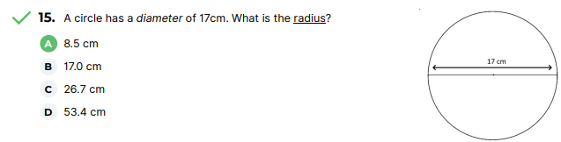

Radius = d/2

= 17cm/2

= 8.5cm

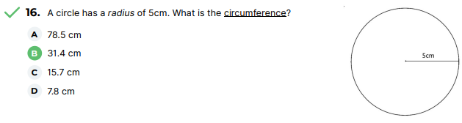

Circumference = 2πr

= 2π x 5cm

= 2(3.14) x 5cm

= 31.4 cm

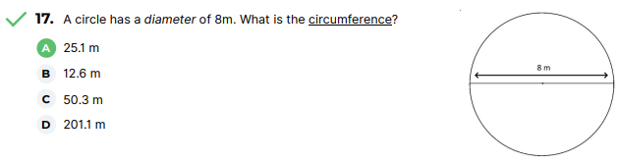

C = πd

= π x 8m

= 25.12m

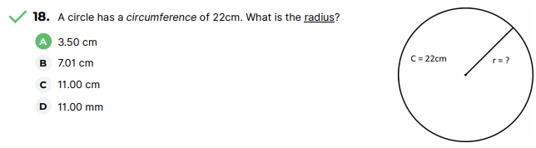

C = πd

= 2πr

22cm = 2πr

22cm = 2(3.14)r

22cm = 6.28

22cm/6.28 = r

3.50cm = r

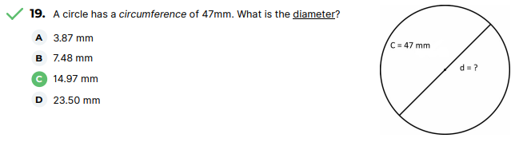

C = πd

47mm = πd

47mm / π = dπ / π

47mm / π = d

47mm/ 3.14 = d

14.97mm = d

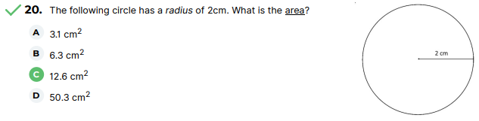

A = πr2

A = 3.14(2cm)2

A = 3.14 x 4cm2

= 12.56cm2

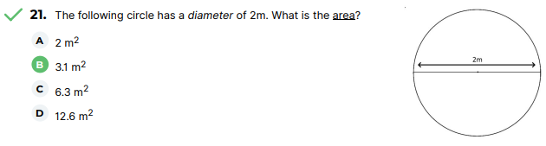

A = πr2

r = d/2

r = 2m/2

r = 1m

A = πr2

A = π(1m)2

= 3.14(1m)2

= 3.14(1m2)

=3.14m2

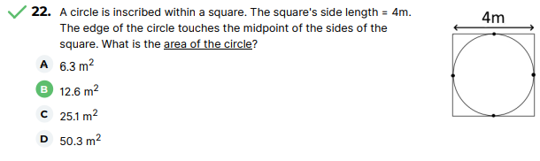

A = πr2

r = d/2

r = 4m/2

r = 2m

A = πr2

= π(2m)2

= 3.14 x 4m2

= 12.56 m2

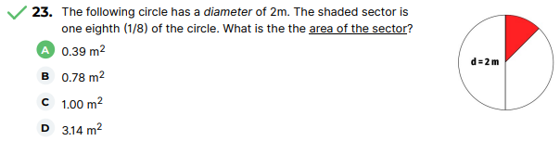

A = πr2

d = r/2

d = 2m/2

d = 1m

A = 1/8(πr2)

= 1/8 x π(1m)2

= 1/8 x 3.14(1m)2

= 0.39m2

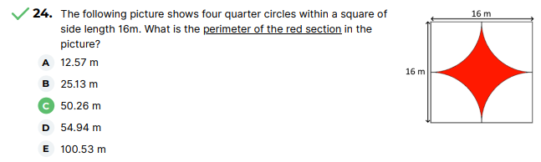

Perimeter of arc = ¼(circumference)

P= 1/4(πd) x 4

Perimeter = ¼(3.14 x16m) x 4

= 12.56m x 16m

= 50.24m

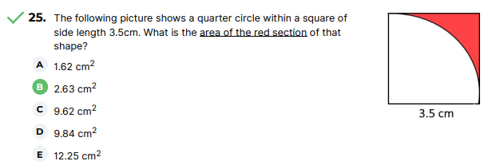

Area of shaded region = Area of Square – Area of quarter circle

= (l x w) – ¼(πr2)

= (3.5cm x 3.5cm) – ¼(πr2)

= 12.25cm2- ¼(π x 3.5cm2)

= 12.25cm2- 9.62cm2

= 2.63 cm2