**CIRCLES UNIT TEST /27**

**True/False /8**

*Indicate whether the sentence or statement is true or false.*

*If false, write the corrected statement in the space provided.*

____ 1. Diameter is the straight-line distance from a circle’s centre to any outside point.

____________________________________________________________________

____ 2. The number π does not end, but can be rounded to 3.14.

*_____________________________________________________________________*

____ 3. The radius of a circle is half the diameter, **r=½ d.**

_____________________________________________________________________

____ 4. The formula for the circumference of a circle (using radius) is **C=πr**.

_____________________________________________________________________

____ 5. A tangent is a straight line that touches a circle at 2 points.

_____________________________________________________________________

____ 6. The formula for the area of a circle is **A=****πr2**.

______________________________________________________________________

____ 7. For every circle, **C ÷ d = π.**

______________________________________________________________________

____ 8. A segment is a “pizza slice”-shaped part of a circle’s area.

______________________________________________________________________

**Matching /6**

*Match the correct term to the lines in this diagram.*

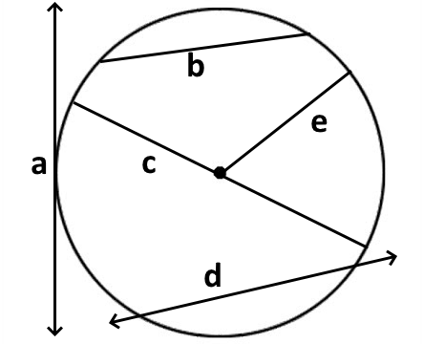____ 9. radius

____ 10. diameter

____ 11. tangent

*Match the correct term to each of the following descriptions.*

|  |  |  |  |
| --- | --- | --- | --- |
| a. | arc | d. | circumference |
| b. | area | e. | sector |
| c. | centre | f. | segment |
|  |  |  |  |

____12. the part of a circle enclosed by two radii and an arc.

____ 13. a curved line that is part of the circumference of the circle

____ 14. the point within a circle that is the same distance from every point of that circle's circumference.

**Multiple Choice /6**

*Identify the letter of the choice that best completes the statement or answers the question. Show your work.*

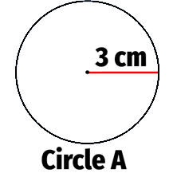____ 15. What is the diameter of **Circle A**?

|  |  |  |  |
| --- | --- | --- | --- |
| a. | 1.5 cm | c. | 3 cm |
| b. | 3.14 cm | d. | 6 cm |

____ 16. What is the circumference of **Circle A**?

|  |  |  |  |
| --- | --- | --- | --- |
| a. | 4.71 cm | c. | 9.42 cm |
| b. | 18.84 cm | d. | 28.26 cm2 |

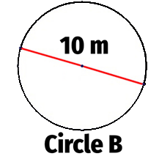____ 17. What is the radius of **Circle B?**

|  |  |  |  |
| --- | --- | --- | --- |
| a. | 3.14 m | c. | 5 m |
| b. | 10 m | d. | 20 m |

____ 18. What is the circumference of **Circle B?**

|  |  |  |  |
| --- | --- | --- | --- |
| a. | 15.7 m | c. | 31.4 m |
| b. | 62.8 m | d. | 78.5 m |

____ 19. A circle has a circumference of 12.56m. What is its radius?

|  |  |  |  |
| --- | --- | --- | --- |
| a. | 2.0 m | c. | 4.0 m |
| b. | 19.7 m | d. | 39.4 m |

____ 20. A circle has a radius of 3.5cm. What is its area?

|  |  |  |  |
| --- | --- | --- | --- |
| a. | 9.6 cm | c. | 9.6 cm2 |
| b. | 22.0 cm2 | d. | 38.5 cm2 |

**Short Answer /3**

*Write your answer in the space provided.*

21. Complete the table for a circle with the given measurement. Show your work. Round to the hundredths.

|  |  |  |  |  |
| --- | --- | --- | --- | --- |
|  | **Radius** | **Diameter** | **Circumference** | **Area** |
| a) | 2 m |  |  |  |
| b) |  | 3.2 cm |  |  |
| c) |  |  | 9 mm |  |

**Problem /2**

*Write your answer in the space provided. As always, show your work.*

22. The shape below shows a circle within a rectangle. What is the area of the shaded region?

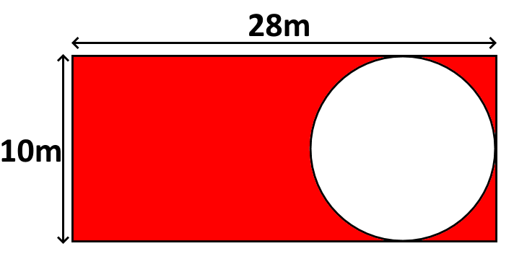

23. *Determine the origin. Show your work.* /2

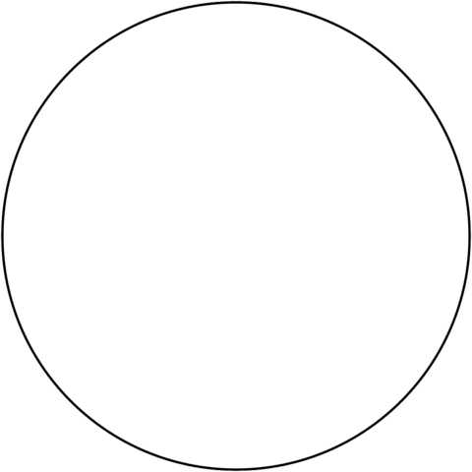

**CIRCLES UNIT TEST – ANSWER KEY**

**True/False /8**

1. **F Radius is the straight-line distance from a circle’s centre to any outside point.**
2. **T**
3. **T**
4. **F The formula for the circumference of a circle (using radius) is C=2πr.**
5. **F A secant is a straight line that touches a circle at 2 points.**
6. **T**
7. **T**
8. **F A sector is a “pizza slice”-shaped part of a circle’s area.**

**Matching /6**

1. **E**
2. **C**
3. **A**
4. **E**
5. **A**
6. **C**

**Multiple Choice /6**

1. **D**
2. **B**
3. **C**
4. **C**
5. **A**
6. **D**

**Short Answer /3**



|  |  |  |  |
| --- | --- | --- | --- |
| **Radius** | **Diameter** | **Circumference** | **Area** |
| 2 m | **4 m** | **12.57 m** | **12.57 m2** |
| **1.6 cm** | 3.2 cm | **10.05 cm** | **8.04 cm2** |
| **1.43 mm** | **2.86 mm / 2.87 mm** | 9 mm | **6.42 mm2** |

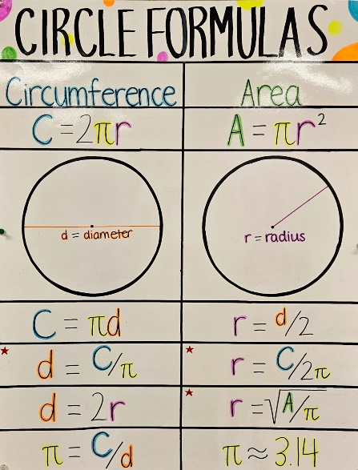

**Problem /2**

**Area of the rectangle Radius of circle Area of the circle**

**A = l x w r = 0.5d A = πr2**

**A = 28m x 10m r = 0.5 x 10m A = 3.14 x (5m)2**

**A = 280m2 r = 5m A = 3.14 x 25m2**

**A = 78.5m2**

**Shaded area = Area of rectangle – Area of circle**

**Shaded area = 280m2 – 78.5m2**

**Shaded area = 201.5m2**

1. *Determine the origin. Show your work.* /3



