**Financial Literacy Unit Test /32**

**1. True or False? (6 marks)**

|  |  |
| --- | --- |
| Money can be exchanged for foreign currency at your local bank. | T F |
| Sales tax is included in the retail price. | T F |
| Tuition is a source of income. | T F |
| Health and Dental are expenses. | T F |
| A buy one get one free sale will reduce the price you pay. | T F |
| A public park, a bridge and the police are paid for by taxes. | T F |

**2. Write the correct term for only 6 of the 10 definitions (6 marks)**

Money received for work or through investments.

A system of money that is in use in a particular country.

Money paid per hour of work.

The original sum of money put into an investment.

A tax imposed on the sale of goods and services.

A tip given on top of the original fee.

Money spent on necessities.

The value of one country’s currency compared to another’s.

A type of tax based upon your earnings/salary.

Money that is owed or due.

**Problem Solving (12 marks)** *Remember your* ***⸫*** *statements!*

**3.** A $50 biker shirt is discounted 25% off. Without taxes, what’s the price?

**4.** A $2999.99 motorcycle is discounted by $200. What’s the pre-tax price?

**5.** Kim buys food in Saskatchewan, where the sales tax is 11%. He buys pizza ($14.99 plus tax) & pop ($6.99 plus tax), how much will his food cost?

**6.** Sian buys a backpack. It costs $59.99 plus tax. How much will she pay?

**7.** A $629.99 jacket is discounted 30% off. What is the pre-tax price?

**8.** Rob has $40, a rose costs $12.00 plus tax. How many can he buy?

**Using this graph, answer the questions below (2 marks)**

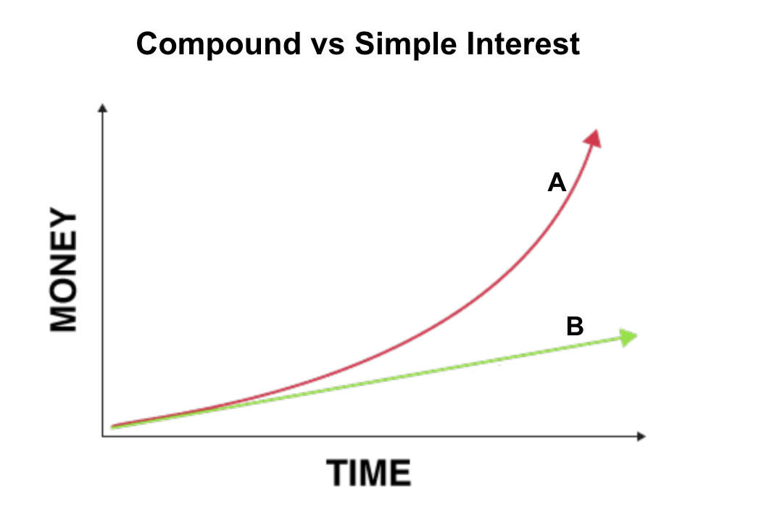

**9.** Which line represents *Simple Interest*?

**10.** Which line is the smarter investment?

**Solve the following conversions (4 marks)** *Remember your* ***⸫*** *statements!*

|  |  |
| --- | --- |
| **Currency** | **Exchange rate with Canadian Dollar** |
| **US Dollar** | **$1 CAD = $0.79 USD** |
| **Lybian Dinar** | **$1 CAD = 3.51 LYD** |

**11.** How much is $10 Canadian Dollars in US Dollars?

**12.** How much is $30 Canadian Dollars in Lybian Dinars?

**13.** Give the formula for SIMPLE INTEREST.

**14.** Give the formula for COMPOUND INTEREST.

**Financial Literacy Unit Test Answers /32**

**1. True or False? (6 marks)**

|  |  |
| --- | --- |
| Money can be exchanged for foreign currency at your local bank. | T |
| Sales tax is included in the retail price. | F |
| Tuition is a source of income. | F |
| Health and Dental are expenses. | T |
| A buy one get one free sale will reduce the price you pay. | F |
| A public park, a bridge and the police are paid for by taxes. | T |

**2. Write the correct term for only 6 of the 10 definitions (6 marks)**

**Income** Money received for work or through investments.

**Currency** A system of money that is in use in a particular country.

**Wage** Money paid per hour of work.

**Principal** The original sum of money put into an investment.

**Sales Tax** A tax imposed on the sale of goods and services.

**Gratuity** A tip given on top of the original fee.

**Expenses** Money spent on necessities.

**Exchange Rate** The value of one country’s currency compared to another’s.

**Income Tax** A type of tax based upon your earnings/salary.

**Debt** Money that is owed or due.

**Problem Solving (12 marks)** *Remember your* ***⸫*** *statements!*

**3.** A $50 biker shirt is discounted 25% off. Without taxes, what’s the price?

**If the shirt is discounted 25% then we will be paying 75% of the total price. $50.00 x 0.75 = $37.50**

**4.** A $2999.99 motorcycle is discounted by $200. What’s the pre-tax price?

**$2999.99 - $200 = $2799.99**

**5.** Kim buys food in Saskatchewan, where the sales tax is 11%. He buys pizza ($14.99 plus tax) & pop ($6.99 plus tax), how much will his food cost?

**$14.99 + $6.99 = $21.98**

**$21.98 x 1.11 = $24.40**

**6.** Sian buys a backpack. It costs $59.99 plus tax. How much will she pay?

**$59.99 x 1.13 = $67.79**

**7.** A $629.99 jacket is discounted 30% off. What is the pre-tax price?

**If the jacket is discounted 30% then we will be paying 70% of the total price. $629.99 x 0.7 = $440.99**

**8.** Rob has $40, a rose costs $12.00 plus tax. How many can he buy?

**Trial and Error:**

**1 rose: $12.00 x 1 = $12.00**

**$12.00 x 1.13 = $13.56**

**2 roses: $12.00 x 2 = $24.00**

**$24.00 x 1.13 = $27.12**

**3 roses: $12.00 x 3 = $36.00**

**$36.00 x 1.13 = $40.68**

**Rob can buy 2 roses.**

**Solving:**

**1 rose at retail price: $12.00 x 1 = $12.00 per unit**

**1 rose at final price: $12.00 x 1.13 = $13.56 unit price with tax**

**$40 ÷ $13.56 = 2.95**

**You can’t buy a partial rose, so Rob can buy 2 roses.**

**Using this graph, answer the questions below (2 marks)**

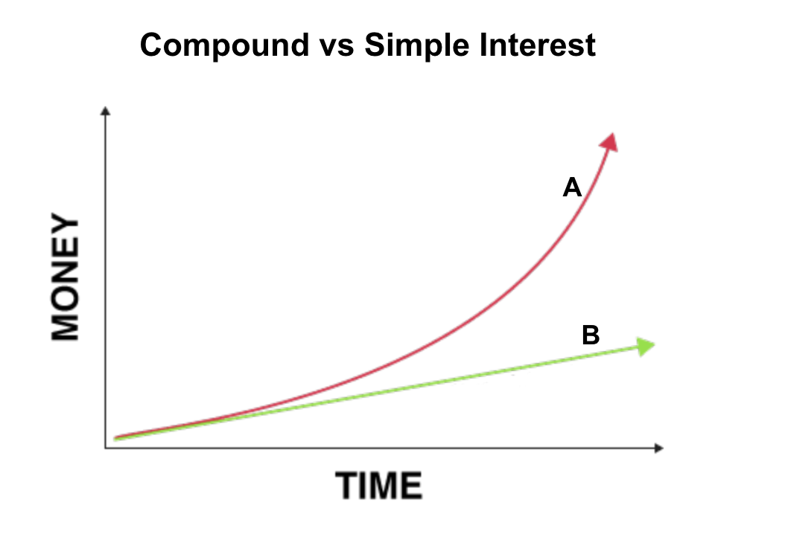

**9.** Which line represents *Simple Interest*?

**Line B represents Simple Interest.**

**10.** Which line is the smarter investment?

**Line A is the smarter investment.**

**Solve the following conversions (4 marks)** *Remember your* ***⸫*** *statements!*

|  |  |
| --- | --- |
| **Currency** | **Exchange rate with Canadian Dollar** |
| **US Dollar** | **$1 CAD = $0.79 USD** |
| **Lybian Dinar** | **$1 CAD = 3.51 LYD** |

**11.** How much is $10 Canadian Dollars in US Dollars?

**$10 x 0.79 = $7.90 USD**

**12.** How much is $30 Canadian Dollars in Lybian Dinars?

**$30 x 3.51 = 105.30 LYD**

**13.** Give the formula for SIMPLE INTEREST.

**I = Prt**

**14.** Give the formula for COMPOUND INTEREST.

**B = P(1+r)t**