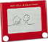
ETCH-A-SKETCH: CONTINUOUS LINE RUBRIC Name: _________________________
CATEGORY  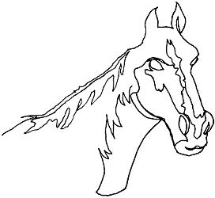 | LEVEL 1  STRUGGLING | LEVEL 2  LEARNING | LEVEL 3  LEARNED | LEVEL 4  MASTERED
KNOWLEDGE & UNDERSTANDING
- Accurate / Appropriate Content
- Design Principles: Unity / Harmony / Balance / Detailed

THINKING
- Planning / Design
- Space is well used / Balanced
- Original / Creative / Attractive / Memorable / Style
- Continuous lines optimized (hidden connections)

COMMUNICATION
- Expresses an idea / mood effectively
- Organization / Neatness
- Purposeful layout / Positioning
- Audience considered
- Art reflection

APPLICATION
- Texture / Detail
- Similar shapes creating unity /harmony
- Effort / Use of time / Independence
- Etch-a-Sketch medium: Used Effectively (ie. Diagonals, Curves, Thickened lines)
- Audience appeal

OVERALL MARK:

