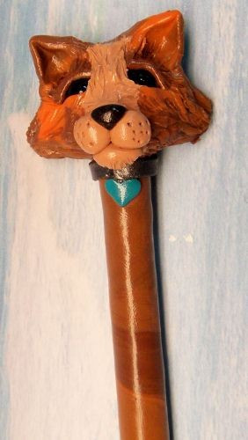FLOWERHEADS! – AIR DRY CLAY SCULPTURE RUBRIC
Name: ______________________ Class: __________

CATEGORY | LEVEL 1  Struggling | LEVEL 2  Learning | LEVEL 3  Learned | LEVEL 4  Mastered
THINKING / DESIGN

Planning Skills: Original / Creative / Attractive / Memorable / Style

Design Elements: Line, Shape & Form, Space, Colour, Texture, Value (shading, stippling)

Design Principles: Contrast, Repetition & Recurring Elements, Variety, Emphasis, Proportion, Balance, Unity & Harmony, Movement / Flow

Critical Thinking: Problem Solving / Artist Reflection / Evaluation & Review

APPLICATION

Effort / Preparedness / Co-operation / Clean up / Use of time / Safe
Skills: (Clay Sculpting & Painting techniques)
Proportion / Balance / Alignment / Continuity

Intended Use / Art Style Appreciation / Understanding of Sculpting Media Form / Critical Analysis of Quality / Process vs. Product

OVERALL:

