PAINT TONES RUBRIC Name: ____________________________

CATEGORY  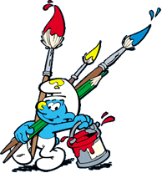 | Level 1  STRUGGLING | Level 2  LEARNING | Level 3  LEARNED | Level 4  MASTERED
KNOWLEDGE & UNDERSTANDING
- Accurate / Appropriate Content
- Design Principles: Colour Gradation, Negative Space, Poem placement
- Silhouette: Appropriate/Impact
Effort / Detailed / Original/Creative

THINKING
- Planning skills & creative thinking
- Original / Creative / Attractive / Colour / Text / Graphics / Usefulness / Logical Layout
- Placement/Size of Silhouette
COMMUNICATION
- Expression of ideas
- Use of conventions & vocabulary
- Flow / Mood / Style
- Paint Strokes: Texture/Consistency

APPLICATION
- Effort / Prepared / Timely / Collaboration / Clean up / Use of Time / Text: Well Placed & Legible
- No Waste of Materials
- Safe & Respectful
Overall Mark: Include this rubric with your art work.

