SKETCHBOOK RUBRIC 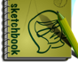 Name: _________________________
CATEGORY  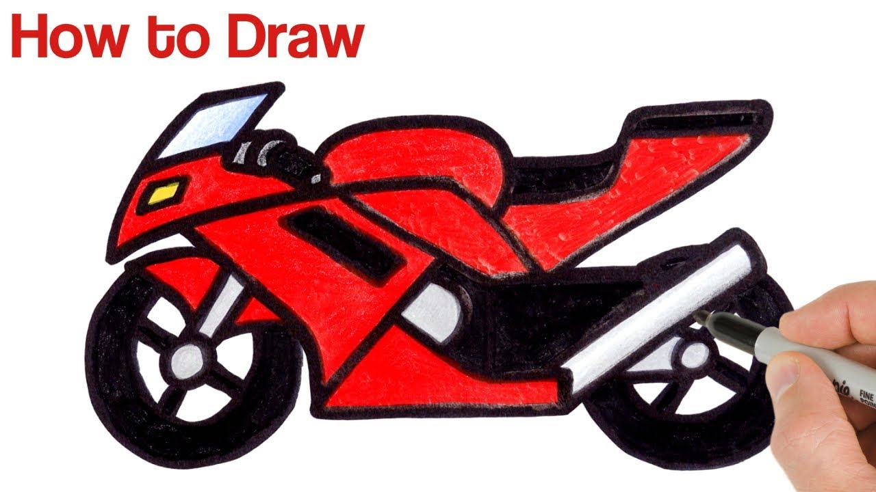 | LEVEL 1  STRUGGLING | LEVEL 2  LEARNING | LEVEL 3  LEARNED | LEVEL 4  MASTERED
KNOWLEDGE & UNDERSTANDING
- Accurate / Appropriate Content
- Design Principles: Unity / Harmony / Balance / Detailed
- Instructions followed

THINKING
- Planning / Design
- Original / Creative / Attractive / Memorable / Style
- Variety of Lines / Textures / Layered Colours / Shading

COMMUNICATION
- Expresses an idea / mood effectively / Style
- Organization / Neatness
- Purposeful layout / Positioning
- Audience considered
- Art reflection

APPLICATION
- Techniques / Texture / Detail
- Similar shapes creating unity
- Effort / Use of time / Independent / Prepared
- Medium used effectively (bold fills, feathering, backgrounds)
- Audience appeal

OVERALL MARK:

