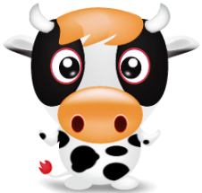 The Cow and the Farmer
Farmer:
It was mid-winter and I saw my cows sitting in the freezing cold, wet field. So I did what any good farmer would do. I went out in the cold to kindly escort them into the barn, so they could warm up. But when I tried to get them in they MOOED at me!

“That is very rude,” I respectfully told them.

I did not want to hurt their feelings but they had hurt mine. To make it worse they successfully trampled over me. Even though they had no reason to do that, and as a finale, they did a cocky dance to prove their victory!

“I’ve had it with these bovine!” I said to myself.

So I returned the favour by trying to scare the cows into the barn. I decided to use the combine. When I brought it out, it had some trouble starting, but it soon revved up. I scared the cows more than sharks scare fish. They started to run to the barn. But one of the cows didn’t move a muscle and I accidentally ran it over.

Just then the authorities showed up. They asked me to explain myself so I told them, “I was trying to get the cows to go into the barn and I got hurt doing so. I tried scaring them with the combine. It was an awfully, awkward, amicable accident!”

But they didn’t believe me so I was immediately sent to prison for five years for animal abuse.

“They could not have come when the cows trampled me,” I said quietly to myself.

I still wonder, to this day, how the authorities knew to come so quick. Could the livestock really be that crafty?

Cow:
It was another warm winter in Alabama and all of us girls were just trying to peacefully eat our grass. We did not want to disturb the farmer because he’s kind of crazy. But he came prowling down to us. So we panicked and MOOED. Then he told us to be quiet, and tried to force us to go in the barn.

“Why would he do this?” My friend Betsy asked.

The farmer must have heard this question. I turned my head for less than a second and the farmer was sitting on top of the big, red dragon. The dragon usually eats our corn.

“I’m scared.” I said in a quivering voice.

Instead of eating the corn, it was going to eat us! The farmer started to yell at us.

“How do you like my combine now, boys?!” the farmer screeched.

He drove the beast straight at us. We ran for our lives, towards the barn. Bob was frozen with fear. THE RED DRAGON ATE MY BEST FRIEND BOB! All of us cows were in shock. So we finally made it to safety inside the barn, and got away from the murdering madman.

I knew I had to stop the madness so I called 911. As soon as the cops got to the site I told them what was happening and they arrested the angry agriculturalist immediately.

“Thank goodness.” I said, while the authorities drove away.

Now that the Farmer Brown is gone, we can finally eat in peace.

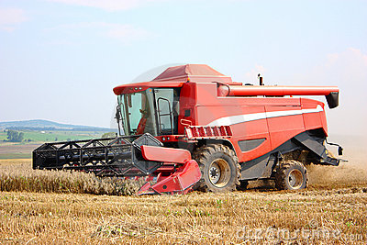 The Big Red Dragon / Combine
The Cows 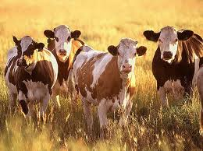
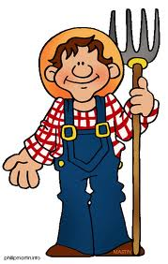The Farmer

