Euphemism 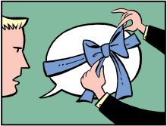

- A literary technique. To replace an offensive or upsetting expression with a saying that is more pleasant or less explicit.

- Often used to refer to sad / gross / uncomfortable topics

  - It fell off the back of a truck.

  - The cat is in a better place.

  - We are going to have to let you go.

  - Grandma has some character lines.

  - She had to go powder her nose.

  - My friend is just big boned.

  - Rover passed away last night dear.

  - Mrs. Smith has a bun in the oven.

  - My older brother is in a correctional facility.

  - Please put the dog out so it can do its business.

  - Has mom and dad told you about the birds and the bees, yet?

  - Uncle Tom got a little tipsy at the Christmas party.

  - I’m between jobs. – I’m between bikes.

