**LOOK UP - addiction - media response** 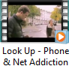

1. What is the message within this media?

2. In detail explain how effective this video is.

3. Add to the script of this clip. Explain your choices.

4. Write a description of this video for your folks.