METAPHORS 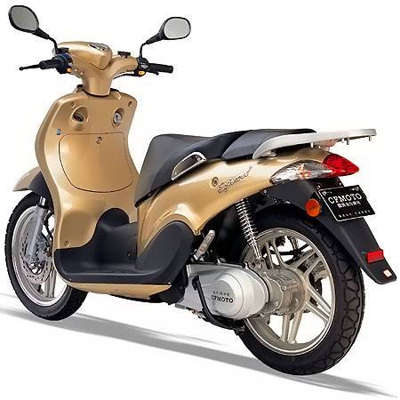
Time is a thief.

Your love is an ocean.

The curtain of night fell.

Mr. Fitch glared at me with fire in his eyes.

You're a pain in the neck!
Mr. Fitch’s students are drowning in homework.
That test was a breeze!

You are the sunshine of my life.
The streets were a furnace, the sun an executioner.
But my heart is a lonely hunter that hunts on a lonely hill.
Men's words are bullets that their enemies take up and make use of against them.
The rain came down in long knitting needles.
The bottom of the ocean is a dark cave.
The goalkeeper was a rock.

America is a melting pot.

Homer Simpson is a pig.

The girl was a picture.

Carl: According to the map, the cabin should be right here.

Lenny: Hey, maybe there is no cabin. Maybe it's one of them metaphorical things.
Carl: Oh yeah, yeah. Like maybe the cabin is the place inside each of us, created by our goodwill and teamwork.

Lenny: Nah, they said there would be sandwiches.
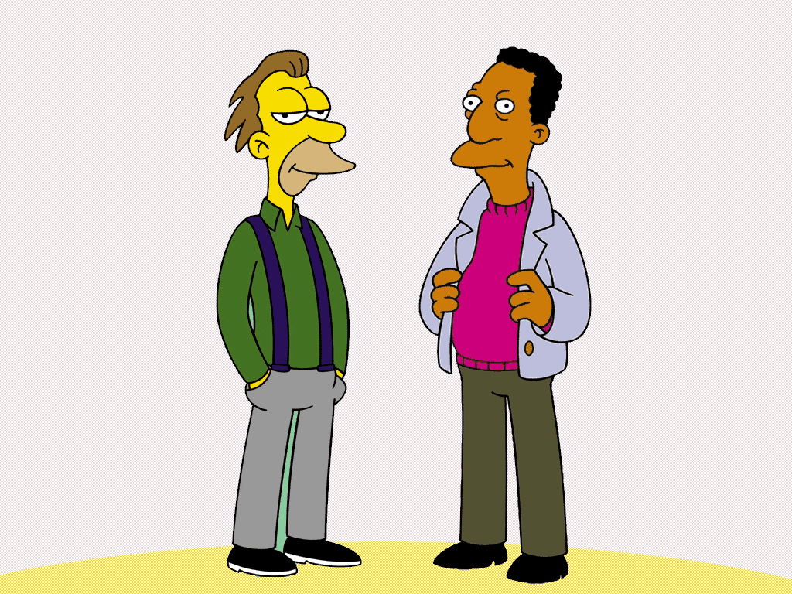
Metaphor Poems
I am a sword,
Sharper than a tongue
Nobody can defeat me,
Because I am a sword,
I can not be hurt by what people say
About me,
I will not show my anger
Against
Someone else.

I AM LAS VEGAS
I am Las Vegas, growing with abandon
awake in the evening,
and by the day.
I am Las Vegas, my hand is the sand,
My feet know no bounds.
NATURE METAPHORS

The snow is a white blanket.

He is a shining star.

Her long hair was a flowing golden river.

Tom's eyes were ice as he stared at her.

The children were flowers grown in concrete gardens.

Kisses are the flowers of affection.

The falling snowflakes are dancers.

The calm lake was a mirror.

MAKE YOUR OWN METAPHORS
1. The moon is a _____________________________________________.
2. His arms were _________________ as they lifted the heavy chair.
3. The stars are ______________ as they twinkle in the night sky.
4. The storm was a ______________ as it clawed against my window.
5. The freshly mowed lawn was a ___________________________.
6. The noisy children were __________________ as they raced through the museum.
7. I was a ___________________ as I tiptoed across the wooden floor.
8. The river was a _________________ as it twisted and turned down the mountain.
9. ___________________________________________________.

