**Authentic Vietnamese Spring Rolls**

**Goal:** To make heavenly and healthy spring rolls.

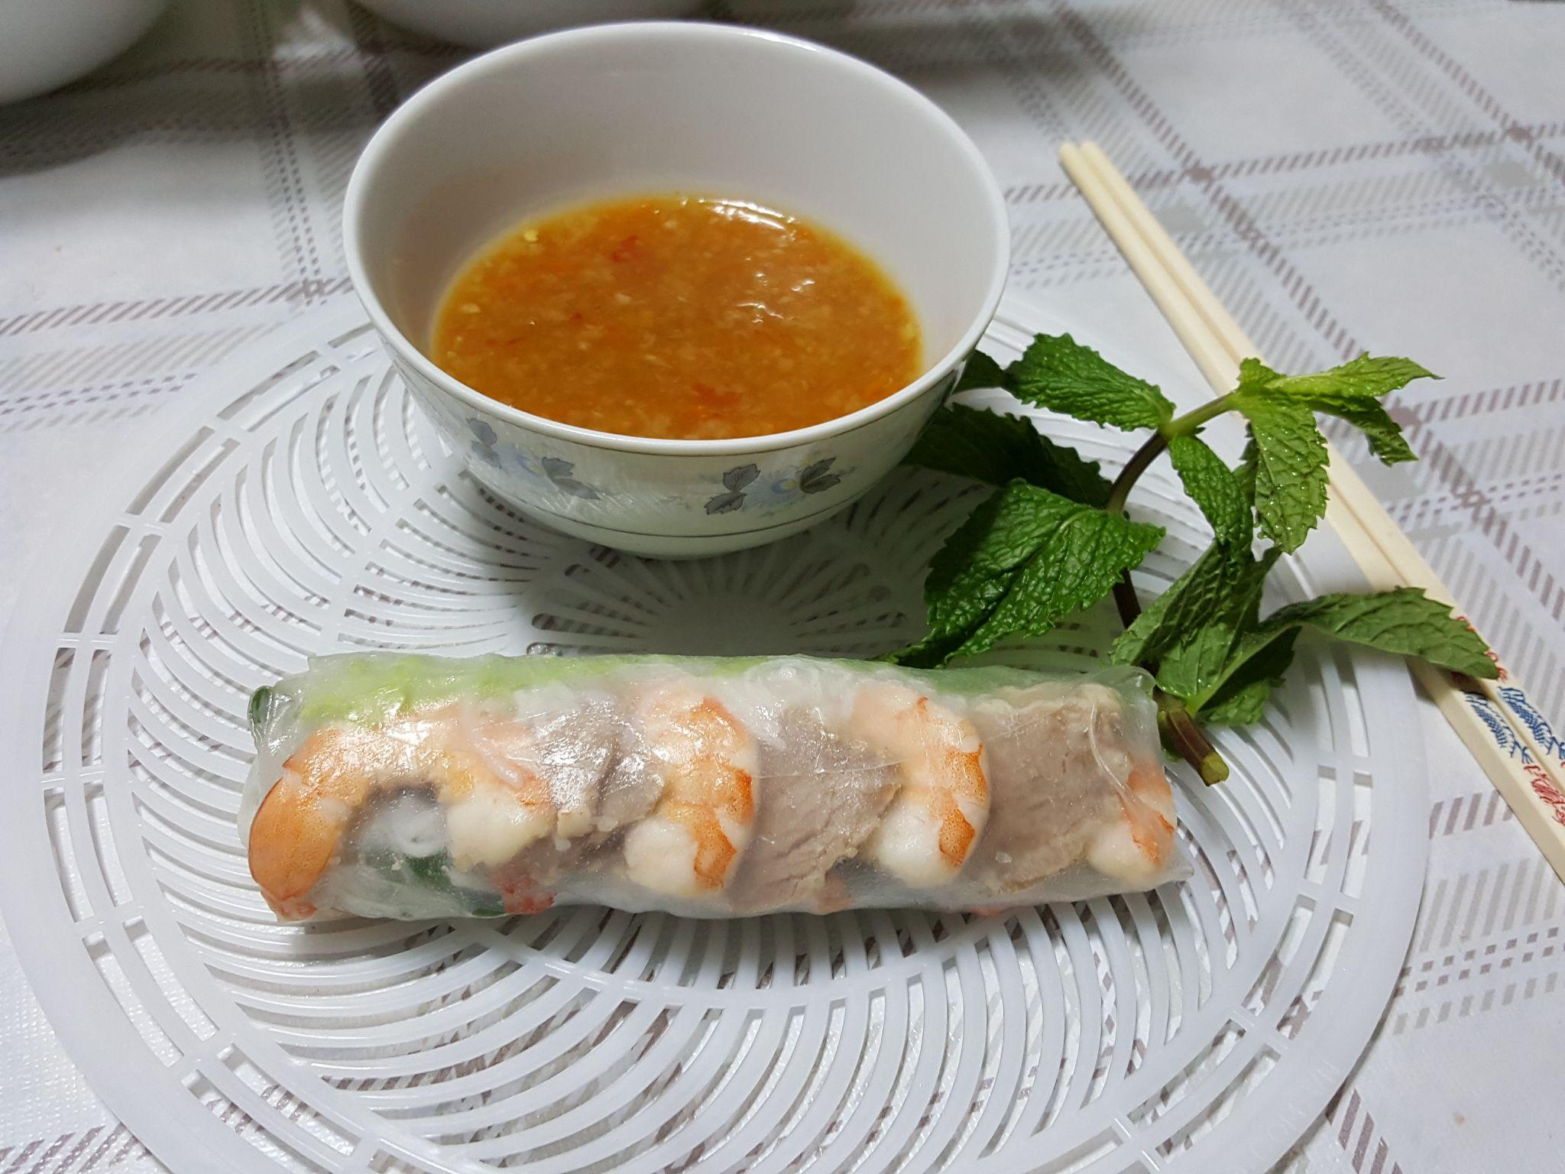

**Time:** 2h  **Serves:** 5(~20 rolls)

**Ingredients:**

* 1 pack rice vermicelli
* 500g shrimp
* 500g pork shoulder/pork belly
* 1 head of lettuce
* Mint
* Basil
* Chives
* Onion
* Cucumber
* Bean sprouts
* 1 pack rice paper sheets
* 1/2 tsp salt
* Sriracha sauce or Chili pepper
* 6 tbsp. hoisin sauce
* 3 tbsp. sugar
* 6 tbsp. peanut butter (optional)

**Items:**

* Sharp knife
* 2 pots
* 1 large plate
* Medium plates
* Small bowls
* 1 colander
* Cutting board
* Paper towel
* Tongs
* Ladle

**Prep:**

1. Obtain a pot, put in 2 slices (140g) of rice vermicelli. Fill with water. Bring it to the stove. Set to medium heat.
2. After it starts boiling for 5 minutes, take out your vermicelli by pouring it into the colander over the sink to dry and strain. Once dry, transfer to a medium bowl.
3. Acquire your pork shoulder/pork belly. Go to the sink and start to rinse the meat with tap water until clean. Once you turn off the tap, take out a clean towel and dry the pork with small dabs.
4. Place the pork and the peeled onion in the pot and fill it with water until the water level is above the pork. Bring the pot to the stove. Set to medium heat. Put a lid on the pot, then bring the water to a boil. Wait 25 minutes for the pork to cook.
5. Once finished waiting, open the lid and use tongs to place the meat down on a plate and then put the shrimp in to cook. Once the shrimp starts floating, the shrimp is ready to take out. Set it on the plate with the pork.

**Warning:** Do not leave your shrimp unattended. They will start to become rubbery and dry once you start eating them.

**Notice:** Don’t discard the boiling water. It is necessary for the dipping sauce.

1. Transfer your pork onto the cutting board. Take out a sharp knife and start to cut the pork. Each piece should have a width of 4 mm and have the approximate length of your thumb. This will make it easier to roll.
2. Retrieve the shrimp from the plate and lay out your slices of pork in a circular fashion on half of the plate. With the shrimp, take them to the cutting board to peel and devein. Lay it out onto the other half of the plate.
3. Wash the vegetables thoroughly at the sink; lettuce, mint, basil, bean sprouts, chives and cucumber. Cut the cucumber into multiple 12 cm strips. Place your herbs and vegetables into a colander to dry. Once dry, put all of your vegetables and herbs assorted into a bowl.

**Sauce:**

Pour in about 210 ml of the boiling water into a medium bowl. Use cooking gloves if necessary. Next, put in the hoisin sauce, sugar, peanut butter (if wanted) and a small drizzle of Sriracha sauce/chili pepper (you can add more for an extra kick). Mix until the desired consistency has been reached.

Now, let’s **roll** on!

**Rolling:**

1. 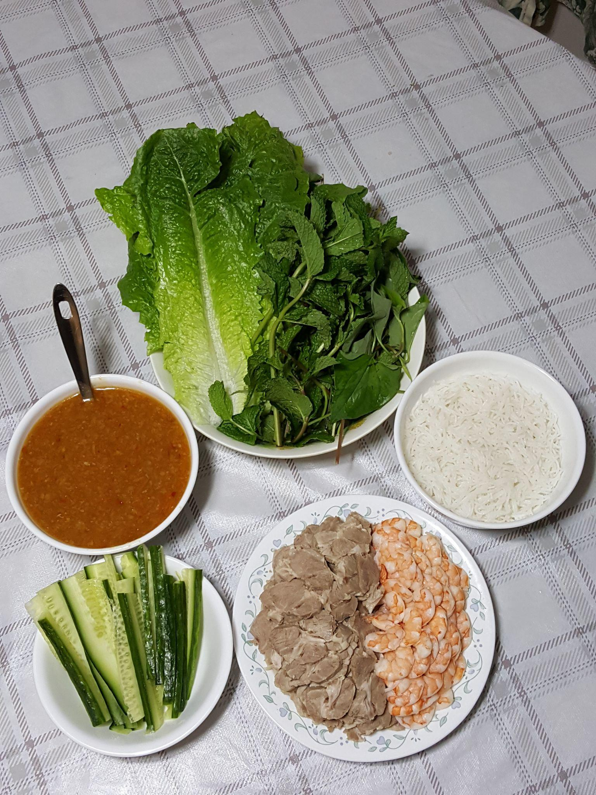Bring to your dining table your: meat plate, dipping sauce bowl. Vermicelli bowl and herb bowl. Take out some small bowls and medium plates for each person. In each bowl, with a ladle, insert an even amount of sauce for each person.
2. Take out a bowl that is as large as the diameter of your rice paper. Fill it with 2 cm of lukewarm water.
3. Open the pack of rice paper, take one sheet and pass it in the water and then take it out immediately. Transfer it to a medium plate and shake off excess water. Do NOT let it soak nor wrinkle.
4. Now, you will start placing your ingredients onto the paper. First, place lettuce in the bottom third of your sheet. Make sure to leave 3 cm of space on the sides. Then, place in your mint, basil, bean sprout, cucumber, chives and then a handful of vermicelli in line and on top of your salad leaf.
5. Then, in a row above, lay the desired amount of pork slices and shrimp. This makes the roll look more appetizing since the meat is revealed.

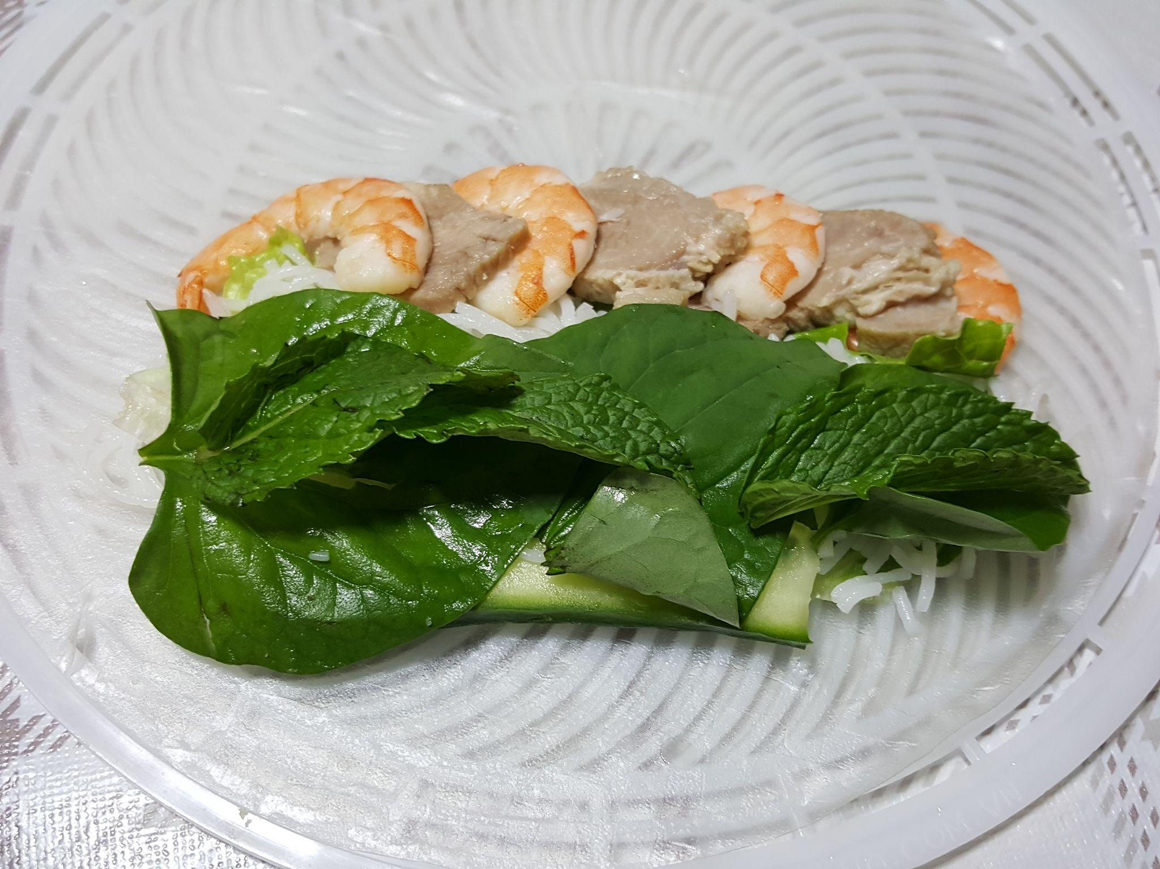

1. **To wrap it all up**, fold the sides inwards. Fold the bottom side upwards, covering the filling. Roll the sheet forward while curling your fingers inwards. This holds the filling in place, keeping it intact.
2. Repeat steps 2-6 to make more spring rolls after you have finished eating the one you have just made.

**Dip and enjoy!**

**Tip**: After finishing rolling your spring roll, do not start to make another. Roll it then eat it immediately. If not, the rice paper sheet will dry up, making it have a weird texture.

Parent signature: _________

Buddy check: _________