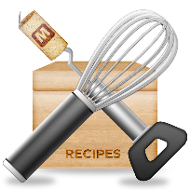 **EASY BREEZY BROWNIE RECIPE**

This writer is not liable for injuries or damage caused to appliances or casualties (i.e. grease fires, food poisoning, intruders that are lured by the smell of brownies, etc…).

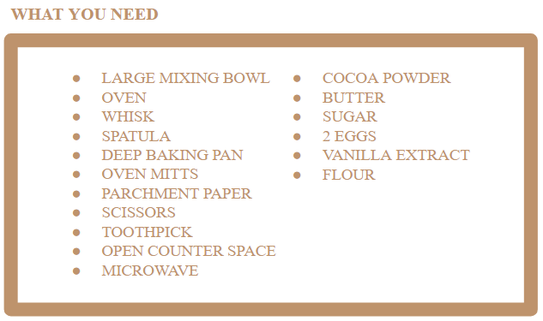

**GOAL:** To make a tasty treat for the whole family to enjoy!

**MAKES:** 15-20 brownies

**CALORIES:** 115 (per brownie)

**READY IN:** 30-45 minutes

**CAUTION:** Put loose hair up. Take off dangling necklaces, drawstrings, etc…

1. First, lay out all the constituents on your counter.
2. Next, add ½ a cup of butter into the large mixing bowl. Heat it up in the microwave until fully melted.
3. Subsequently, add 2 tsp of vanilla extract into the mixing bowl with the butter.
4. Mix the ingredients thoroughly with your whisk after adding each new ingredient.
5. Now, crack both eggs into the mixing bowl. Ensure there are no egg shells inside the bowl. If so, carefully extract them with immaculately clean hands.
6. Then, add 1 cup of sugar to the mixing bowl along with ⅓ a cup of cocoa powder.
7. After that, add ½ a cup of flour to your concoction.

**OPTIONAL:** Add ½ a cup of Chipits chips into your batter for a unique and original flavour!

1. Once your batter is thoroughly mixed, preheat your oven to 350°F or 180°C.
2. While it heats up, cut, fit and place a piece of parchment paper in the baking pan.
3. Once your pan is lined with parchment paper, slowly pour your batter into the pan, making sure to scrape all the batter out of the bowl using a spatula.
4. After that, even out your batter. Now, wait for your oven to heat up.
5. Once your oven is ready, place the pan in the oven. Make sure to wear oven mitts while doing so, to ensure that you do not get burned.
6. Let them bake for 20 minutes.
7. Take the brownies out of the oven (use oven mitts). Place them on a flat surface. Make sure you don’t put them on a counter that isn’t heat-resistant.

**TIP:** Poke the brownies with a toothpick. If the toothpick emerges with batter on it, they need to be baked for an additional 5-10 minutes.

1. Finally, let the brownies cool for 15-20 minutes. Then take the brownie out of the pan. The parchment paper should ensure a smooth removal. Cut it into small portions.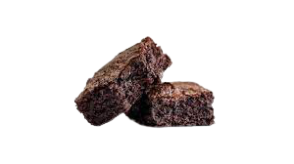

**ENJOY!**

**This recipe is sponsored by because you can never go wrong with some good old fashioned chocolate chips!**

