RECIPE

Making a Terrific  
Tiramisu

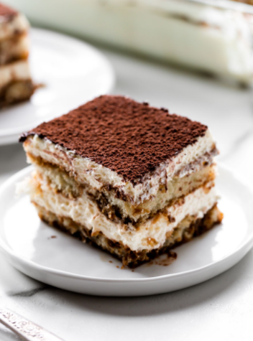

**Ready in**: **8-10 hours**

**Serves**: **10 people**

**Calories**: **600 calories**

**Goal**:  **To make a delicious dessert for family and coffee lovers!**

# Ingredients / Equipment:

* 2 cups of Strong Coffee
* 2/3 cups of Sugar
* 6 Egg Yolks
* 2 cups Heavy Cream
* 2 tsp Vanilla Extract
* 16 oz. (450 g) Mascarpone Cheese
* 2 packs Ladyfinger Cookies
* 1/3 cup of Cocoa Powder
* Hand Mixer/Stand Mixer/Whisk
* Medium Saucepan
* 3 medium sized bowls (Bowl #1, Bowl #2, Bowl #3)
* Sift
* A Baking Dish
* A Paper Towel
* Fridge
* Stove
* Plastic Wrap

# Preparation:

**Custard:**

1. Whisk sugar and eggs together in bowl #1, until combined.
2. Turn stove, on medium heat, and put saucepan on the hot stove.
3. Pour egg-sugar mixture into the saucepan and whisk the mixture CONSTANTLY, until sugar is dissolved, it has thickened, and is a light yellow hue.
4. Turn off the stove and let the mixture cool.
5. Set aside for later.

**Mascarpone Cream:**

1. Cream together the heavy cream and vanilla extract, in bowl #2, until stiff peaks form. Use the hand mixer, stand mixer, or whisk for this.
2. Whisk the mascarpone cheese by itself for a few seconds in bowl #3.
3. Add custard into mascarpone cheese and mix.

9**.** Fold the whipped cream into

the custard until incorporated.

**Assembling:**

10**.** Dip lady-finger cookies, one at a time, into the strong coffee for a second on each side.

11**.** Place the dipped finger into the

bottom of the baking dish

(number of cookies may vary

depending on the dish).

12**.** Repeat until the bottom of the

baking dish is covered in a neat layer of cookies.

13**.** Then **append** ½ of the

mascarpone cream on top of

the cookies and spread evenly.

14**.** Repeat steps 11-14 until the

baking dish is about fully

covered to the top.

15**.** Put cocoa powder into sift, and sift cocoa powder lightly on top of the tiramisu.

16**.** **Envelop** the top of the baking

dish with plastic wrap.

17**.**  Keep in the fridge for at least

8-10 hours (longer would be

best), or until the dessert has

set.

18. ENJOY!!

**Tips:**

* **Don’t overmix heavy cream and vanilla extract or else it’ll turn into butter (Step 6).**
* **Better to use stand mixer or hand mixer for this recipe.**