**Make an Astounding Orange Juice!**

**Goal:** A classic, nostalgic refreshment for the whole family to enjoy.

|  |  |
| --- | --- |
| **Ingredients** | **Equipment** |
| * 295 mL Minute Maid frozen canned orange juice * 3 medium sized oranges * 5L warm water * 200g granulated white sugar * ½ tbsp. honey | * Large pot * Kitchen knife * Cutting Board * Blender * Measuring cup * Wooden spoon * 3 large 2L jugs or bottles |

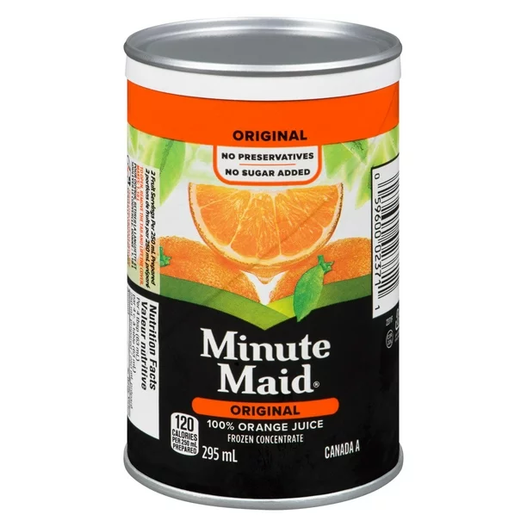

**MAKES:** 6 litres of orange juice **PREP TIME:** ~15 mins

**SHELF LIFE:** 1-2 weeks

**TIP:** Don’t forget to wash your hands!

**Instructions:**

1. Start by thawing out your canned orange juice. Run under hot water to help loosen it from the can. Open your can by prying the metal top apart with a spoon (the water should have softened the paper can, making it easier.) Pour this inside your pot, and set aside.
2. Wash your oranges- rinse under warm tap water one at a time, rubbing gently with your hands.
3. Use a knife and cutting board to cut your oranges into quarters, small enough to fit in your blender so it blends well. Make sure to peel away the orange skin.
4. 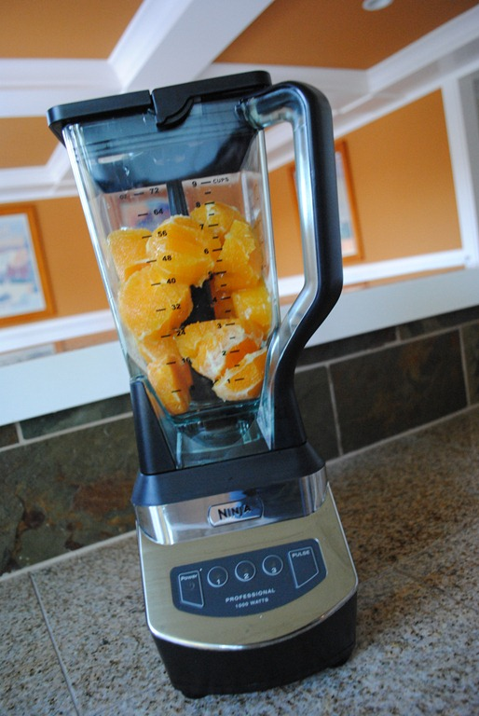Next, place your oranges into a blender. Measure and add 3 litres of water into the blender as well. This helps blend the oranges more smoothly. Blend in intervals of 5 seconds until it turns into a juice.

**Optional:** Strain out the pulp if desired - this will give your drink a smoother and less lumpy and viscous texture.

1. When your canned orange juice is completely liquid and thawed, making sure not to spill anything, combine your blended orange mix into your canned orange juice inside the pot.
2. Once combined, stir in an additional 2 litres of warm water. Mix well.
3. After it’s completely mixed, add in the sugar. You may lessen the amount according to your taste if desired.
4. Gradually coalesce the sugar into the pot with the orange juice mixture - pouring all the sugar in at once might make it solidify and create sugar lumps within your drink.
5. Then, squeeze in your honey - adjust according to your own preferences.
6. Stir until any remaining clusters of sugar or honey dissolve.
7. After that, divide your orange juice into three separate jugs or bottles, and store in the fridge. If your jugs or bottles are not large enough to hold all the juice, divide into smaller containers.
8. Proceed to store in a refrigerator for an hour.
9. Finally, pour into a glass, enjoy it with ice and serve your delectable orange drink to friends and family.

**Super Savvy Secrets:**

* Using multiple types of oranges may result in a bolder, unique taste and colour.
* Store in a refrigerator - leaving it out in open air will make it spoil and go bad.
* The mix of both store bought and natural orange juice gives it a refreshing organic flavour, without losing the classic store bought juice taste.
* It’s scientifically proven that 10 out of 10 people will absolutely adore this drink!

