**Making Fancy French Toast**

**You will need:**

4 pieces of bread Cinnamon

Mixing bowl Butter

An electric griddle Counter space

5 dinner plates Vanilla extract

A tablespoon of sugar Maple syrup

A teaspoon of salt Icing sugar

1 large egg ½ cup of milk

**Goal:** To create a heartfelt breakfast for the family.

**Serves:** Four people **Prep time:** 15 min

1. Take out the ingredients. Place on counter in a way that you can see all of them.
2. Take out a clean bowl, plate and griddle. Plug in the griddle.
3. In the bowl mix 1 egg and ½ cup of milk. Whisk them for 30 seconds.
4. Add one tablespoon of sugar to the amalgam (mix). Whisk for 10 seconds.
5. Infuse 1 teaspoon of salt into your mixture. Whisk for 5 seconds.
6. Add a pinch of cinnamon. Keep whisking until you see no clumps of cinnamon.
7. Turn on the griddle to medium heat.
8. Lather butter on the griddle. It should bubble right away.
9. Dip the bread in your concoction. ***SOAK FOR A COUPLE OF SECONDS***.
10. Put bread on the griddle.
11. Repeat steps #9 & #10 four times with new piece of bread.
12. After all bread is on the griddle, give it two minutes. Flip & repeat till golden brown.
13. Take off the griddle put on one plate to sit. Do not forget to turn off your griddle.
14. While it sits, grab four dishes and plate the food.
15. Put a dollop of butter on the French toast.
16. Drizzle maple syrup on your meal.
17. Sprinkle with icing sugar.
18. Clean up.

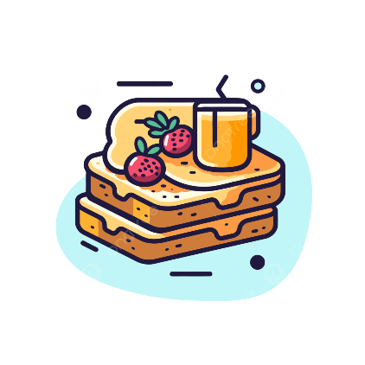

**Voilá.** Enjoy your French toast.