**Shoelace Necklaces - Step by Step**

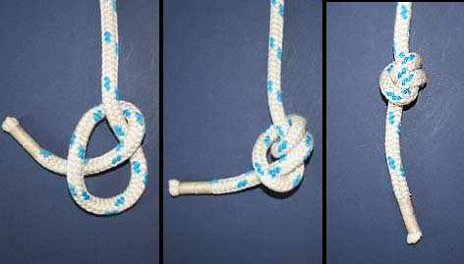**Goal**: Make a **plaited** necklace to show off to your friends.

**Materials**

* 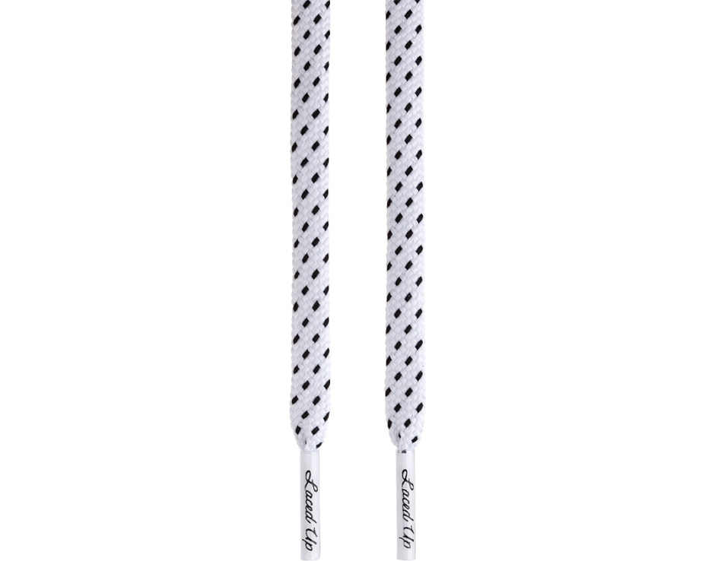Three shoelaces, 90 centimeters each (does not matter what colour, round shoelaces work better).
* 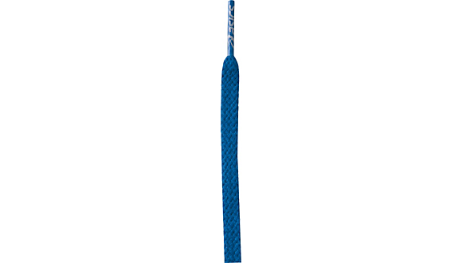Anything sturdy that you can fit your hand through
* A ten centimeter long flat rock

**Steps**

1. Double knot the ends of the three laces to the **robust** object, approximately .5 centimeters apart.
2. Braid the shoelaces by taking the lace on the left and placing it over top of the lace in the middle. The left lace is now in the middle.
3. 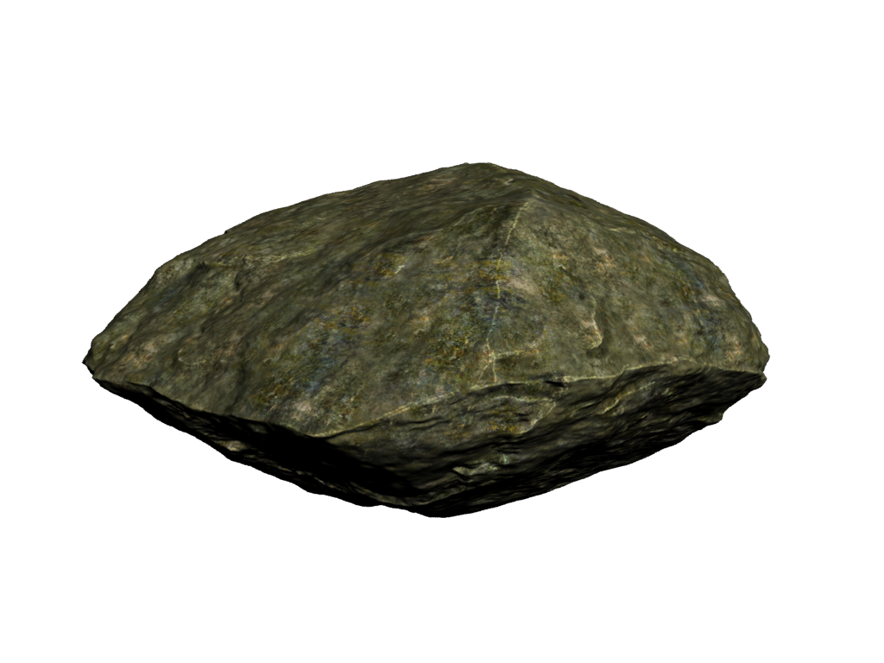Take the lace on the right and place it over the middle lace, pulling the middle lace to your right.

**Aglets**

1. Repeat step two then three until there are three centimeters of space left at the ends.
2. Weigh the aglets of the laces down with the rock, on a flat surface, so the rock is covering the ends.

A goes over B. C goes over A. B goes over C. A goes over B. C goes over A. B goes over C. Repeat after every three transformations. Pull the laces tight so there are no gaps.

1. 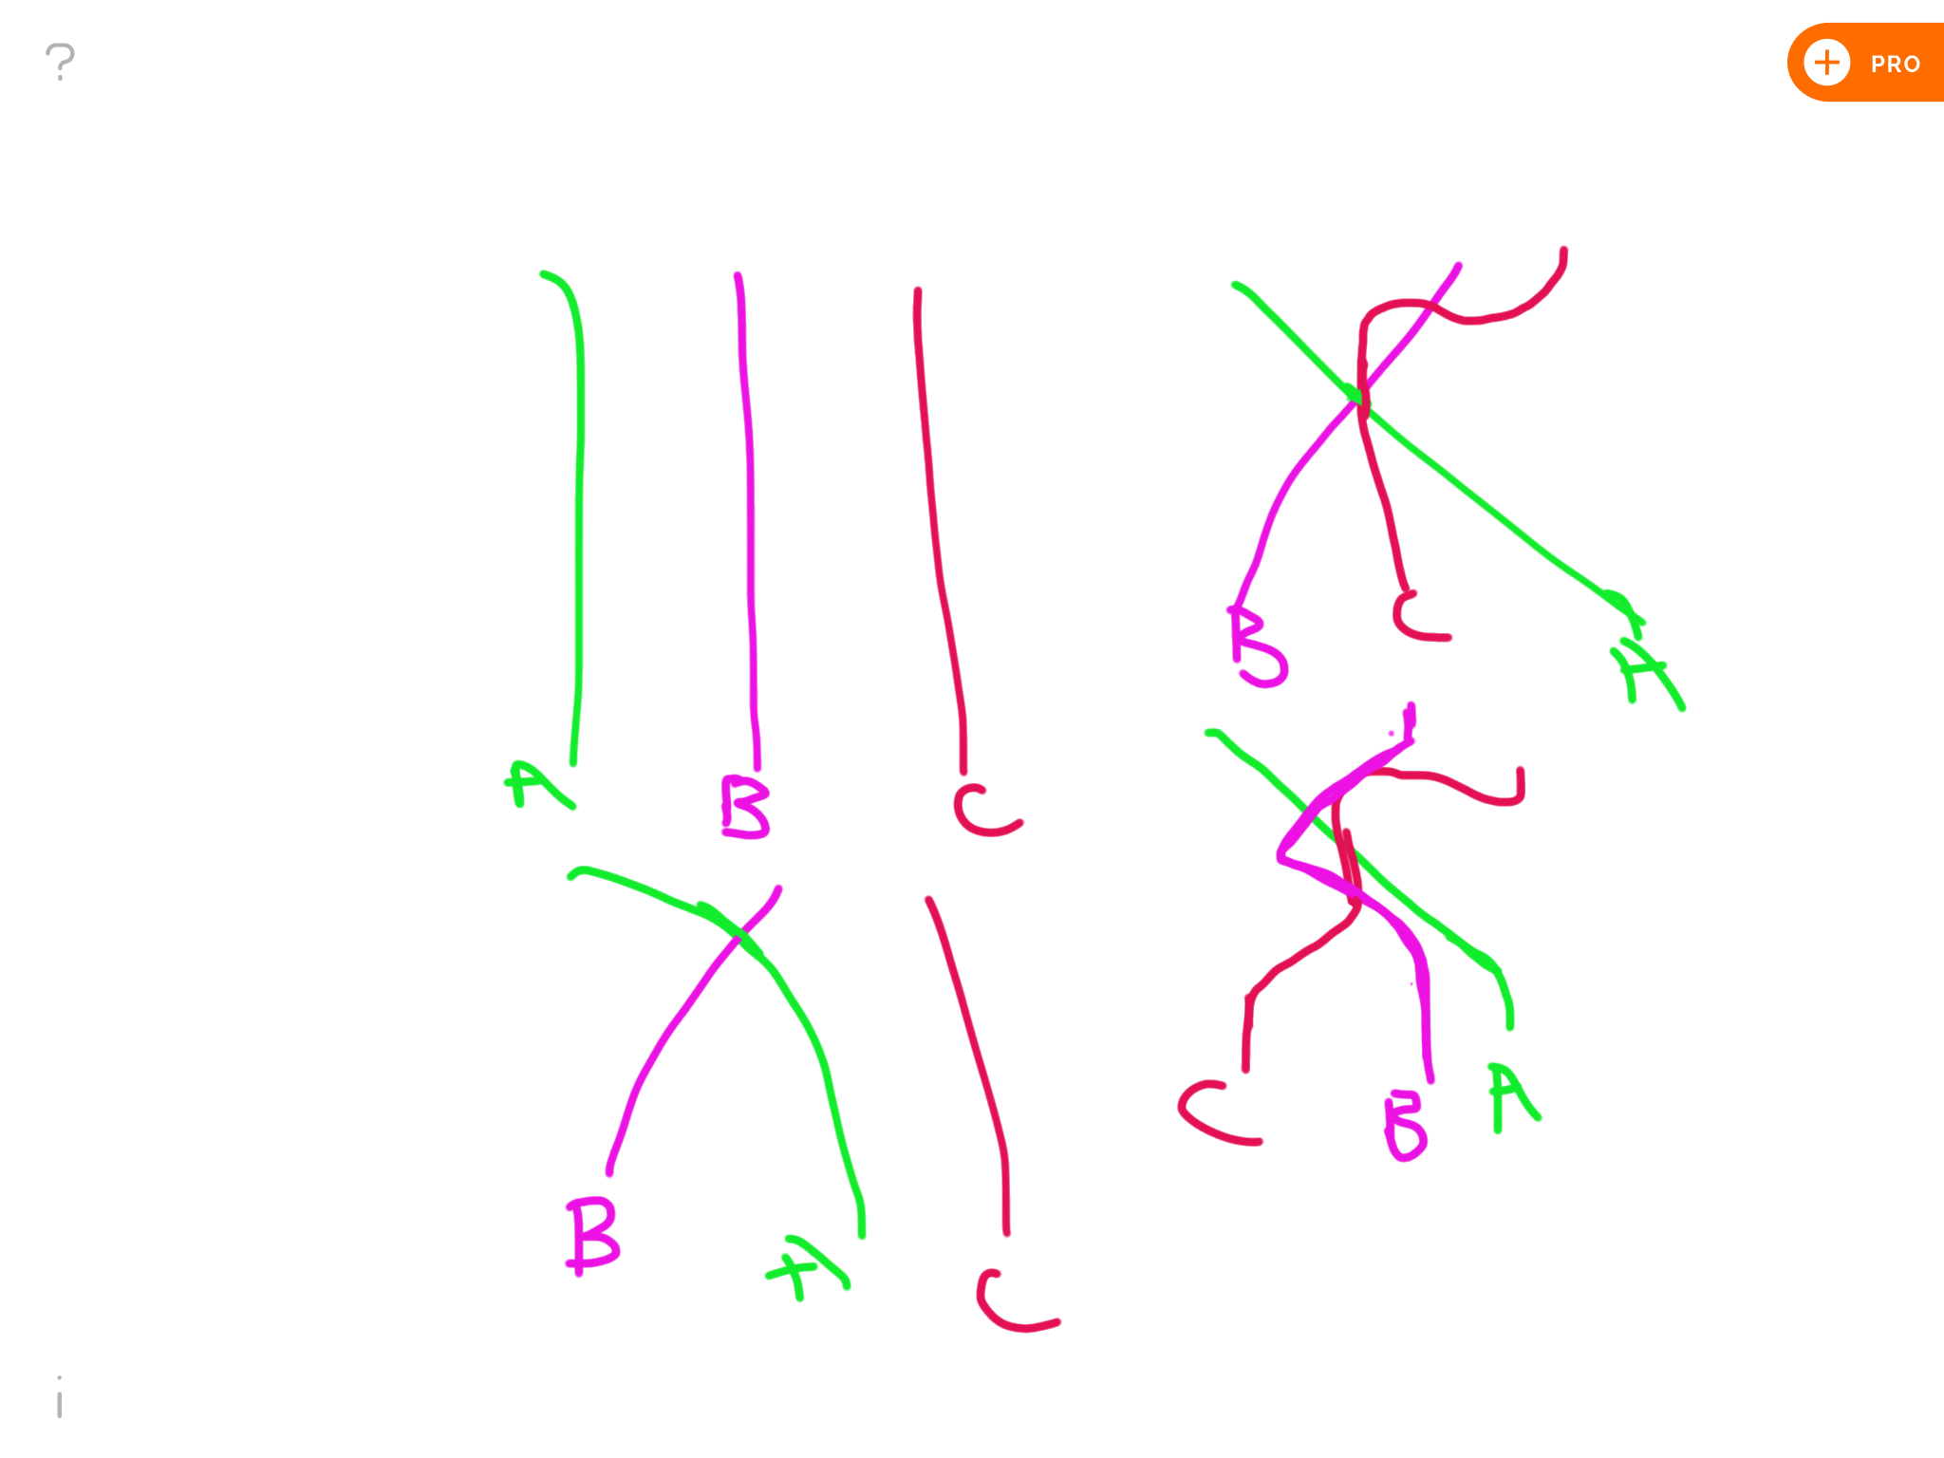Carefully untie the ends that are attached to the sturdy article.
2. Hold the ends that were tied in one hand.
3. Cautiously take the rock off of the other side.
4. Grab the non-braided ends in your unoccupied hand.
5. Tie each end together so you have three double knots.

**Conclusion:** Now you have a really **phat** necklace that won’t get caught on your hair and will fit over your head anytime!