**Making Banana Strawberry Smoothies with Friends**

**Goal:** Being social and having fun in kitchen!

**Items:**

|  |  |
| --- | --- |
| * A blender | * 2 cups of crushed ice |
| * 1 banana | * Whipped cream |
| * 2 cups of strawberries | * ~15 minutes of your time |
| * 1 cup of Greek yogurt | * A craving for treats |

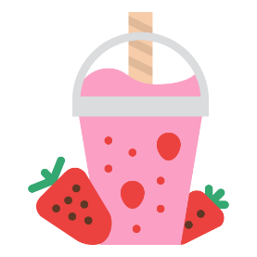 **Instructions:**

1. Take out an electric blender. Place it on the kitchen counter. Remove the blender lid.
2. Pick a ripe banana and place beside the bowl.
3. Get the strawberries from the fridge and wash them well.
4. Peel the banana. Cut it into small pieces into the bowl. Rinse with cold water.
5. Cut the strawberries into halves. Place them gently in the bowl.
6. Measure 1 cup of Greek yogurt. Add it to the minced fruit.
7. Blend the ingredients with the blender until smooth.
8. Get ice cubes from the freezer. Crush them well. Add 2 cups worth to the mixture.
9. Make sure the lid is on the blender. Blend until it’s smooth with no lumps.
10. Pour the smoothie into glasses for a confidante and yourself.
11. Add as much whipped cream as you like.
12. Serve with a straw.
13. Sit down, put your feet up and relax. Now enjoy this delicious smoothie.

**Warning**: This drink is highly addictive!