FIRST IMPRESSIONS

Flag

Waving

Red hair bow

Town mayor

Motorcycle

A camp

A star

Bread

FIRST IMPRESSIONS
 Flag 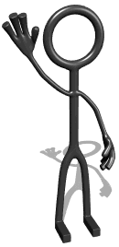Waving

 Red hair bow 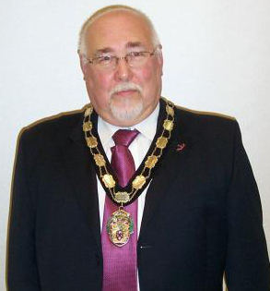 Town mayor

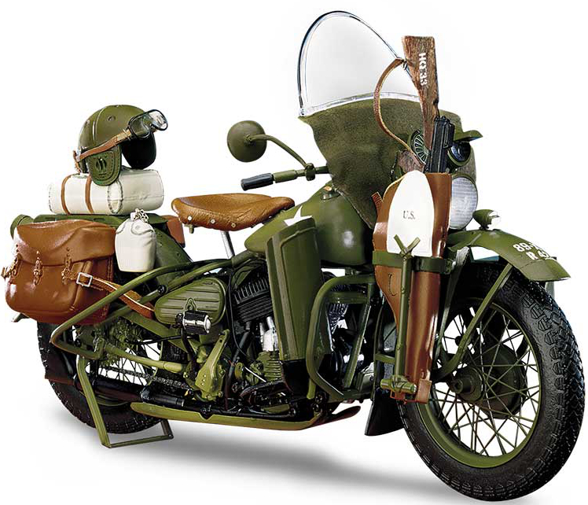Motorcycle  A camp

A star 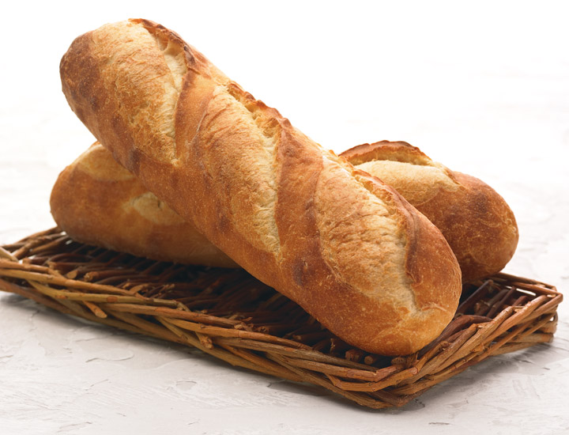 Bread

Response Poems to “Rose Blanche”

Rose Blanche
Electric wire fence, angry.
Sharp thorns, sharper than knives.
Scared soldiers, disgusted by Hitler.
Spiked branches, defiant.
Tree stumps, no longer full of life.

Bedraggled flowers, pitying them.
Then curling up, frightened.
Trees glancing, shocked.
Grass looking away.
Snow melting,
Each drop like a tear.
Rose Blanche
Death, Death, Death
Followed her.
Melting snow taking time
Soldiers in the distances
Please go away!
Trees warn her
This is not where you should stay.

Is this how it should be
A lifeless forest
A stump that can’t grow because of
What surrounds it?
I wonder what more I could face
Could l face such a terrible place?

