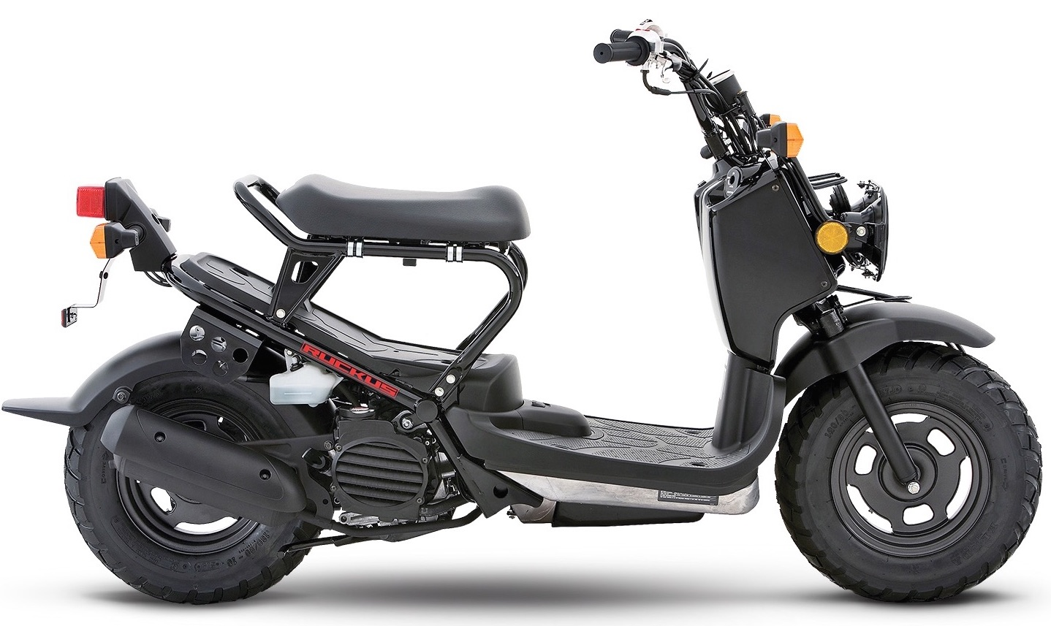 SIMILES – A comparison using LIKE or AS
A simile is a figure of speech that compares two things that are alike in some way
- “cute as a kitten” comparing the way someone looks to the way a kitten looks

- “as busy as a bee” comparing someone’s level of energy to a fast-flying bee

- "as happy as a clam" comparing someone's happiness to the contentment of a clam

- "Life is like a box of chocolates, you never know what you're going to get." comparing the uncertainty of life to the uncertainty of choosing a certain chocolate

- "as agile as a monkey" implying someone can move as well as a monkey does

Similes Add Depth to Language
Similes can make our language more descriptive and enjoyable. Writers, poets and songwriters use similes to emphasize what they are trying to convey. Similes can be funny, serious, mean, or creative. Eg. -
- You were as brave as a lion.

- They fought like cats and dogs.

- He is as funny as a barrel of monkeys.

- This house is as clean as a whistle.

- He is as strong as an ox.

- Your explanation is as clear as mud.

- Watching the show was like watching grass grow.

- Don’t just sit there like a bump on a log.

- They are as different as night and day.

- She is as thin as a toothpick.

- Last night, I slept like a log.

- They wore jeans, which made me stand out like a sore thumb.

- My love for you is as deep as the ocean.

- I am so thirsty, that my throat is as dry as a bone.

- As common as dirt - As light as a feather
- As tall as a giraffe - As tough as nails
- As sweet as sugar

- Ricky ran as fast as ______________________________________.

- The road is slippery like ____________________________________.

Create 3 – 5 similes of your own.

