SLOGAN ANSWER SHEET

1. NIKE - Just Do It.
2. SUBWAY - Eat Fresh.
3. EA Sports - It’s in the Game.
4. HMV - His Master’s Voice.
5. APPLE - Think Different.
6. DISNEY - The Happiest Place on Earth.
7. MCDONALD’S - I’m Lovin’ It.
8. NERF - It’s ____ or Nothin’!
9. PLAYSTATION - Play Has No Limits.
10. COCA-COLA - Taste the Feeling.
11. ADIDAS - Impossible is nothing.
12. KFC - It’s Finger Lickin’ Good.
13. POKÉMON - Gotta Catch 'Em All!
14. YOUTUBE - Broadcast Yourself.
15. THE HUDSON’S BAY COMPANY - Pro Pelle Cutem
16. AMAZON - Work Hard. Have Fun. Make History.
17. SKITTLES - Taste the Rainbow.
18. CANADA POST - Delivering a stronger Canada.
19. LEGO - Play On.
20. M&Ms - Melts in Your Mouth, Not in Your Hands.
21. RICE KRISPIES - Snap! Crackle! Pop!
22. NINTENDO - Now you're playing with power.
23. TIM HORTONS - Always Fresh.
24. XBOX - Jump In.
25. OREO - Milk’s Favorite Cookie.
26. UNDER ARMOUR - Protect This House.
27. WALMART - Save Money. Live Better.
28. BURGER KING - Have It Your Way.
29. BARBIE - You Can Be Anything.
30. CANADIAN TIRE - Canada’s Store.
31. MINECRAFT - Build. Play. Explore.
32. SCOTIABANK - You’re richer than you think.
33. ENERGIZER - It keeps going, and going, and going.
34. KITKAT - Have a break. Have a ______.
 | 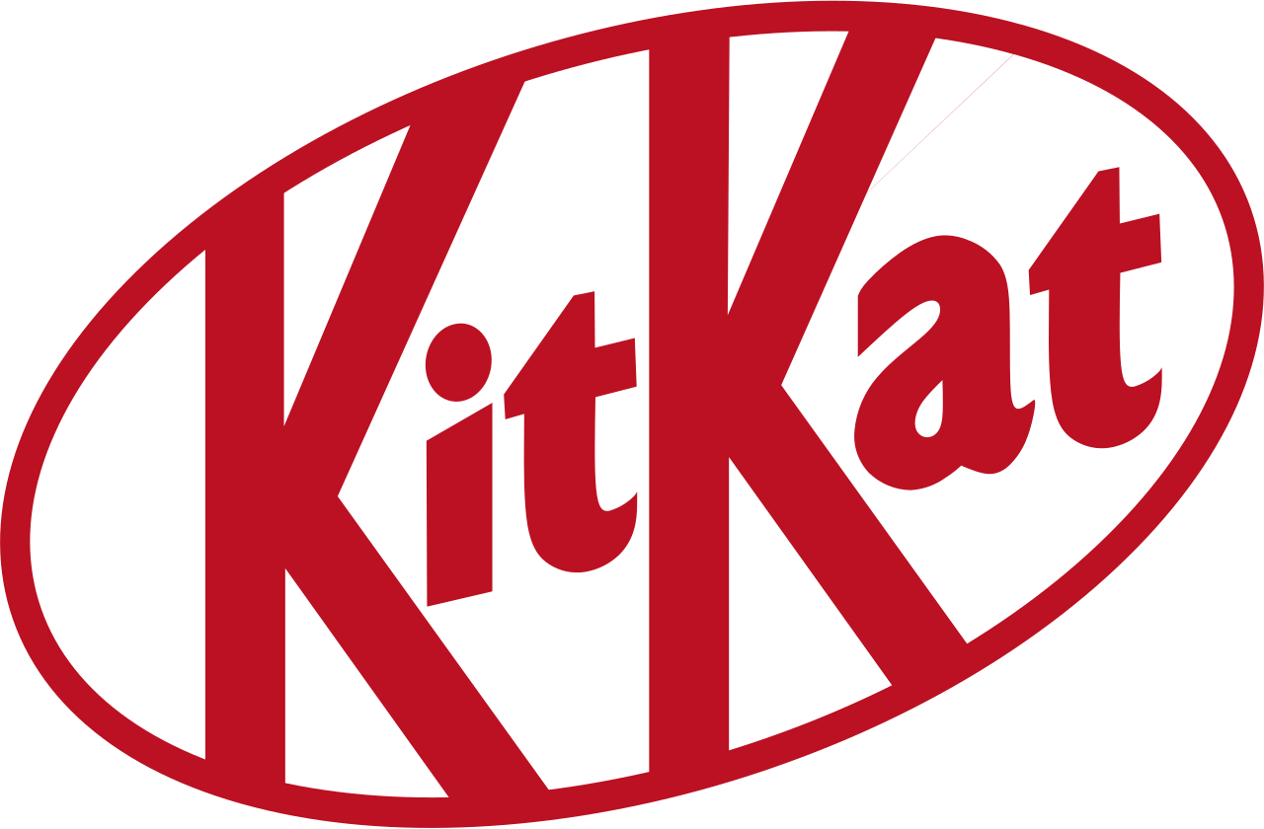
 | 
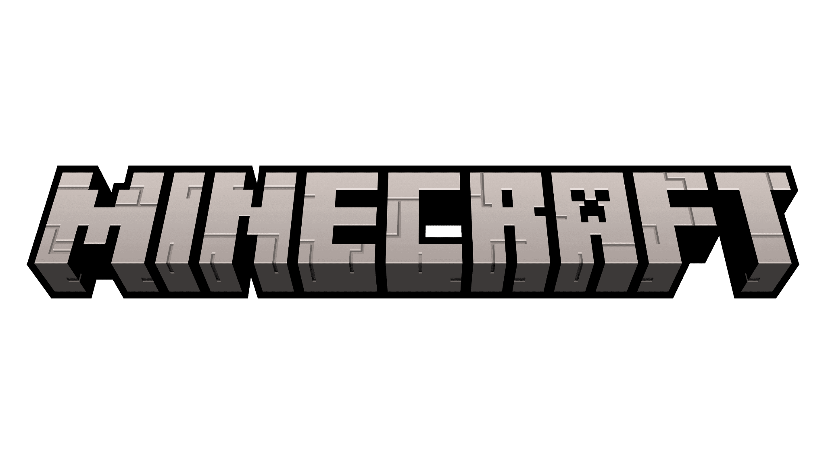 | 
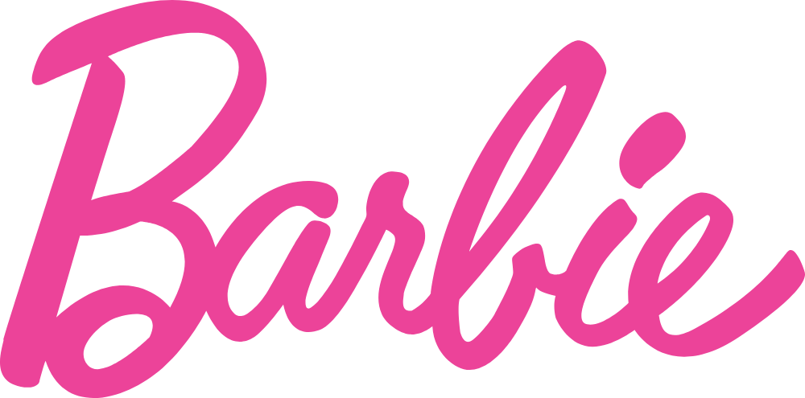 | 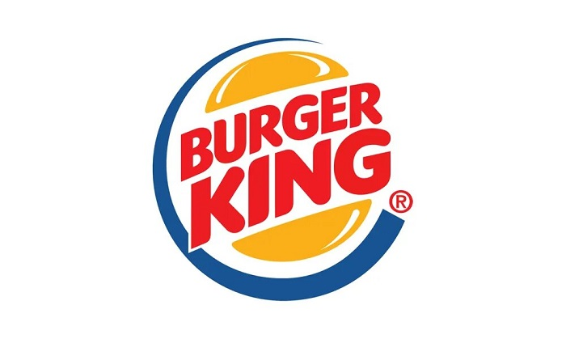
 | 
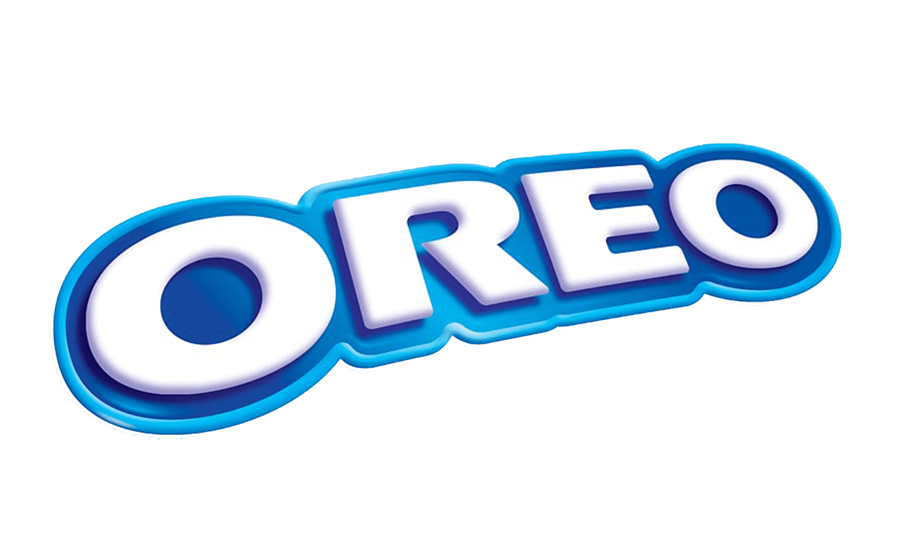 | 
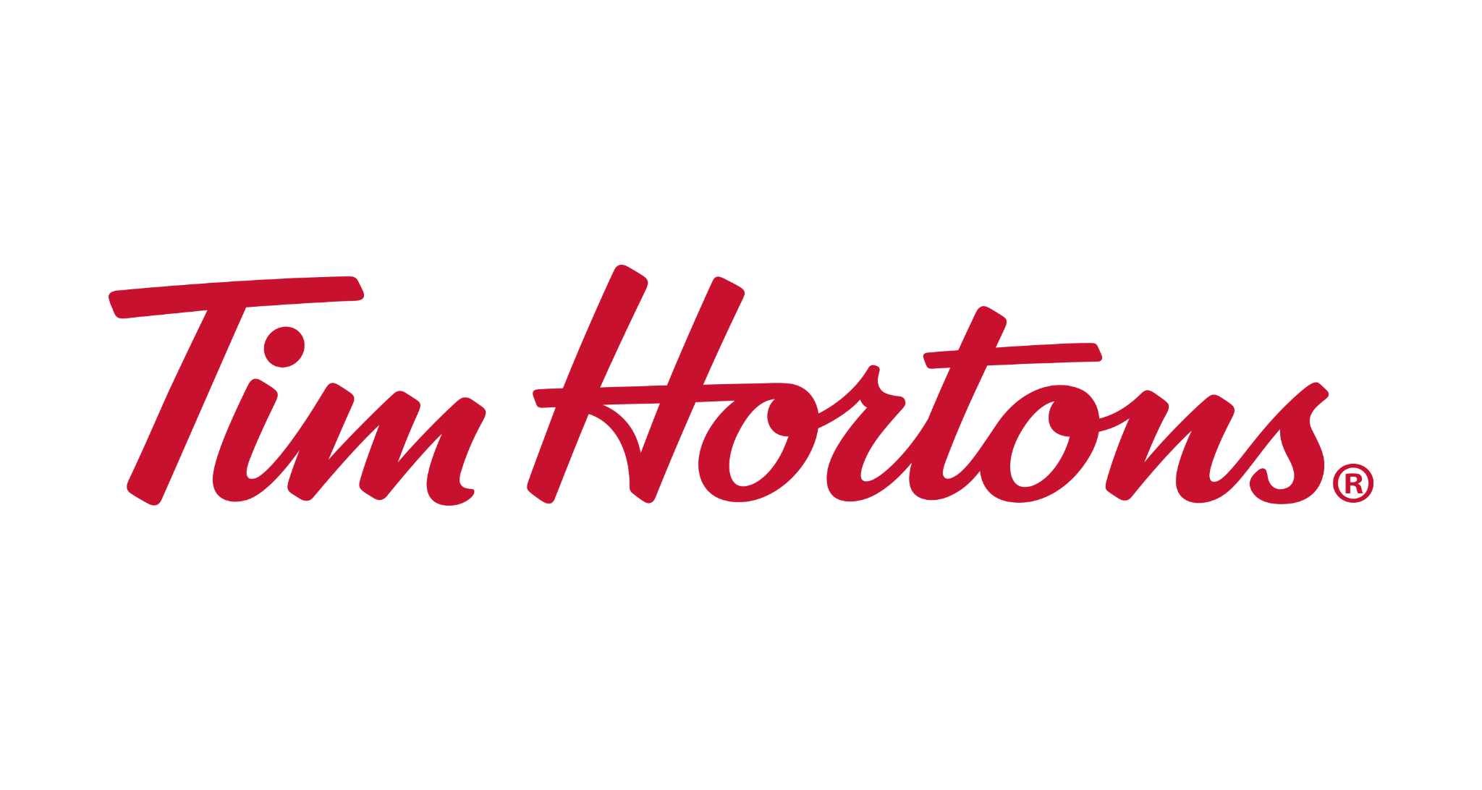 | 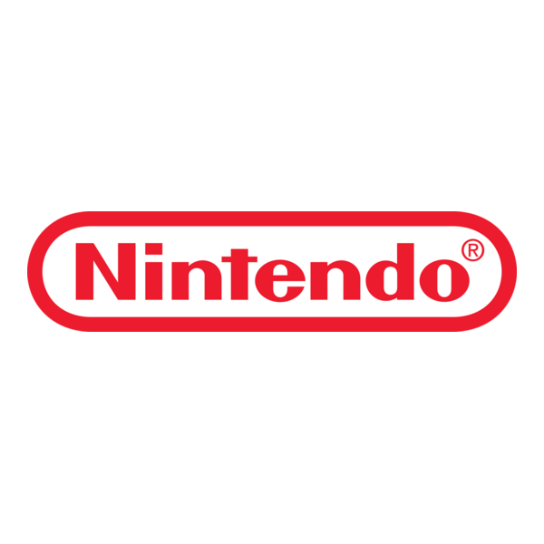
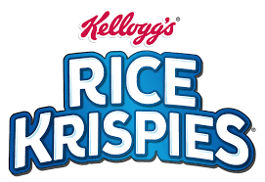 | 

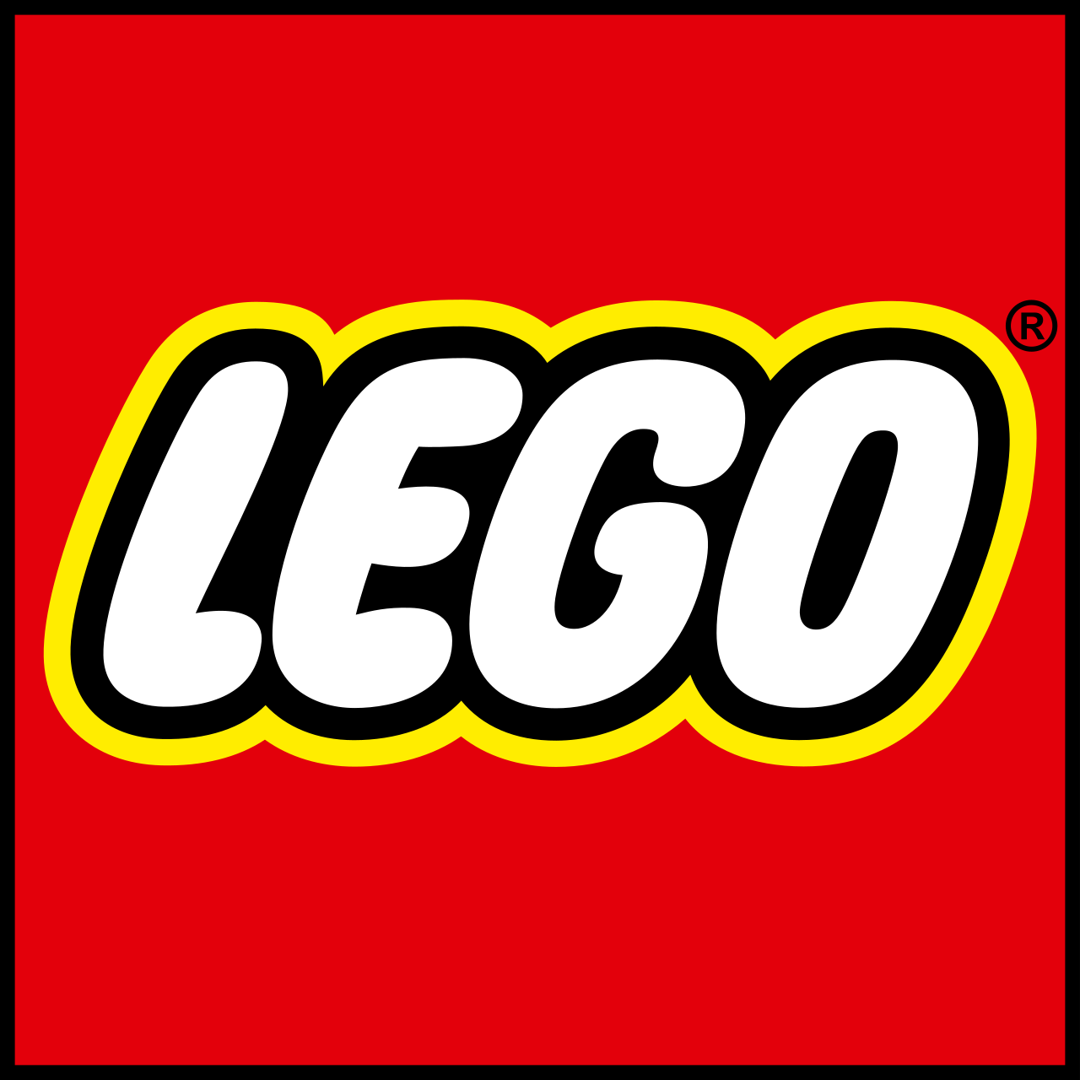 | 
 | 
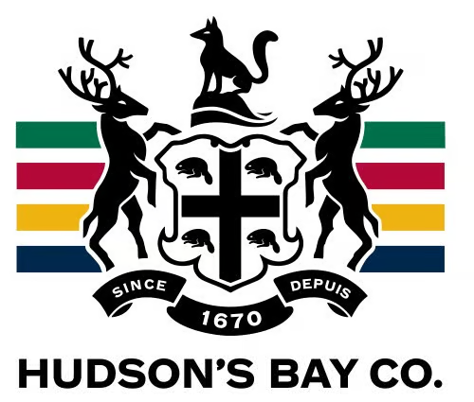 | 
 | 
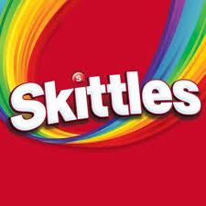 | 
 | 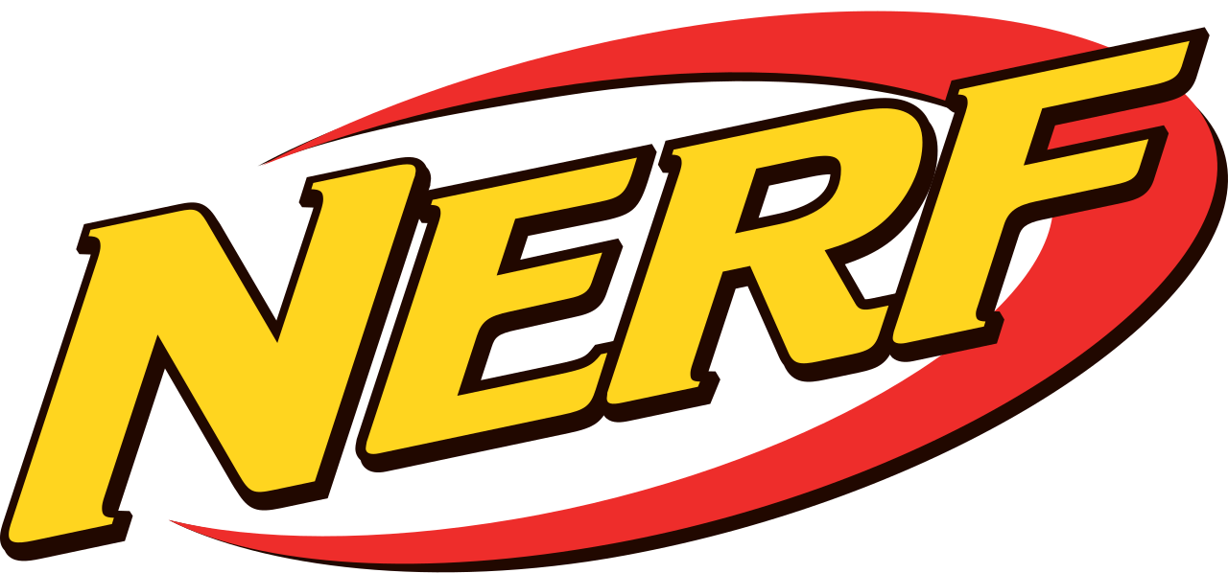
 | 
 | 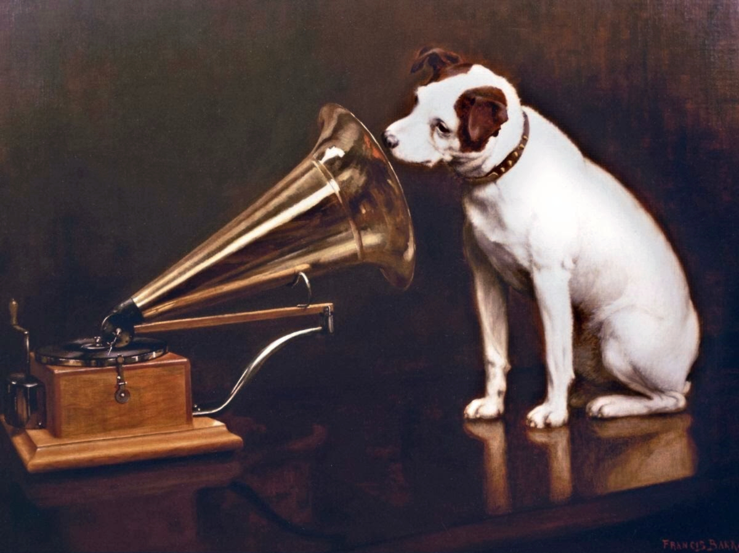
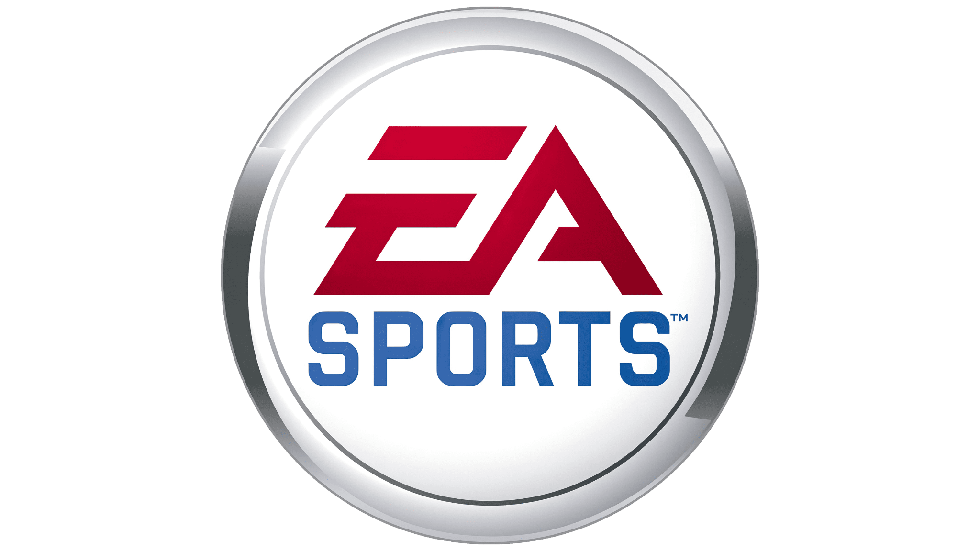 | 

Play On. | It’s ____ or Nothin’!
Think Different. | Snap! Crackle! Pop!
It keeps going, and going, and going. | Work Hard. Have Fun. Make History.
Play Has No Limits. | Just Do It.
It’s in the Game. | Canada’s Store.
Eat Fresh. | Taste the Feeling.
Protect This House. | His Master’s Voice.
Taste the Rainbow. | Broadcast Yourself.
Milk’s Favorite Cookie. | Save Money. Live Better.
Melts in Your Mouth, Not in Your Hands. | The Happiest Place on Earth.
I’m Lovin’ It. | Now you're playing with power.
It’s Finger Lickin’ Good. | Gotta Catch 'Em All!
Build. Play. Explore. | Impossible is Nothing.
You’re richer than you think. | Have It Your Way.
Delivering a stronger Canada. | You Can Be Anything.
Always Fresh. | Have a break. Have a ______.

Jump In. | Pro Pelle Cutem.

