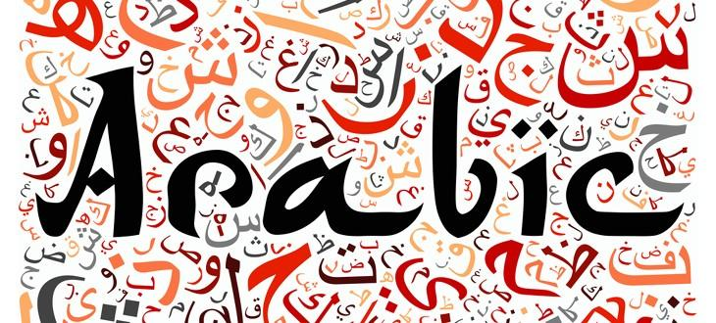

**SPELLING WORDS**

|  |  |  |
| --- | --- | --- |
| 1. cotton | 8. giraffe | 15. elixir |
| 2. adobe | 9. monsoon | 16. mosque |
| 3. henna | 10. algebra | 17. sequin |
| 4. lilac | 11. tariff | 18. ghoul |
| 5. crimson | 12. saffron | 19. alchemy |
| 6. safari | 13. azure | 20. serendipity |
| 7. hazard | 14. carafe |  |

**ARABIC WORDSEARCH**

|  |  |  |  |  |  |  |  |  |  |  |  |  |  |  |  |  |
| --- | --- | --- | --- | --- | --- | --- | --- | --- | --- | --- | --- | --- | --- | --- | --- | --- |
| **G** | **W** | **A** | **B** | **T** | **I** | **E** | **O** | **Z** | **S** | **A** | **F** | **A** | **R** | **I** | **C** | **J** |
| **M** | **Y** | **S** | **A** | **F** | **F** | **R** | **O** | **N** | **M** | **I** | **D** | **Q** | **P** | **T** | **N** | **K** |
| **I** | **E** | **R** | **U** | **Z** | **A** | **H** | **S** | **T** | **E** | **O** | **D** | **C** | **G** | **C** | **O** | **E** |
| **R** | **I** | **C** | **R** | **E** | **O** | **P** | **O** | **H** | **E** | **N** | **N** | **A** | **S** | **O** | **L** | **N** |
| **O** | **L** | **U** | **Q** | **D** | **A** | **I** | **U** | **T** | **U** | **P** | **I** | **S** | **K** | **T** | **L** | **I** |
| **I** | **J** | **E** | **L** | **U** | **O** | **H** | **G** | **L** | **Z** | **C** | **T** | **A** | **O** | **T** | **R** | **U** |
| **S** | **E** | **R** | **E** | **N** | **D** | **I** | **P** | **I** | **T** | **Y** | **R** | **D** | **F** | **O** | **U** | **Q** |
| **A** | **Y** | **S** | **C** | **O** | **L** | **E** | **Z** | **E** | **O** | **M** | **W** | **I** | **T** | **N** | **N** | **E** |
| **B** | **F** | **V** | **A** | **N** | **E** | **Y** | **A** | **D** | **S** | **E** | **Y** | **C** | **M** | **I** | **E** | **S** |
| **E** | **F** | **O** | **L** | **B** | **J** | **O** | **G** | **U** | **N** | **H** | **K** | **P** | **O** | **S** | **Z** | **V** |
| **R** | **I** | **X** | **I** | **L** | **E** | **D** | **I** | **E** | **A** | **C** | **Q** | **W** | **S** | **B** | **O** | **L** |
| **A** | **R** | **I** | **L** | **T** | **G** | **M** | **R** | **T** | **I** | **L** | **U** | **E** | **Q** | **A** | **E** | **N** |
| **I** | **A** | **L** | **G** | **E** | **B** | **R** | **A** | **L** | **G** | **A** | **E** | **O** | **U** | **T** | **B** | **O** |
| **A** | **T** | **A** | **U** | **O** | **C** | **Z** | **F** | **P** | **A** | **D** | **C** | **A** | **E** | **P** | **O** | **U** |
| **N** | **U** | **W** | **C** | **A** | **R** | **A** | **F** | **E** | **T** | **R** | **O** | **M** | **A** | **Q** | **D** | **K** |
| **E** | **R** | **C** | **V** | **B** | **A** | **I** | **E** | **O** | **B** | **I** | **D** | **R** | **A** | **Z** | **A** | **H** |

