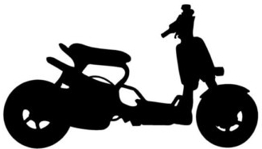 FASTENERS SPELLING TEST

1. fasteners | 8. glue | 15. screws
2. bungee cords | 9. laces | 16. staples
3. buttons | 10. latches | 17. stitches
4. chains | 11. magnets | 18. ratchet
5. cinch straps | 12. prongs | 19. velcro
6. buckles | 13. rivets | 20. zippers
7. elastic bands | 14. safety pins

