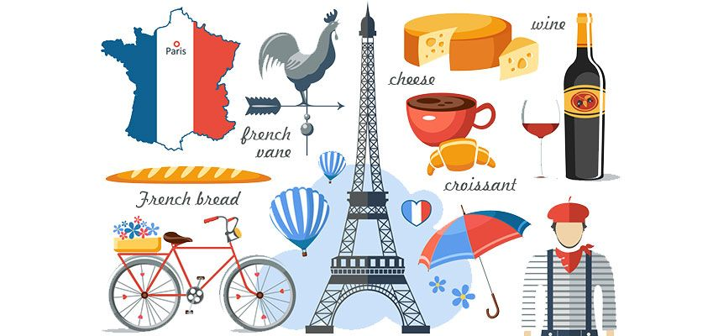

**FRENCH SPELLING WORDS**

|  |  |  |
| --- | --- | --- |
| 1. bureaucracy | 8. finesse | 15. rapport |
| 2. camouflage | 9. foyer | 16. rendezvous |
| 3. chassis | 10. fuselage | 17. repertoire |
| 4. croissant | 11. impasse | 18. souvenir |
| 5. debacle | 12. mystique | 19. surveillance |
| 6. entourage | 13. physique | 20. vogue |
| 7. fatigue | 14. quiche |  |

Load image into Gallery viewer, French Flag Cutout Party Accessory (1 count)
 **FRENCH WORDSEARCH**

|  |  |  |  |  |  |  |  |  |  |  |  |  |  |  |  |  |
| --- | --- | --- | --- | --- | --- | --- | --- | --- | --- | --- | --- | --- | --- | --- | --- | --- |
| **A** | **V** | **C** | **M** | **R** | **O** | **I** | **T** | **S** | **O** | **U** | **V** | **E** | **N** | **I** | **R** | **P** |
| **Y** | **R** | **O** | **Z** | **C** | **R** | **E** | **N** | **D** | **E** | **Z** | **V** | **O** | **U** | **S** | **H** | **R** |
| **J** | **A** | **Q** | **G** | **Z** | **I** | **K** | **C** | **A** | **M** | **O** | **U** | **F** | **L** | **A** | **G** | **E** |
| **F** | **P** | **X** | **K** | **U** | **V** | **F** | **H** | **R** | **Z** | **S** | **D** | **G** | **U** | **E** | **V** | **P** |
| **U** | **P** | **J** | **I** | **N** | **E** | **R** | **A** | **U** | **O** | **F** | **O** | **Y** | **E** | **R** | **K** | **E** |
| **S** | **O** | **V** | **I** | **M** | **P** | **A** | **S** | **S** | **E** | **I** | **K** | **M** | **D** | **G** | **L** | **R** |
| **E** | **R** | **W** | **V** | **Y** | **S** | **Q** | **S** | **J** | **Q** | **N** | **S** | **C** | **E** | **T** | **O** | **T** |
| **L** | **T** | **L** | **F** | **S** | **M** | **E** | **I** | **V** | **S** | **E** | **Z** | **S** | **B** | **P** | **M** | **O** |
| **A** | **O** | **H** | **P** | **T** | **U** | **I** | **S** | **D** | **L** | **S** | **K** | **O** | **A** | **J** | **F** | **I** |
| **G** | **N** | **L** | **G** | **I** | **Q** | **R** | **B** | **G** | **T** | **S** | **Y** | **O** | **C** | **N** | **A** | **R** |
| **E** | **R** | **J** | **Q** | **Q** | **U** | **I** | **C** | **H** | **E** | **E** | **B** | **S** | **L** | **K** | **T** | **E** |
| **L** | **G** | **T** | **G** | **U** | **E** | **N** | **T** | **O** | **U** | **R** | **A** | **G** | **E** | **P** | **I** | **H** |
| **K** | **H** | **F** | **L** | **E** | **P** | **N** | **N** | **P** | **C** | **L** | **I** | **M** | **D** | **V** | **G** | **O** |
| **H** | **M** | **B** | **U** | **R** | **E** | **A** | **U** | **C** | **R** | **A** | **C** | **Y** | **B** | **N** | **U** | **K** |
| **W** | **J** | **X** | **Y** | **S** | **U** | **R** | **V** | **E** | **I** | **L** | **L** | **A** | **N** | **C** | **E** | **A** |
| **H** | **M** | **N** | **W** | **X** | **O** | **L** | **P** | **H** | **Y** | **S** | **I** | **Q** | **U** | **E** | **A** | **J** |

