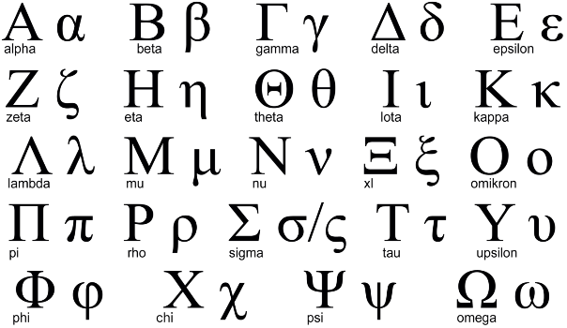

**GREEK SPELLING WORDS**

|  |  |  |
| --- | --- | --- |
| 1. amphibious | 8. euphemism | 15. nemesis |
| 2. anomaly | 9. eureka | 16. odyssey |
| 3. archaeology | 10. hierarchy | 17. periphery |
| 4. chaos | 11. hydraulic | 18. phobia |
| 5. chronology | 12. lethargy | 19. protocol |
| 6. diagnosis | 13.metamorphosis | 20. triumph |
| 7. eulogy | 14. monotonous |  |

** GREEK WORDSEARCH**

|  |  |  |  |  |  |  |  |  |  |  |  |  |  |  |  |  |
| --- | --- | --- | --- | --- | --- | --- | --- | --- | --- | --- | --- | --- | --- | --- | --- | --- |
| **A** | **D** | **P** | **R** | **O** | **T** | **O** | **C** | **O** | **L** | **P** | **T** | **C** | **E** | **I** | **A** | **E** |
| **R** | **I** | **C** | **D** | **E** | **U** | **R** | **E** | **K** | **A** | **O** | **J** | **H** | **U** | **I** | **R** | **Q** |
| **L** | **A** | **M** | **P** | **H** | **I** | **B** | **I** | **O** | **U** | **S** | **Y** | **A** | **B** | **E** | **P** | **G** |
| **L** | **G** | **N** | **J** | **T** | **L** | **E** | **S** | **U** | **F** | **U** | **S** | **O** | **K** | **E** | **L** | **P** |
| **H** | **N** | **H** | **O** | **M** | **C** | **H** | **I** | **N** | **M** | **Y** | **H** | **S** | **W** | **O** | **D** | **P** |
| **Y** | **O** | **I** | **B** | **M** | **K** | **Q** | **B** | **Z** | **E** | **P** | **H** | **O** | **L** | **X** | **U** | **A** |
| **D** | **S** | **E** | **Y** | **R** | **A** | **U** | **H** | **B** | **B** | **M** | **H** | **L** | **W** | **K** | **C** | **R** |
| **R** | **I** | **R** | **M** | **F** | **Z** | **L** | **X** | **F** | **Z** | **T** | **E** | **O** | **D** | **E** | **R** | **C** |
| **A** | **S** | **A** | **Z** | **S** | **O** | **D** | **Y** | **S** | **S** | **E** | **Y** | **S** | **F** | **G** | **T** | **H** |
| **U** | **D** | **R** | **N** | **V** | **I** | **G** | **F** | **H** | **G** | **H** | **V** | **A** | **I** | **V** | **F** | **A** |
| **L** | **R** | **C** | **P** | **E** | **R** | **I** | **P** | **H** | **E** | **R** | **Y** | **G** | **J** | **S** | **U** | **E** |
| **I** | **N** | **H** | **V** | **A** | **O** | **J** | **Q** | **I** | **V** | **N** | **C** | **C** | **Y** | **N** | **W** | **O** |
| **C** | **D** | **Y** | **H** | **Z** | **M** | **M** | **O** | **N** | **O** | **T** | **O** | **N** | **O** | **U** | **S** | **L** |
| **N** | **H** | **T** | **M** | **E** | **T** | **A** | **M** | **O** | **R** | **P** | **H** | **O** | **S** | **I** | **S** | **O** |
| **W** | **E** | **U** | **P** | **H** | **E** | **M** | **I** | **S** | **M** | **U** | **Z** | **F** | **Y** | **C** | **A** | **G** |
| **L** | **C** | **H** | **R** | **O** | **N** | **O** | **L** | **O** | **G** | **Y** | **E** | **U** | **L** | **O** | **G** | **Y** |

   