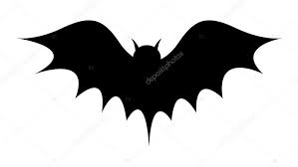**Liz Austen saves the Baron**

**L**isten to the voices that warn you of danger  **I**nvestigate the life of the Baron and his fiancée **Z**ero tolerance does Liz have for Simon

**A**nxious is she of sleeping on death row **U**nusual and mysterious shadows follow her in the mansion **S**uspicion of Lobos until the end  **T**errified of vampires was the Baron

**E**scape from the creature in the crypt **N**o one knew Lobos’ plan to kill the Baron

**S**uperstition like curiosity can kill you **A**sylums where people who were mentally ill were kept long time ago  
**V**ampires are a myth is that what you think? **E**verything you see is real or is it? **S**ave yourself from the evil that lurks around you

**T**empted was Liz to look inside the vampire’s coffin **H**ope you can hide from the one who is watching you when you sleep

**E**rase the nightmares that live inside your mind  **B**ury themonster that has taken over your life  
**A**sk for your soul to be saved this night **R**emember that you are never alone **O**h God, you will keep me from harm **N**ever forget that this life is only a journey