VOCAB. 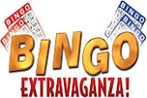
- Fill out your Bingo Card with Vocab. Terms from this Science Unit. Review the definitions!
- You may include one FREE SPACE.
- If there are less than 24 terms for this unit, you may also include a colour.
- The Teacher will call out the definitions only. Pay attention.
- Two lines of “5 across” are needed to win.

