**CLIMATE GRAPHS**

**Name: ______________________ Date: _____________________**

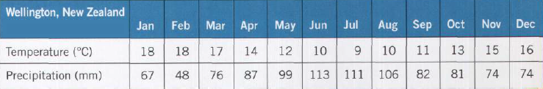

1. Use the information *above* to calculate the following. Show your work!
   1. approximate average temperature *(Hint: Use the highest and lowest temperatures.)*



**(18+9)/2 = 13.5 °C**

***or* (18+18+…+16)/12 = 13.58 °C**

* 1. temperature range

**18 – 9 = 9 °C**

Wellington, New Zealand. The seasons are reversed in the southern hemisphere.

* 1. total precipitation *(Remember: units!)*

**67+48+…+74 = 1018 mm**

1. On graph paper, *neatly* draw and label a **climate graph** for Wellington, New Zealand.

Remember:

* **The red line graph shows the average monthly temperature.**
* **The blue bar graph shows the total monthly precipitation.**
* **The unit of measurement must be listed (Temperature °C / Precipitation mm).**
* **Use a ruler and pencil. No pens, nor markers!**
* **Including the latitude / longitude of the place is a nice touch**
* **Staple the graph to this worksheet!**

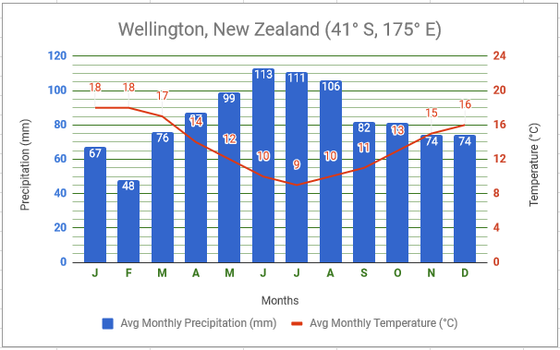

**87**

1. Toronto is in the northern hemisphere, and Wellington is in the southern hemisphere. How has this affected their temperature lines? Why is this so?

**Peak of temperature line for Toronto is in July, whereas in Wellington, the peak occurs in January.**

**This happens because the seasons are reversed in the northern and southern hemisphere.**

