**CLIMATE GRAPH**

**Name: ______________________ Date: _____________________**

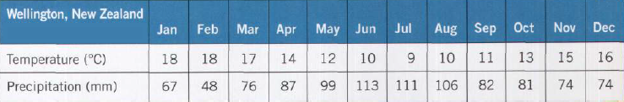

1. Use the information *above* to calculate the following. Show your work!
   1. approximate average temperature *(Hint: Use the highest and lowest temperatures.)*



* 1. temperature range

Wellington, New Zealand. The seasons are reversed in the southern hemisphere.

* 1. total precipitation *(Remember: units!)*

1. On graph paper, *neatly* draw and label a **climate graph** for Wellington, New Zealand.

Remember:

* **The red line graph shows the average monthly temperature.**
* **The blue bar graph shows the total monthly precipitation.**
* **The unit of measurement must be listed (Temperature °C / Precipitation mm).**
* **Use a ruler and pencil. No pens, nor markers!**
* **Including the latitude / longitude of the place is a nice touch**
* **Staple the graph to this worksheet!**

1. Toronto is in the northern hemisphere, and Wellington is in the southern hemisphere. How has this affected their temperature lines? Why is this so?

