**Climate Quiz**

/12

1. Explain the difference between weather and climate. (2 marks)

2. Fill in the blank for each statement below. (2 marks)

1. The blue bars on a climate graph represent _____________________________.
2. The red line on a climate graph represents _____________________________.

3. Circle true (T) or false (F) for each statement below. (4 marks)

1. T or F: The title of a climate graph should include both the location and the year.
2. T or F: If a city is close to a body of water, its temperature will be more variable.
3. T or F: If a city is close to the equator, its temperature will be more constant.
4. T or F: If a city is in the Southern hemisphere, it will be hottest in June - August.

4. Answer the following questions about the climate graph shown below.

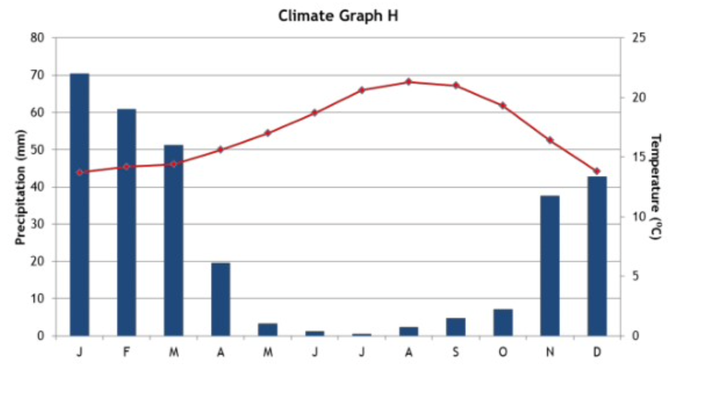

1. Which month has an average of 20 mm of precipitation? (1 mark)
2. Which month has the highest average temperature? (1 mark)
3. What is the approximate temperature range over the whole year? (1 mark)
4. Which hemisphere is this city in? (1 mark)