**Climate Quiz**

/8

**IMPORTANT:** Answer as many questions as you can, but keep in mind that your quiz will be graded out of 8 marks (instead of 12 marks).

1. Explain the difference between **weather** and **climate**. (2 marks)

2. Fill in the blank. (2 marks)

1. The **blue bars** on a climate graph represent ____________________________.
2. The **red line** on a climate graph represents _____________________________.

3. Circle “True” or “False” for the statements below. (4 marks)

1. True or False: The **title** of a climate graph should include both the **location** and the **year**.
2. True or False: If a city is **close** to a **body of water**, its temperature will be more **variable**.
3. True or False: If a city is **close** to the **equator**, its temperature will be more **constant**.
4. True or False: If a city is in the **Southern** hemisphere, it will be **hottest** in **June**, **July**, and **August**.

4. Answer the following questions about the climate graph shown below.

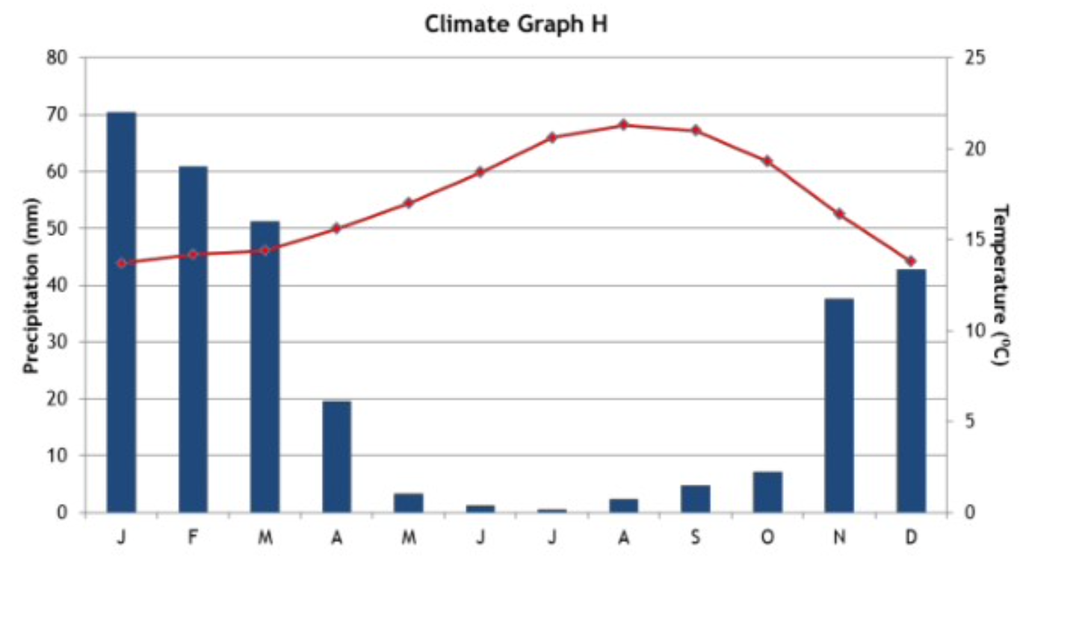

1. Which **month** has an average of **20 mm of precipitation**? (1 mark)
2. Which **month** has the **highest average temperature**? (1 mark)
3. What is the approximate **temperature range** over the whole year? (1 mark)
4. Which **hemisphere** is this city in? (1 mark)