**Climate Graphs**

What is *climate*?

______________________________________________________________________

______________________________________________________________________

What is *weather*?

______________________________________________________________________

______________________________________________________________________

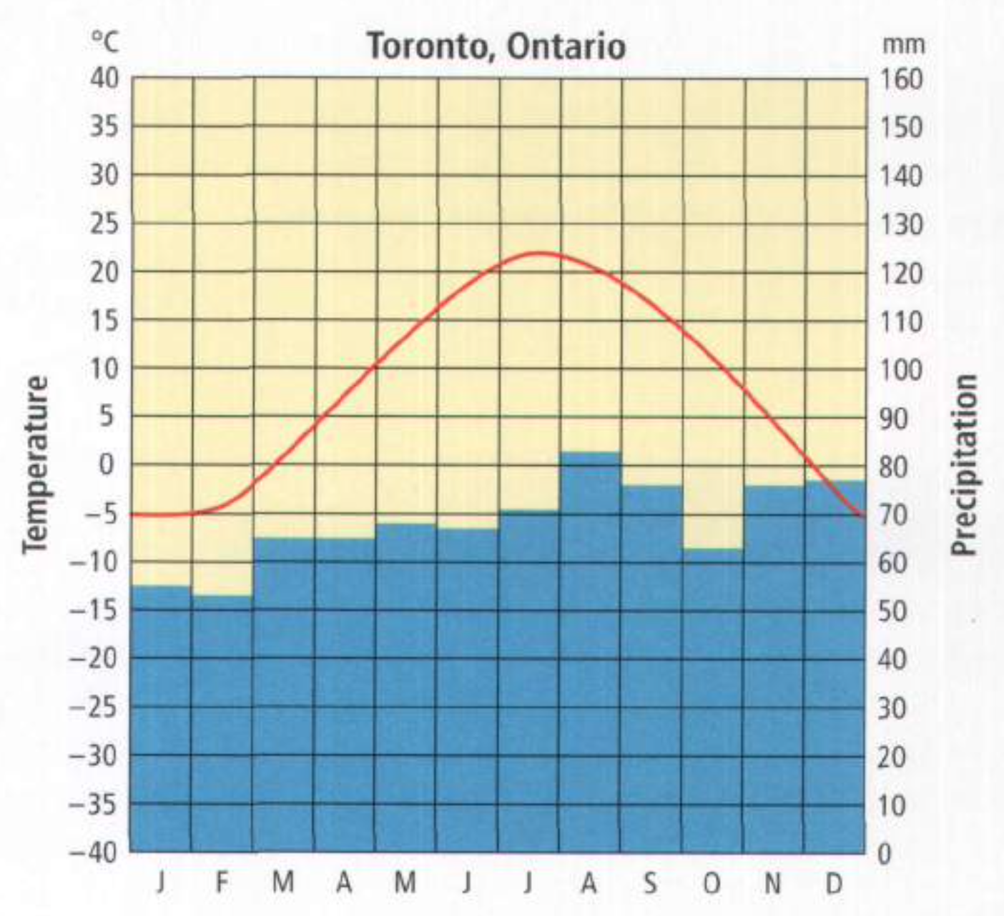

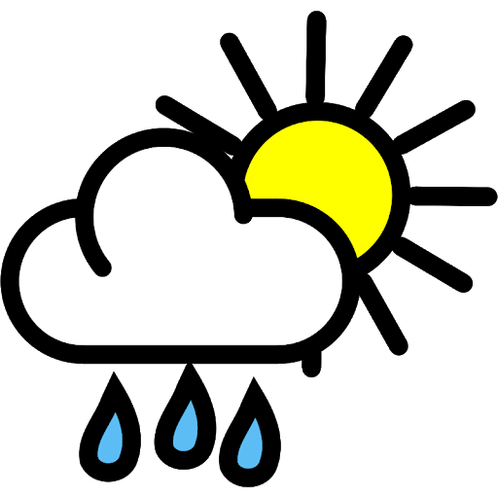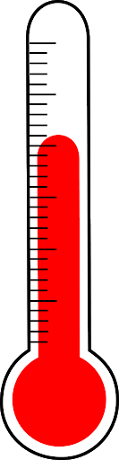

Key elements of climate graphs:

* ________________________________________________________________
* ________________________________________________________________
* ________________________________________________________________
* ________________________________________________________________
* ________________________________________________________________
* ________________________________________________________________

Factor #1: Northern vs. Southern Hemisphere

* The hottest months in the Northern hemisphere are _______________, _______________, and _______________.
* The hottest months in the Southern hemisphere are _______________, _______________, and _______________.
* This is because the Earth is tilted on an axis of 23.4°.
  + In the Northern hemisphere’s summer, it’s titled in towards the sun.
  + In the Northern hemisphere’s winter, it’s titled out and away from the sun.

|  |  |  |
| --- | --- | --- |
| Northern Hemisphere:  ____________  Southern Hemisphere:  ____________ |  | Northern Hemisphere:  ____________  Southern Hemisphere:  ____________ |

Factor #2: Proximity to the Equator

* Places close to the equator have more __________________ temperatures throughout the year.
* Places far away from the equator have more __________________ temperatures throughout the year.

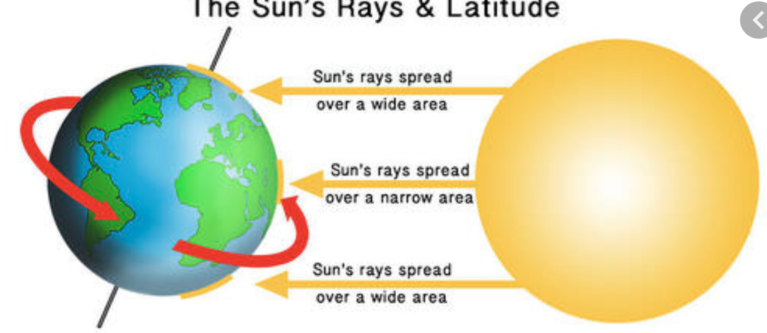

Factor #3: Proximity to a Body of Water

* Places close to a body of water have more __________________ temperatures throughout the year.
  + This is called a __________________ climate.
* Places far away from a body of water have more __________________ temperatures throughout the year.
  + This is called a __________________ climate.

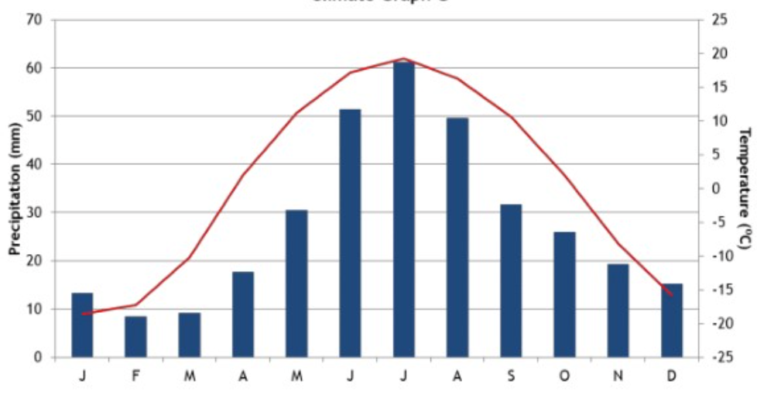

* What is the average monthly precipitation in May? _____________________
* What is the temperature range for this city? _____________________
* Which hemisphere would this city be found in? _____________________

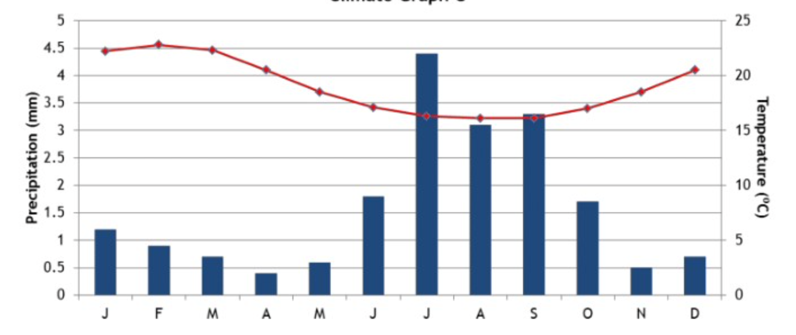

* Which hemisphere would this city be found in? ________________
* Do you think this city is far from or close to the equator? ________________
* Do you think this city is far from or close to a body of water? ________________