**Assignment: Make Your Own Climate Graph**

Using the table below and the template provided to you on the next page, make a climate graph for the city of Wellington, New Zealand.

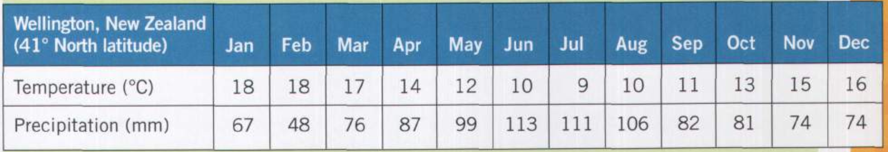



Use a ruler, pencil crayons, and a pencil. NO PENS OR MARKERS!

Remember the key elements to include in your climate graph…

* Top: Location and year
* Bottom: Months
* Line graph in red (average temperature for each month)
* Left: Scale for average temperature (°C)
* Bar graph in blue (total precipitation for each month)
* Right: Scale for total precipitation (mm)

Use the climate graph below as a reminder of what your climate graph should look like.

